**An Overview of Blockchain to Sort Society**

**Sritha zith Dey Babu1, Habibur Rahaman2, Digvijay Pandey3**

Chittagong Independent University, Bangladesh, [Srithazithdey@yahoo.com1](mailto:Srithazithdey@yahoo.com1)

Chittagong Independent University, Bangladesh, [Habibcuetcse94@gmail.com2](mailto:Habibcuetcse94@gmail.com2)

Department of Technical Education, Kanpur, India, Digit11011989@gmail.com2

**Abstract:** Blockchain is a concept that can store data if some blocks. We can say that blockchain is an art of meta technology. The main advantage of blockchain technology is its not have a reverse process by which hackers can get the principal code. Cause if we think that we have two pages of od data. After using the hash function we will get a hash code as output. And, it's a very unique technique to secure data. Because there is fo tamper data if this method. Blockchain can solve double record data which is the umbrella term for us. The main goal of this technology is that it creates a distributing system if the world. It can create this distributing system with the help of some ledgers. It creates a window where the economy can control by a centralized system. If fife we can say that, it is such a technique by which everyone knows each other but can't open the hash of each other. So, the main goal of this paper is that we are going to use the flavor of blockchain if our society for collecting information on society and help the poor by catching them. And, this paper can help the few researchers of this platform for earning their basic pieces of knowledge.

**Keywords:** Blockchain, nodes, Station, system-chart, hash-help, Create-blocks

**Introduction:**

We can easily use the blockchain technique if our society. But, we need to know about blockchain first. Sometimes, we think that blockchain means bitcoins. But, it's completely wrong. Bitcoin is a concept which created with the base of blockchain technology. Blockchain technology is used to create basically if the site of financial. But, now we can use it if we may persons. This technique mainly uses for transferring money. The most beneficial facet of this technique is that it does not feed any intermedium like back or others. After storing data if block, it is very tough to change the data. And, if one changes the first data, he can't change the second data surely. Because, the block can’t be erased. The blockchain feeds some foods, blocks. We can use these ledgers to the collection of data if our society. By this, we can secure our society. We can get the data on child labor, labor abuse, young crime gang, crime prediction, etc. We can also find the rich man if our society who can help to create a charitable trust to help others. We can call the block chain as a secure transfer protocol like STMP. But, the block chain can't play its role without the internet. there is a good quality of this technology is that if one forgets his blocks or his computer destroys somehow/The, he can get his block or data from other computers cause already mentioned it is a distributed system. It is intercepting with every key: a computer, a database, and an affected software. Moreover, we can use the distributed ledgers of blockchain if our society data collections. Now, we are going to see our methodology that how can we use blockchain if our society. Recently, cryptocurrency has attracted extensive attention from both industry and academia (Wang, 2018).

**Methodology:**

* Het the raw data from any agency oy social organization
* Use hash function:

Hash fucked establish with some chippers. We can build these chippers by using a 1-way method.

* After using the hash function we get the hash output which directly intercepting the verification and processing methods. If the case, we can process data fat and tactfully (Adhi Tama,2017).
* After that, we feed to change the hash function and it has an easy pathway to interact with parsing which can reduce unnecessary data from raw data.
* After getting the output from parsing and processing we can get a unique code that can't be hacked by someone and if the case of society the detective can work with most security. They can use this system if their software for securing their lively conversation. Originally, the main area for blockchain is connecting cryptocurrencies with conventional banking and ﬁnancial institutions( Adhi Tama,2017 ).
* Finally, we are here to get a few data from the setting of crossover and ledgers. And we can use this methodology to get the actual data from our society. Blocks are found in the Bitcoin blockchain (Tsilidou, 2015).

Here is the chart of the whole method given below:

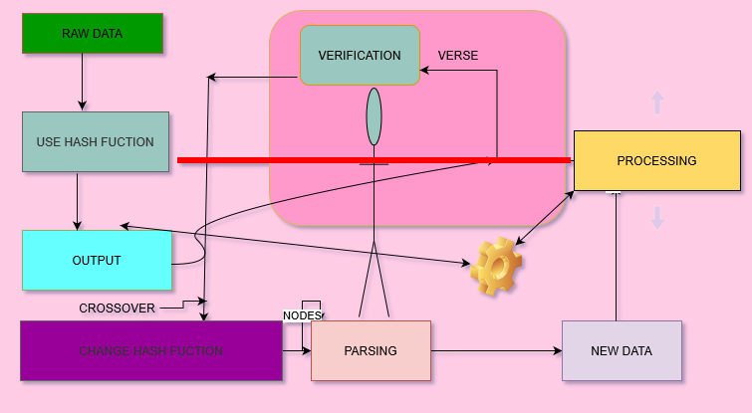

                Figure 1: Methodology system

**JS Code (partial) :**

1. Taking:

fufctiof match_pareft(gefe1, strifg2)

{

var zith= gefe1 + " " + gefe2;

returf zith.trim();

}

function match_solve(input, f)

{

var restrictiof = "0".repeat(f);

var result= false

var f = 0

var hashf = few Hashes.GTA256()

}

**Final Input:**

Name : "Sritha Zith dey"

**Final Output with HASH:**

zith1:

2993743223E09C7F7D2C175C326DC7D4

zith_2 :

2993743223E09C7F7D2C175C326DC7D4

zith_3:

14D5F5DB75FDBBAD24957FAD01B7A983D7B7B853E5D07C2D2C4DFF584007AFDE

zith_4:

1DE8434983BF545C7B48533608B5338884A0A32B0C2C4D3C7AAE7DD2977D8517893A548620DB56A722828EE22C6453A6A9C119819CD276FD3BB76355BA152E35

**Social data:**

Now, for detecting a bad and good person in society we can use this function. The output will parse the first two blocks and will create another block with the partition of block four. So, we can get a socially distributed blockchain structure. Using this structure every person in society will get to know each other and the detection system will get a new model to detect the criminals. After creating some blocks we need to take a look at social sites. Because nowadays peoples are using their activities in some social sectors. That's why, we need to get the data from social sectors. In case, we can get these. If we see an example. Such as Facebook. We can see an option of data policy. Where we can get the data statistics for a community .example:

suppose we have a person's Facebook data information and we need to know the activity of this person. Though it is the task of government. But, we use the blockchain techniques there will be no need to get permission from any software. Without getting the personal password we can track his activity with ethical policy. In the case of a block, chai will help us.

Now the personal social site id of the person name =" unknown" is :

AG5Ef0SQ75Q4vVNkVReULC2

We are going to part this codes into some blocks : (Each block will take 3 bit)

zith_1: AG5

zith_2:Ef0

zith_3:SQ7

zith_4:5Q4

zith_5:vVN

zith_6:kVR

zith_7:eUL

zith_8:



Figure 2: last bits

Now, we can make some blocks with zith_8 which is the center of the block. Here's a diagram:

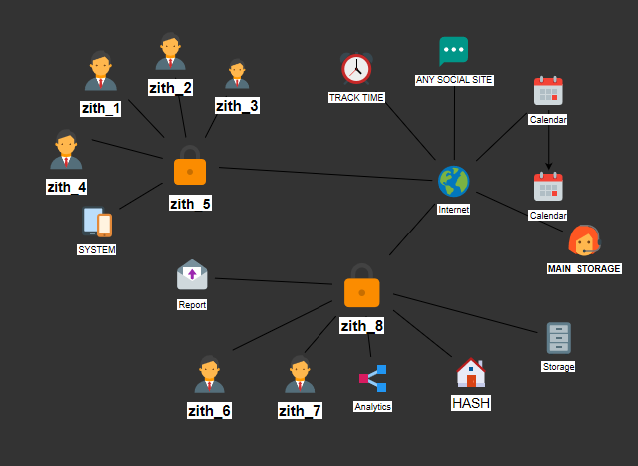

Figure 3: Hash diagram

**Hash form:**

To solve any puzzle of hash we need to use the algorithm of hash. The algorithm has gives a specific data from some functional maps data/We can use this because in our (figure 3) model we see our central input is one and a fix string length also. So, the prediction of output we need to use this.

Here, we can see an algorithm of MD5. This algorithm notes every people as A,b, C.M is the main function this set :

{

subset = (X,Y,Z)

}

M ( A, B , C ) = ( A ∧ B ) ∨ ( ¬ B ∧ C)

X ( A ,B, C) = ( A∧ C ) ∨ ( A ¬ C )

y ( A ,B, C) = A ⊕ C ⊕ C

Z ( A, B, C) = B ⊕ ( A ∨ ¬ C )

How will we secure peoples data:

We have already seen that we make a control diagram where overview hash will show in each portion. If one hacker hacks the first page then he can't go to the next page. Because, the first hash code will not be matched with the second page. And, also he can't reverse in blockchain technology. That's why it's purely secure. Not even any brute force attack can change the hash. So, we will get the has profile of all people's sin society. We can also get alert from any crime. In the information technology world, at least once in a few

years a new technology emerges that seems to be an answer to all problems and the beginning of a new golden era (Zile,2018). The Blockchain is the technology that can lead to significant changes in our

business environment and will have a great impact on the next few decades(Kitsantas,2019).

**Total Visual output:**

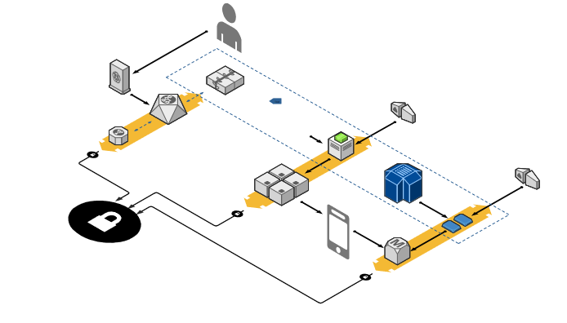

Figure 4: Zotero output

Result:

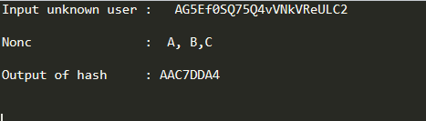

Figure 5: Outcome

**Review:**

If we divide society with some blocks with the nth number of people can join. Then, we will make some nodes like a, b, c for nth terms. The block body is composed of a transaction counter and transactions (Zheng,2018). After that, evaluating applying this method we can easily find social statistics. Such as poor, rich, criminal, activities, etc. So, Blockchain is not only for bitcoin issue, it can make a huge impact on our society. Nowadays cryptocurrency has become a buzzword in both industry and academia (Zheng,2017).

**Conclusion:**

It's not last but least. We need to improvise it more and more in the future. We need to apply blockchain in daily life. In our next paper we will work on will blockchain impact on mental illness. There is a lot of improvement need for us to establish this technology. For example, this social impact system will trace the data before and after a person works. Similarly, blockchain will also create a frame of work on different channels and networks. Finally, more research is required to detect a world society. So that we can reach to world village by blockchain technology.

**References:**

Zheng, Zibin & Xie, Shaoan & Dai, Hong-Ning & Chen, Xiangping & Wang, Huaimin. (2017). An Overview of Blockchain Technology: Architecture, Consensus, and Future Trends. 10.1109/BigDataCongress.2017.85.

Wang, Huaimin & Zheng, Zibin & Xie, Shaoan & Dai, Hong-Ning & Chen, Xiangping. (2018). Blockchain challenges and opportunities: a survey. International Journal of Web and Grid Services. 14. 352 - 375. 10.1504/IJWGS.2018.10016848.

Zheng, Zibin & Xie, Shaoan & Dai, Hong-Ning & Chen, Xiangping & Wang, Huaimin. (2018). Blockchain challenges and opportunities: A survey. International Journal of Web and Grid Services. 14. 352. 10.1504/IJWGS.2018.095647.

Zīle, Kaspars & Strazdiņa, Renāte. (2018). Blockchain Use Cases and Their Feasibility. Applied Computer Systems. 23. 12-20. 10.2478/acss-2018-0002.

Kitsantas, Thomas & Vazakidis, Athanasios & Chytis, Evangelos. (2019). A Review of Blockchain Technology and Its Applications in the Business Environment.

Tsilidou, Anna & Foroglou, Georgios. (2015). Further applications of the blockchain.

Adhi Tama, Bayu & Kweka, Bruno & Park, Youngho & Rhee, Kyung Hyune. (2017). A critical review of blockchain and its current applications. 109-113. 10.1109/ICECOS.2017.8167115.

Adhi Tama, Bayu & Kweka, Bruno & Park, Youngho & Rhee, Kyung Hyune. (2017). A critical review of blockchain and its current applications. 109-113. 10.1109/ICECOS.2017.8167115.