**A simple study about Child labor**

Sritha zith Dey Babu1, Habibur Rahaman2, Digvijay Pandey3

Chittagong Independent University, Bangladesh, [Srithazithdey@yahoo.com1](mailto:Srithazithdey@yahoo.com1)

Chittagong Independent University, Bangladesh, [Habibcuetcse94@gmail.com2](mailto:Habibcuetcse94@gmail.com2)

Department of Technical Education, Kanpur, India, Digit11011989@gmail.com2

**Abstract:** The primary phenomenon is not too strong at the 1st view of preventing labor abuse. A lot of problems may be raised to solve this problem. That's why we need to concentrate firstly in the sector of retrenchment. Because, It has a huge chain in our country. We can't break the chain early. We need to decode the chain and need to find the hash codes of these chains. But, there are different types of nodes to face all the big issues and problems strategically. That's why we maximum stations and networks which are we can track with some strategies by manufacturing a bridge of chain management and control system. So, we need to draw the system which can collaborate directly with the labors. In this paper, we are going to show the bridge which can zip the child labor into a folder. After that, we can extract this folder and also can treat every child very carefully. We can make up the function of GA, Blocks to reducing the problems. Four strategies of CS (Computer Science) can improvise the chain of replacement. Such as Data- set to function, function to Labor, labor to verification, and verification to control the action with the TWM method. TWM method is a completely new and impactful method that is going introduce in this paper which can improve child labor mentality. The impact of the TWM method can create also some blocks by which the block-chain method can make its implementation in the future into this topic. In fine we can say the goal and motive of this paper are to make a society that is free from child labor.

**Keywords:** Motivational strategy, Block-chain, Nodes, Control System, TWM method, Extraction

**1. Introduction:**

Under the age of 18 anyone treats as child labor. At a very young age it's not fair to work. The age is for earning knowledge and every countries government has Govt. school from where one can get an education. Child labor is an insidious evil. (Sajal Lahiri, 2001).The backbone of a nation is education. But, the generation of a nation is a child. Performed some work means child working. And there are also some types of work. Physical work and mental work are the most vibrate types of work. But the dangerous thing is physical work. It affects a child's body and makes a child weak. Another thing is that mental work which makes a child mind very dirty. Child labor is one of the most powerful vehicles that transmit poverty across generations” (Agarwal, 2013). Social protection and labor programs aim at reducing poverty, improving the wellbeing of the poor, and protecting households from economic shocks” (Ana C. Dammert, 2017).

**1.1 Minimum age:**

There isn’t only one minimum age for work. In the case of some works, it should not be less than 15 years. And, for light works it can be 13. But, in some countries, it's different. But we think there is no difference when it comes to child labor. The minimum age should be 18 to engage in some works. Because, at the age of 18 one can understand the value of works, sexual harassment, etc. So, to set the exact age of child working, we need to set the school leveling age. If we can engage the children into some academic works than they won't get the scope of work. In the present scenario many children are going to intercept themselves with some heavy works invoice of money.

**1.2 Social Monitoring:**

The existing system of social auditing about this matter is not the best system to reduce child labor. It needs some updates. So, we can make some blocks in a society where we can assign some auditors and into the blocks we can improvise some nodes also. Blocks give the folder and nodes open then folder. And, after opening the folder we get some files of data- set. In fine we can say that now it is easier to track child labor. For increasing the performance of the audits we can set some methods. Which are given below:

* Find the child labor with nodes
* Site inspection
* Take some interview for them
* Make a data set of child labors
* Find the third party
* Give the data to the police

**2. Methodology:**

1. Monitoring:

Monitoring is not a very tough one or not very easy to find child labor. But, with the help of some social sites, media, neighbors we can track the labors. We need to set some hotspots using data mining. This means, after getting the list of all children's in a village, we have to check and find their previous working data. By which we will get an output of main victims (child laborers). Then, we have to visit the location and need to get some interviews from neighbors. Perhaps, we can get the third parties who are making child labor. Finally, a monitoring system can help police or other organizations to arrest the third parties and secure the children. We will show that borrowing increased substantially more in treated relative to control communities, both on the intensive and the extensive margin” (Alessandro Tarozzi, 2015).

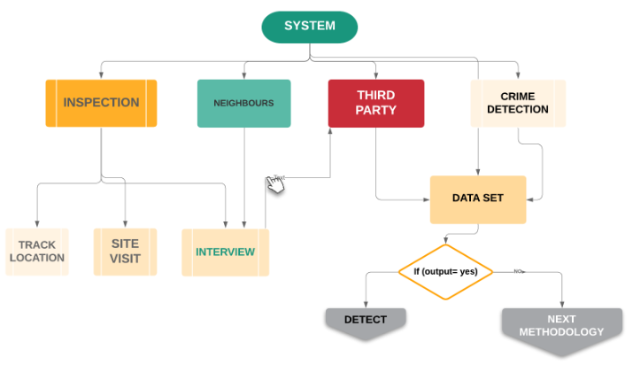

Figure 1: Monitoring

**b. Using the control system:**

Using interpolation we can protest and decrease this problem. So, the control system takes the security responsibility by which labor can work freely. For this system we need to make a bridge between CS to Labor. In some contexts, strategies addressing multiple constraints may be necessary to achieve larger overall effects across multiple outcomes” (Birte Snilstveit, 2016). For implementing this system every company has to submit their labors list with their NID card number, and three types of contact number:

* Personal Contact Number
* Family Contact Number
* Emergency Contact Number

Now here's a figure of total control system:

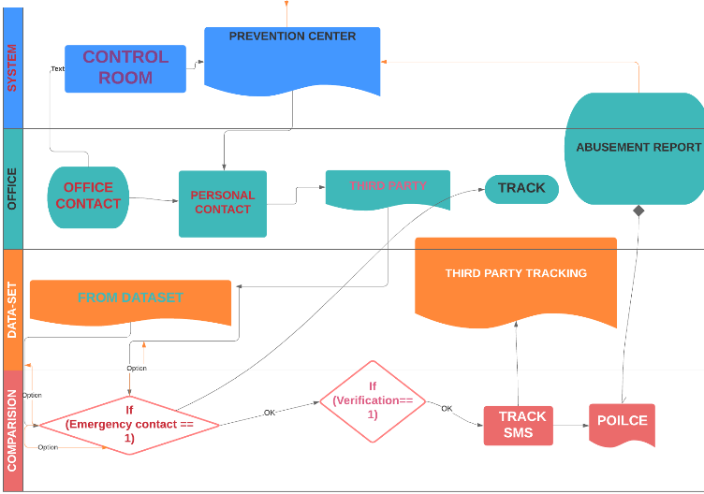

Figure 2: Control system

**3. TWM method:**

TWM is a new method by which we can change the child labor mentality.

T = Time

W = Work

M = Money

In this method, we can give some tasks to them. Though, We will give them some condition also. We can use the data collection work, third party data processing work, social gang detecting work, surveying work, drawing, sports. We can give them some hand costs for these tasks and can admit them in a Government school. We can give them some books, online classes introduction, social interaction, etc. But, we need to do this concerning time, work, money. The equation has to be proportional.I have given the input as {10 ,12 ,14}.Then, the output is:

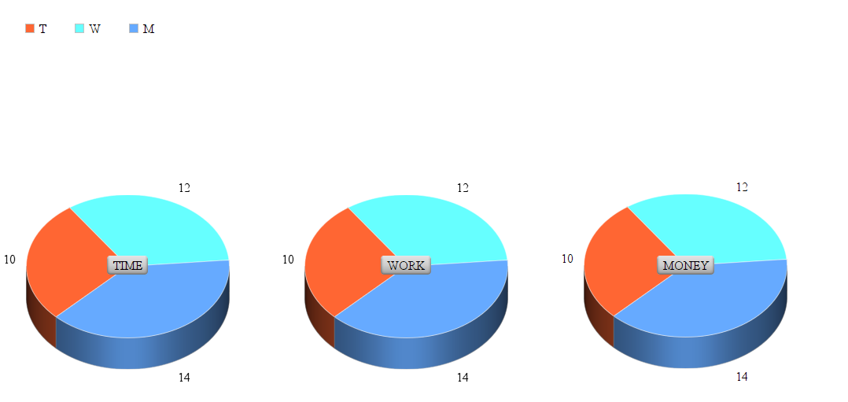

**Figure 3: output**

**4. Best solution:**

1. Reducing poverty
2. Establishing strong law
3. Education
4. Ethics
5. Donation
6. Alert and action

**5. Analysis:**

Now, we think we need to take some actions to reduce child labor. The actions are:

a) Inform themselves about child abuse.

b) Arrange a campaign.

1. Redden.
2. Show the actual task.
3. Encouragement.
4. Make a network.

**6. Review:**

There is some hybridism about child labor definition in both research and business terms. The paper reviews how the word “ Child labor” make our society day. The significant progress that has been made demonstrates that the overall strategy as set out in the ILO action plans including The Hague Roadmap appears to be sound and producing positive results in terms of strategic policy direction” (Department, 2013). So, here is a formula:

If, minimum age rage of child working level is M and noted by Ms. K demo laws evaluate the difference between age Ageckh to ( Ms-1).

When the value of K will be zero then, the value of the age range is the child is not now perfect for work.

In formulas:

Pckhs =K(Ageckh-Ms+1>0) (Ageckh - Ms +1)

where K ( ) is an one-one function. Pckhs  puts value = 1 if (chield age = legal).

**7. Conclusions:**

Finally, We can remove this problem slowly forever with the usage of awareness. We have to target the children of poor families. Generally, they go there. So, We have to create the most number of employment in poor families. Govt. have to provide jobs for them.

**References:**

Agarwal, A. (2013). Child Labour in India. *Indian Labour Journal*, 1099.

Alessandro Tarozzi, J. D. (2015). The Impacts of Microcredit: Evidence from Ethiopia. *American Economic Journal*, 54-89.

Ana C. Dammert, J. d. (2017, 3). Effects of Public Policy on Child Labor Current Knowledge, Gaps, and Implications for Program Design. *World Bank Working Paper*.

Birte Snilstveit, J. S. (2016). *The impact of education programs on learning and school participation in low- and middle-income countries.* London: International Initiative for Impact Evaluation (3ie.

Department, G. a. (2013). *Marking progress against child labor.* Geneva: International Labour Office.

Sajal Lahiri, M. S. (2001). CHILD LABOR. *World Economics*, 69-93.