CREDIT POLICY OF COMMERCIAL BANKS OF THE REPUBLIC OF UZBEKISTAN AND ITS MAIN DIRECTIONS

Samadov Ortiq Abdualim’s son
Researcher of Finance
Karshi engineering economic university, Uzbekistan,
Khamrayeva Zilola Khamro's daughter
Researcher of Accounting and auditing
Karshi engineering economic university, Uzbekistan,

Annotation: This article discusses the credit policy of commercial banks and its main directions. The data are based on statistical analysis of the last 2 years. The credit policy of commercial banks operating in the Republic of Uzbekistan is the main focus. Theoretical proposals and conclusions are formed on the topic.
Keywords: Banking system, credit policy, credit analysis, bank resources, active banking operations, lending, bank loans, special loan reserves, bank capital, regulatory capital, additional capital, risky assets.
Introduction: The issues of improving banking activities and identifying priorities for the development of the banking system are at the center of economic, political and social life of the country today. The banking system is an integral part of the national economy. Banks, as credit intermediaries, perform specific functions, including the ability to collect cash flows and redistribute them between sectors of the economy. By performing these functions, banks must contribute to sustainable economic growth. The banking system is one of the most important sectors of the country's economy. First, banks contribute to the creation of gross national product by providing services to legal entities and individuals; second, the direction of cash flows, banks are a crucial link in the financial infrastructure of the national economy; and thirdly, careful response to changes in the economic situation caused by the actions of government agencies, banks are agents of economic policy of state stabilization. Expansion of the stable resource base in banks, regular introduction of new types of deposits and savings, as well as savings from the population and as a result of measures taken to further improve the system of acceptance, storage and management of time deposits, an increase in the loan portfolio of banks will be achieved. This, in turn, will allow banks to finance more investment projects. Lending services to agricultural enterprises, manufacturing, construction, trade, supply and services, export and import operations, small businesses, farmers and farms, regardless of ownership and loans to individuals. Loans from commercial banks are one of the sources of financing the current and investment costs of business entities and play an important role in ensuring sustainable economic development. The bank's lending process is the process from the date of the client's application to the bank and the period between the signing of the loan agreement and the repayment of the loan. The beginning of the lending process means that a credit relationship has been established between the client and the bank. In this process, the bank has the right to request any document from the borrower and before issuing a loan, it is necessary to thoroughly study the financial condition of the borrower, give him a loan only after he finds it creditworthy and constantly monitor it until the loan is repaid.

Literature review: The first ideas about credit analysis belong to western scholars. According to N. Brook, credit policy means the integration of organizational needs, rules, laws, and management philosophy. It contributes to the development of corporate culture. The bank's reputation in policy development will be strengthened and the basis for future results, as well as internal and external audits, will be established. There are a number of great ideas about banking, especially the famous writer M. Twain, who said, "A banker is a person who gives you an umbrella when the sun rises and takes it away from you when it rains." Leading foreign scholars on credit policy and financing of commercial banks, including Y. Babicheva, YF Zhukov, YV Stepanov, B.K. Irishev, O.I. Lavrushin, F.Mishkin, Ye.B. The research of scientists such as Lauts serves as an important theoretical and methodological basis. It should be noted that F. Mishkin's book "Economic Theory of Money, Banking and Financial Markets" is one of the main sources of information on the refinancing policy of the US Federal Reserve. Also, Uzbek economists Sh.Abdullayeva, U.O.Azizov, T.I. Bobakulov, O’.A. Abdullayev, RR Tojiev, NH Jumayev and others provided general opinions on the forms of financing operations of central and commercial banks and the refinancing policy of the Central Bank of the Republic of Uzbekistan and the disclosure of existing problems. Also, the theoretical basis of this article are the Decrees, resolutions of the President of the Republic of Uzbekistan and the normative acts of the Oliy Majlis and the Cabinet of Ministers in this area.

Analysis and results: The main goal of the Bank's credit policy is to ensure high return on bank assets, maintain liquidity, diversify risks, comply with applicable economic standards related to credit operations, to form a loan portfolio in accordance with lending principles, implementation of a set of measures. The lending process is reflected in Article 4 of our Law on Banks and Banking. More specifically, it was mentioned that during the activities of banks, they will carry out lending operations on their own behalf and at the expense of borrowed funds, subject to the repayment, interest and maturity of loans. Over the course of long-term development, banks have become a large and diverse financial service provider. They provide loans to various sectors of the economy, purchase and sale of securities, management of corporate property and a number of other financial transactions. However, despite this, credit operations remain a primary asset operation for commercial banks. Banks in developed countries now offer more than 300 banking operations and services. Among them, the credit operations of banks are undoubtedly the most important. In a number of developed countries, the share of credit operations in the total assets of the bank ranges from 19.9% ​​to 83.25% on average. Lending rates of commercial banks, of course, depend on the adequacy of bank capital. The better the capital flow in the bank, the higher and higher the bank's creditworthiness. Another important aspect is that a well-established bank capital policy will prevent commercial banks from becoming dependent on the state. It is gratifying that over the past two years, commercial banks of the country have been improving this activity. The following clear statistical table is a clear proof of this.

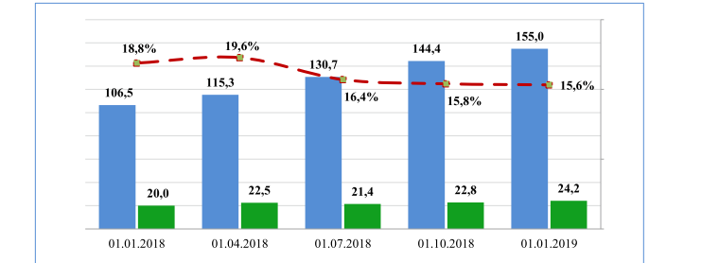
Bank capital adequacy ratios
Figure 1
- Amount of assets at risk The amount of regulatory capital
- Regulatory capital adequacy,%

Looking at the table above, at the beginning of 2018, the number of assets at risk was 106.5. But every quarter, that number has been growing at around 15%. 8.8% in the first quarter was slightly lower due to financial disruptions at the beginning of the year. If we compare the beginning of 2018 and the beginning of 2019, we will see a net growth of 48.5%. From the data in the table, it is clear that the growth of risky assets at a time when the volume of regulatory capital is flat, shows an increase in confidence in commercial banks. As of January 1, 2019, 39.8% of commercial bank loans were made in industry, 12.5% ​​in transport and communications, 6.4% in trade and general services, 5.6% in agriculture, 3 , 5% to the construction sector and 14.6% to individuals. High lending to the industry is a strategic process, mainly involving state-owned banks. It is no secret, for example, that a number of other banks, such as Sanoat Qurilish Bank, Ipoteka Bank, and Qishloq Qurilish Bank, have been mobilized for large-scale state construction. At present, the bulk of loans provided by commercial banks of the republic at their own expense and borrowed funds are long-term, mainly for the modernization of strategic sectors of the economy, support for small business and private entrepreneurship. investment projects.
Dynamics of commercial bank lending
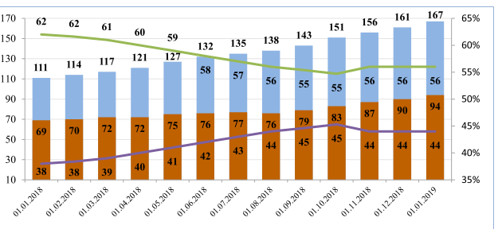
Figure 2

Total loans Loans in foreign currency, Share of loans in foreign currency Share of loans in national currency

The table shows that the share of foreign currency loans in the structure of loans of commercial banks decreased from 62% to 56%. The decline was mainly due to a decrease in the share of foreign currency loans in the total loan portfolio of state-owned commercial banks from 66.4% to 58.7%. Commercial banks also work with problem credit lines. As of January 1, 2019, the total non-performing loans in the total loan portfolio of commercial banks amounted to 2.6 trillion rubles. soums. This is $ 351 billion from problem loans in 2018. soums or 16% more. Tashkent accounts for 52% of non-performing loans. The remaining 48% was formed at the expense of other regions. It is clear that central banks, unlike branches, are not afraid to take more risks, they are not afraid to undertake large investment projects. Analyzing the banking system in general, we can see that there are a number of shortcomings in the system, and we consider them as follows.
1. the share of the bank's regulatory capital in risky assets is unstable and fluctuates regularly;
2. Increase in the share of problem loans in total loans.
Increasing the purchasing power of commercial banks by investing in the real sector of the economy and lending to the population, increasing the bank's capital remains an important task for commercial banks today.

Conclusion: Based on all the above analyzes, we can say that further increase the level of capitalization of banks, including increasing the share of tier II capital in the regulatory bank capital, increasing the efficiency of commercial banks' lending system, including the use of modern methods of creditworthiness; Expansion of the practice of using certain types of loans (overdraft, overdraft, overnight and microloans) can take the banking system of our country to new heights.

References:
1. Law of the Republic of Uzbekistan "On Banks and Banking". Tashkent, Uzbekistan, November 5, 2019.
2. Regulation of the Central Bank of the Republic of Uzbekistan No. 905 "On requirements to the credit policy of commercial banks", March 2, 2000.
3. Annex to the Resolution of the Board of the Central Bank of the Republic of Uzbekistan dated April 14, 2018 No. 14/21
4. Analysis of banking activities. TM Karaliyev and others. Study guide. Financial institutions. T .: «NiSO pOligraf», 2016. - 136 p.
5. REPORT ON THE ACTIVITIES OF THE CENTRAL BANK OF THE REPUBLIC OF UZBEKISTAN IN 2018
6. Scientific electronic journal "International Finance and Accounting". № December 6, 2017
7. Benchmarking credit policies of international banks BankTrack Boothstraat 1c 3512 BT Utrecht Netherlands December 2007
8. JOINT STOCK COMMERCIAL BANK “WINTER CONSTRUCTION BANK'S CREDIT POLICY FOR 2016
9. Z.D.Niyozov, SH.Q.Boboev. money, credit, and banks tutorial Samarkand
10. Alimov I.I. Finance. –T .: TDIU. 2007
11. MAIN DIRECTIONS OF AGROBANK'S CREDIT POLICY FOR 2019 DECISION NUMBER 6/5, 2019
12. Andros S. CREDIT POLICY OF COMMERCIAL BANKS AND ITS EFFECT ON BANKING
13. Websites.
1. www.travel-library.com www.thebanker.com
2. http://www.bankofengland.co.uk/markets/forex/index.htm
3. http://www.bankofengland.co.uk/markets/money/index.htm
4. http://www.bankofengland.co.uk/coreuproses.htm
5. http://www.boj.or.jp./en/sirYo.htm
6.www.cbu.uz

