**Nseobot & Anietieimo’s Covid-19 City Re-Entering Model**

**IME ROBSON NSEOBOT,** *Lecturer*

Department of Business Administration

Akwa Ibom State Polytechnic,

Ikot Osurua, Ikot Ekpene, Nigeria

Email: [nseobot857@gmail.com](mailto:nseobot857@gmail.com). Ph. +2348034255040

**ANIETIE IMO EFFIONG,** *Principal Officer*

Delcanimoff Integrated Services,

No. 2 Barracks Road, Uyo,

Akwa Ibom State, Nigeria

Email:delcanimoff@yahoo.com. Ph. +2347037599895

**Abstract**

# *Coronaviruses are a group of enveloped viruses with nonsegmented, single-stranded, and positive-sense RNA genomes. Apart from infecting a variety of economically important vertebrates (such as pigs and chickens), six coronaviruses have been known to infect human hosts and cause respiratory diseases. Among them, severe acute respiratory syndrome coronavirus (SARS-CoV) and Middle East respiratory syndrome coronavirus (MERS-CoV) are zoonotic and highly pathogenic coronaviruses that have resulted in regional and global outbreaks Coronaviruses possess a distinctive morphology, the name being derived from the outer fringe, or ―corona of embedded envelope protein. In order to avoid the uncontrolled spread of COVID 19, countries round the world announced lockdowns unanimously some earlier and some later. No doubt the shutdown has slowed the spread of coronavirus, however, it has other repercussion, ranging from economic slowdown, diminishing the production to note a few. It is not an exaggeration to say that covid-19 city reopening business environment will be characterized with a lot of uncertainties and expectations, to survive and grow in this turbulences environment. This study has presented a city reentering model that if properly implemented will enhance effective reentering that result in business survival will climax in business growths.*

**Introduction**

The outbreak of the world endemic of corona virus Covid-19 has unarguably taken the world unaware, unprepared thus, leaving the affected countries to suffer the devastating dead crises, disruption of social activities which has proportional effects on revenues generations, as well as economic breakdown etc. It is an established fact that coronaviruses belong to the Coronaviridae family in the Nidovirales order. The pandemic represents crown-like thorn on the outer surface of the virus; thus, it is named as a coronavirus. The virus can infect any persons irrespective of their age and gender.

As part of government and INOGs, at all levels around the world has put machineries on ground to contend the spread of Covid-19, City lock down, shut down, restriction of movements, prohibition of public gathering in religious and circular organizations as well as social activities is one among. The outbreak of the virus has pushed economies of both developed and developing nations around the world into low output, illiquidity and unemployment. These are distinguish by its rise in unemployment rate, falls in the availability of credit, poor output and investment, numerous bankruptcies, reduced amounts of investment in trade and commerce, as well as currency value fluctuations.

Businesses around the world, especially those in developing countries, have been in a pitiable situation as a result of covid-19 outbreak and the policy of city lock-down measures to contend its spread leads some nation’s economy into bombshell. Most of businesses and organizations has lost grasp of the market shares as a result of the virus due to the fact that majority of the businesses requires 75% physical contacts with clients. The ripple effect of the virus on businesses includes but not restricted to salary downsizing, overtime with no incentives for most of them in other to be more productive, delay in or no emolument, etc. The collapse of existing companies and firms as a result of the covid-19 has a maximized effect on a good number of businesses around the around the world. A sizeable integer of workers will be relieved of their jobs, while some will experience salary downsizing. The outbreak of the virus has created an unfriendly and harsh economic weather around the world to continue in businesses operation.

Recovering from covid-19 city locked-down and stay at home order are relatively out of the control of corporate, business, SMEs, Micro Entrepreneurs and Startups. Fundamentally, the resolution of the current economic situation is at governmental levels and dependent on a well-balanced, structured strategic approach; suitable fiscal and monetary policies, grassroots integration, enabling environment for doing businesses etc. that provide for both short term and long-term scenarios. So, while we await favorable returns. The model below explains process of city re-entering process that will help businesses.

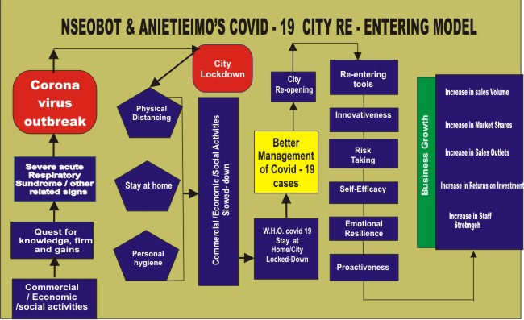

The advent of corona virus is as a result of explorations, quest for knowledge either for gains or firms which led to the outbreak of corona virus (Covid-19). This disease belongs to the family of pathogen that does cause severe acute respiratory syndrome (SARS) which can be contacted easily by another person. In the bid to manage the spread of the virus, different measures and modalities are employed that has negatively affected economic activities around the world. The outbreak of the virus has altered the conventional way of life and business operations around the world thus; businesses that require physical contact may be forced out of the market.

As part of measures to curb the spread of covid-19, government at different levels across the globe has introduced city locked-down to achieve the initiative of “stay at home”. In the words of Umoh, Nseobot, Hamid, Elyassami, Effiong, Ette, & Soomro, (2020) lockdown is a security measure resulting in person or group of persons being prevented from leaving or entering a building, city, location, country either by air, land, water etc. in the event of an emergency e.g covid-19. This method of confinement is used to minimize the possibility of spread of the virus around the society.

If city must be reopened for entry and continuous commercial, economic and social activities, there must be an evident of better management of covid-19 cases in the affected nations, there must be a downward slope in the curve of newly confirmed cases and death. Then, we can say that, there is a better management of covid-19 cases.

Reopening the city for activities comes with a shift in activities and operations, if business owners/managers must continue to hold on to their market shares, there must be a corresponding mental re-orientation to adapt to the changing situation. City re-entering tools is the mental orientation and planned method of business owners/managers to access the post covid-19 society. Re-entering tools includes: innovativeness, risk taking, self-efficacy, emotional resilience and proactiveness. Innovativeness is a creative thinking that gives birth to new ideas, capacity, products, market, methods and processes that provides better result that meets new requirements and challenges. Innovativeness upon adoption will give the affected business competitive advantages over her competitors.

Post covid-19 businesses must take calculated risks so as to get advantages, instead of taking risks that would have proportional effects on the overall success of the business. Typical parts of risk-taking included but limited to injecting resource to a course of action, loans, taking action within the face of uncertainty e.g covid-19 as well as committing funds in to a business with little and or no technical skills or knowledge.

Post covid-19 business owners/managers with new innovative ideas and blue print for risk should have emotional resilience which is often seen as the degree to which a person believed in their capability to successfully perform a tasks or specific goals notwithstanding difficult situation and scarce resources. After, implementing the new innovative idea and taken all the calculated risk, some result may go out proportion or even not commiserating the efforts of the firm. Then the need to develop emotional resilience to stay positive in the market amidst their fallen expectations, emotional resilience is firm’s ability to adjust to tense and awful circumstances and event in the courses of running and managing the business operations. The practice of emotional resilience will usher in proactiveness spirit among post covid-19 firms which will help the firm activities carryout a view to avoid future problems, requirements and changes that are suitable in detection and judgment of new opportunities.

In summation, businesses that effectively utilized city re-entering model will experience business growth that connotes increase in sales, returns on investment, increase in sales outlets, increases in market shares, and increase in staff strength.

Covid-19 city reopening business environment will be characterized with a lot of uncertainties and expectations, to survive and growth in this turbulences environment, success oriented businesses, government, non-profit making organization even families are strongly recommended to embrace and untilled the above model.

**References**

Umoh M. J.; Nseobot, I. R., Hamid Y., Elyassami, S. Effiong, A. I, Ette, U. & Soomro, M. A, (2020) Covid-19 City Locked Down: Implications on Human Welfare in Developing Countries. International Journal Of Business Education And Management Studies. Vol. 4. Issue 1.