**Impression of Information Technology and Binary in Businesses**

**TARUN DANTI DEY**

### srithazith019@gmail.com

**Chittagong Independent University, Bangladesh**

**&**

**SRITHA ZITH DEY BABU**

**Chittagong, Bangladesh**

**Abstract**

The advances in information and communication technology over the past few years have no excuse. And with that comes the certainty that this development will continue and be so strong that technology will be in all branches of the world**.**Thanks to information technology, people's lives have become much easier, simpler and more comfortable. It is now very easy to travel around the world from home, marketing, banking, various services or the virtual world. That is why now there is no work of man where technology has not touched. In the face of the challenges of the 21st century, information and communication technology has opened the door to endless possibilities for the world's poor. In the continuity of history, after the agrarian revolution, the industrial revolution, the present world is going to face a new revolution called information revolution. The main purpose of this paper is to explain to people how information and communication technology is related to us and business and to present the strategic aspects of information and technology and also to present how to select a product using binary.

# Keywords: Internet, Binary, HAR method, Information technology, Customer

# Introduction

Needless to say, if this century is called a new one, it will be the century of information technology. Information and communication technology is playing a vital role in the development and poverty alleviation of a country as a result of the globalization of the present century. Computers and the Internet are the tools of information and communication technology. Thanks to computers and the Internet, the world is now a global village. It is said that the world has come to the fingertips, not the palms of the hands. Extensive use and successful application of computer technology seeks to play a leading role in developing any underdeveloped country. Computer is a type of technology through which education, medicine, entertainment, economics, politics, investment, business, planning, research, control, design, etc. can be connected through a process. And this flow of information is integrated into a coherent formula and seeks to keep people of all races, religions and castes in the world constantly connected with the flow of information. We have seen the exchange of information in the twentieth century between telegraph, telephone, telefax, telex, postal, courier service etc. With, but now with the unprecedented progress of the worldwide communication system And all these mediums are nothing new. The idea of ​​how quickly and efficiently the sender can reach the recipient in each case is now serving as the basis for the inventor's multiple inventions. The Internet is an unprecedented, groundbreaking, unimaginable and incredible revolution in the way information is exchanged using computer and satellite technology. The main purpose of any business is to produce products or services in less time and at lower cost. At the same time delivering it to the consumer in the fastest time. ICT has been making significant contributions in everything from procurement of raw materials for products to personnel management, quality improvement of workers, production management, marketing and obtaining exchange value of services.Through integrated and innovative application of hardware, software, entrepreneurs can grow their business as well as increase profits.Information Technology (IT) capabilities play a significant role in increasing company performance (Aydiner et al., 2017; Benitez et al., 2018; Oh et al., 2016).During recent years, ICT has redefined the industry, culture, and social order. ICT refers to ultimately integrate economic and cultural institutions.This integration occurs as a result of the use of information technology.

**Literature Review:**

**Business Tech Definition**

Discussing business means that we are addressing usefulness, worth, benefit, etc. The value may reveal if there is an interaction among two or more systems or subsystems. One system works on the other one and vice versa, or the system works at the instigation of other systems. Why the systems would mutually operate? It may be because there is a force that drives them to work. This force is latterly called the technology, usefulness, worth, benefit, and the like. In other words, this definition can help accomplish the stage of value creation by benefiting system processes. There are various types of values such as normative value, realist value, and perceived value.

**Computer Based Business and Tech**

Computer-based technology has infiltrated many aspects of life and industry, yet there is little understanding of how it can be used to promote student engagement, a concept receiving strong attention in higher education due to its association with a number of positive academic outcomes (Laura A. Schindler,2017).WIth the computer people can store their daily data with creating a database.

**Strategical Use**

Empirical data from previous shows, the alignment issue was addressed in several researches and numerous methods, techniques and tools were proposed. Indeed, the business and IT performance are tightly coupled, and enterprises cannot be competitive if their business and IT strategies are not aligned with each other. This paper proposes a literature review useful for evaluating different alignment approaches, different techniques applies with the aim of discovering similarity, maturity, capability to measure, model, asses and evolve the alignment level existing among business and technological assets of an enterprise in the flavour of binary. The proposed work can apply to analyze the alignment research in the Information journal and the Journal of Strategic Information Systems that are the ones that more published on this topic. For the human resources industry in specific, HR technology is used to attract, hire, retain and maintain knack, support administration, and analyze workforce management.(GAMIAO & VIADO, 2020).

**Methodology:**

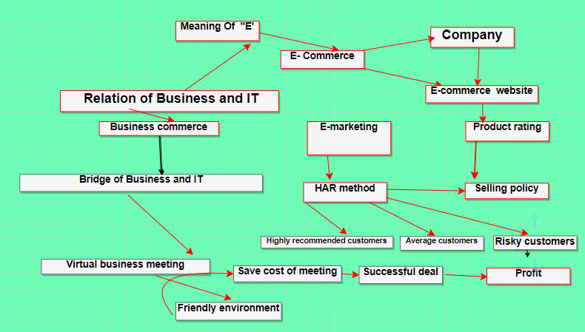

# A. Impact Of internet as a resource

The Internet is the storehouse of the world's inexhaustible store of knowledge. In fact, the Internet is a sea of ​​information, from which people all over the world can get the information they need. But these savings deposits are such that the information stays here permanently. At the same time, the Internet basically plays four roles. It simultaneously acts as a network or activity, a medium, a market (the perimeter of the world) and a platform for transactions.

“E” as the last letter in Internet usage has assumed great importance not only in the world of information and communication technology but also in businesses. It has become an important component for a large number of areas of research. So we can mention: electronic marketing, electronic commerce, electronic finance, electronic commerce, electronic learning, electronics markets and others(Afërdita Berisha-Shaqiri , 2015).

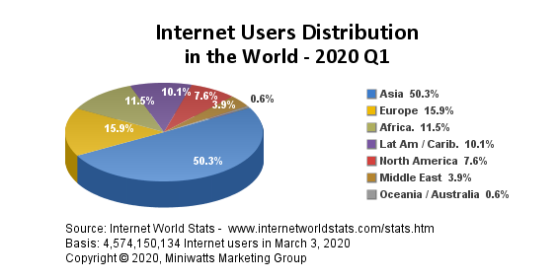

Based on the following data about the use of internet in the world in 2020, there are more than 4 billion users of the network, thus constituting a percentage of 58.7% of all mankind (2020/Q2). Information technology today has become a regular feature of the global society. Statistics show the ongoing Internet usage by Continents.

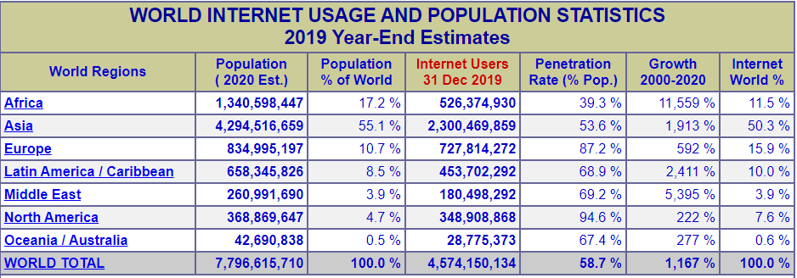

**Source** : Internet World Stats - <https://www.internetworldstats.com/stats.htm>

Copyright © 2020, Miniwatts Marketing Group

The Internet is the best way for a business to connect with customers and clients. Companies are using high-speed internet to speed up the production. Uses of the internet in business: Companies are getting customer data and buying habits and creating selling strategies based on the analysis.

# Electronic business

Electronic business (e-business) refers the customers to the use of the Web, Internet, intranets, extranets or some combination thereof to conduct business. E-business is similar to e-commerce, but it goes beyond the simple buying and selling of products and services online based on comapines.

Information technology is one of the relevant factors which nowadays is helping businesses to penetrate in new markets for being innovative and producing new products and services. Therefore, we can come to the conclusion that the role of information technology in the business is vital.

There are six basic types of e-commerce —

1) Business-to-Business (B2B)

2) Business-to-Consumer (B2C)

3) Consumer-to-Consumer (C2C)

4) Consumer-to-Business (C2B)

5) Business-to-Administration (B2A)

6) Consumer-to-Administration (C2A) — and all of them represent a different purchasing dynamic.

Key elements of the surroundings include:

* Global Infrastructure
* suppliers
* clients

So, being connected to the internet, companies have the opportunity to research and build products faster, build websites and applications that promote their products, monitor consumer behavior. It is worth to mention one of the most revolutionary developments in advanced communication technologies, such as voice over internet protocol (VoIP), which includes all types of voice communication transmitted through the internet, between computers or in hybrid form between PC and regular phone. E-business can intercept a range of functions and services. The range from the development of intranets and extranets to the provision of e-services over the internet by application service providers**.** So, E business in one of the key terms in this business era. And is also grows trust between suppliers and customers. Using this technology are seen in the rapid implementation of products and services as well as in the great speed to meet customer requirements. We can say that as a result of the use of new technology, a new economic structure is developing, building an intelligence network that has become a new reality. Online business is a method for directing business over the Web. (Sandip U. Deshmukh,2019)

**Business and Technology:**

Business Technology as a model describes all technology to help a company to run its business and operational processes. The technology of binary and genetic flavour can be customer-facing applications and solutions, business-critical production and logistics solutions, or back office financial systems, among others. Technology has many forms among them binary encoding and genetic algorithm can make the solve of product choosing problem. We often face a problem of product choosing. We import products with obtaining some terms such as price, quantity, quality. In this paper we are going to introduce the business with technology and also a new method of selling product in the most number. We can solve the product choosing problem with binary encoding where we will consider every product as a gene and with the addition of genes we will get chromosome which will be the luster combination of our desired products. After choosing a luster combination of product we need to sell the products rapidly. That’s why we are introducing our new method which name is HAR method. This method will separate customers in three different categories. This method will attract every customer to buy the product. With this HAR method the importer can set a network of products. A controversy exists in the literature regarding the type of suppliers to consider when leveraging external knowledge for exploring discontinuous innovation. (Sihem Ben Mahmoud-Jouini, 2019). HAR method can also be use for parallel projects. Parallel projects are often a means of speeding up this process by actively pursuing learning spillovers.( Ties Van Bommel,2019).

**Sale increasing method:**

After buying your product you have to give a huge amount of attention to your marketing, selling and also to the networking department.So, here are some methods to increase a product market rating and selling. We have created a method whose name is "HAR" method.

H : Highly recommended customers

A : Average customers

R : Risky customers

E. Highly recommended customers:

According to a software or website whoever will be downloading the products app and will buy the product within the first 10 customers, they will be offered the product for free for 6 months.[The choice of consumers will be random]

F. Average customers :

Whoever will be downloaded the product's app and will buy product within 10 very first consumer's will be offered the product for free for 3 months

.[The choice of consumers will be random].But,the condition is each and every customer has to share the product app and encourage another minimum 5 consumers to download the app and buy the product as well.The downloaded process or confirmation should be notified to the company or company website by mentioning the consumers details.

G. Risky customers:

We can handle this type with some ladders, such as:

a) Social media scrolling where customers will see the advertisement of the product when he\she will browse any social site or app.

b) Whoever will install the app at least once, they will be offered the product for discount in a big range for one time.

c) One can share the app and can create a group into the app. For creating a group the required members number is at least 5. For each group the group creator or admin will get an offer to spin a table(virtual table in app) which will contain several numbers of discount prices.

**4. Business channel:**

Now to increase a product rating there is no alternation of technology. We can use technology to increase a product rating and also sells. So, technological ingredients are: Website, Software(Apk, Ios etc), SEO optimization etc. If one make a software or website for his\her products , products rating will be in top. So, the bio-business view is given below:

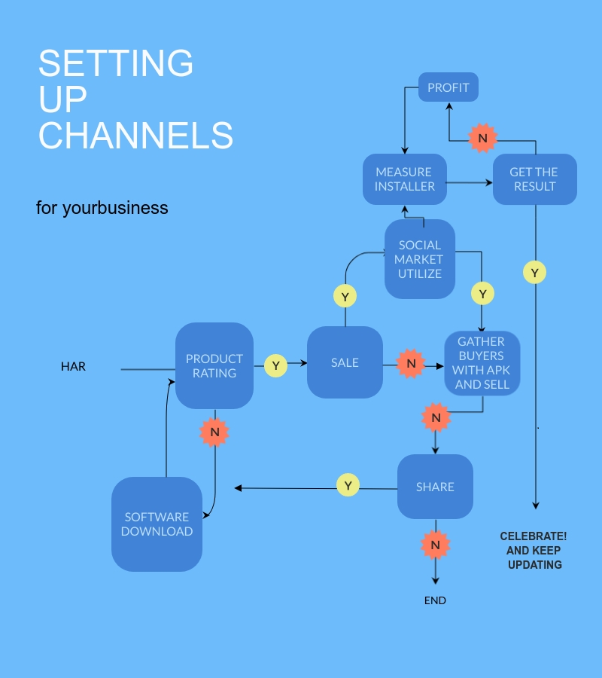

**5. Analysis:**

Product selection is the process in which retailor choose the shape or material of the product as per market demand. Term included in product selection :- • rate• demand • Price.Product selection is a decision process, in which the design team selects one or few product concept for further procedure • An entrepreneur establishes a business unit with a modest investments in a small scale level. • As he senses business opportunities from the changing environment, keeps on adding, improving and dropping different types of product. • A small business unit progressively becomes large through additional investments.So, here we will solve this problem by binary encoding method.

**6. What is Binary :**

Binary (or base-2) is a numeric system that only uses two digits — 0 and 1. Computers operate in binary, meaning they store data and perform all calculations using only zeros and ones. Below is a list of several decimal (or "base-10") numbers represented in binary. A single binary digit means True (1) or False (0) in boole an logic. However, multiple binary digits mean large numbers and perform functions. In fact, any integer can be represented in binary. The binary number system is the lingua franca of computing, requisite to myriad areas, from hardware architecture and data storage to wireless communication and algorithm design. (Yvon Feaster, 2012).

Below is a list of several decimal (or "base-10") numbers represented in binary.

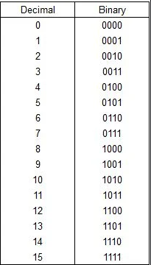

Source : <https://www.instructables.com/id/How-to-Convert-Numbers-to-Binary/>.

**Product choosing using Binary encoding in business:**

The binary encoding of information has formed our art. Collection of information and the derived knowledge both become feasible in any form of modern storage media efficiently, and free from error. Transportation becomes equally easy to any signal carrying media cheaply, effectively. The highways and byways for information and knowledge are only a click away in a networked society as much as a thought process is a twinkle away in an open mind which is the key factor to form binary into business. So, in this paper we are forming binary encoding system. Product choosing is one of the biggest problems in this field. So, when importers buy products they have to mark many things. Among those fitness or quality of the products and price of the products are the key factors.

**8. Making a table of products:**

So, here we will see a solution to this problem by a binary encoding method which is also a part of genetic algorithms. And this will also show us the connection between science and business. Let's think you have three products which are A,B,C. Now see the table given below:

|  |  |  |
| --- | --- | --- |
| **PRODUCT** | **PRICE** | **FITNESS** |
| **A** | 5 | 10 |
| B | 10 | 20 |
| C | 15 | 30 |

These are the three products. In this table fitness means quality of the product.

Now, you have to put your budget. Let's consider your budget is 25 units as the price and fitness demand is 45 units. We consider the value of price and fitness as unit. And your total max budget is 70 unit. Now, evaluate the maximum probability of combination of these three products. And consider every set of combination as a chromosome and products as gene. Now, we are going to our next step where we will get the best combination using genetic method.

**Genetic-combination:**

So, here the next step is gene-comb.And the set of products by combining single or multiple are :

Q1 = {A} ; where, Q1 is a chromosome, A is a gene

Q2 = {B} ; where, Q2 is a chromosome, B is a gene

Q3 = {C} ; where, Q3 is a chromosome, C is a gene

Q4 = {A,B} ; where, Q4 is a chromosome, A is a gene and B is a gene

Q5 = {A,C} ; where, Q5 is a chromosome, A is a gene and C is a gene

Q6 = {B,C} ; where, Q6 is a chromosome, B is a gene and C is a gene

Q7 = {A,B,C} ; where, Q7 is a chromosome, A is a gene , B is a gene , C is a gene

If we add every Chromosome we will have some population. Such as :

Q1 + Q2 + Q3 + Q4 + Q5 + Q6 + Q7 = Q (Which is the total population) .Which is the highest value of total products.

And, if we add all gene's we will get a set of chromosomes. Now, we will move into our next step.

**Binary-combination of price**

Now, take a 3 bit table for locating these chromosomes. And, put 0 or 1 in case of absence and present. We are taking a 3 bit table because the number of products is 3. We will format or take the table with this formula which is given below.

Table bit number = Number of products.

Now , we will locate every chromosome with a 3 bit table where 1st bit means A, 2nd bit means B and 3rd bit means C.

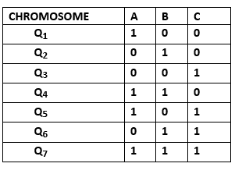

Here, We can get the combination with simple binary encoding.

**Computation:**

Now, put the value of (price) A,B,C in every chromosome. And compute the total expense of each chromosome. Here, Expense means price.

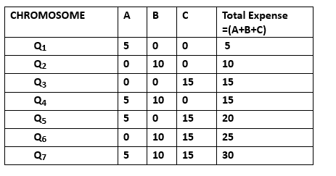

Your max budget was 25 units of price. Here , we found the best match for you. Look at Q6 = 25. Which equals your budget.Or, You can select every chromosome escape Q7. Because,

Q1 < total budget = satisfied

Q2 < total budget = satisfied

Q3 < total budget = satisfied

Q4 < total budget = satisfied

Q5 < total budget = satisfied

Q6 < total budget = satisfied

Q7 > total budget = not satisfied ; It's exceeding your max budget.

**Binary-combination of fitness:**

Now, take a 3 bit table for locating these chromosomes. And, put 0 or 1 in case of absence and present. We are taking a 3 bit table because the number of products is 3. We will format or take the table with this formula which is given below.

Table bit number = Number of products.

Now , we will locate every chromosome with a 3 bit table where 1st bit means A, 2nd bit means B and 3rd bit means C.

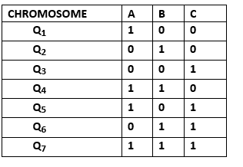

Now, put the value of (fitness) A,B,C in every chromosome. And compute total expense of each chromosome.Here, fitness means quality.

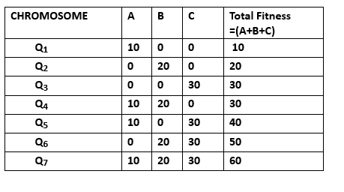

Your max budget was 45 units of fitness or quality demand. Here , we found the best match for you. Look at Q5 = 40. Which equals your budget. Or, You can select every chromosome escape and Q6 and Q7. Because,

Q1 < total demand = satisfied

Q2 < total demand = satisfied

Q3 < total demand = satisfied

Q4 < total demand = satisfied

Q5 < total demand = satisfied

Q6 > total demand = not satisfied; It's exceeding your max demand.

Q7 > total demand = not satisfied; It's exceeding your max demand.

**Graphical view:**

Now, we will add every satisfied price and quality chromosome with each other and will make a graph. Total budget = total expense + total fitness.Here, total budget = (T1 ,T2 ,T3 ,T4 ,T5 ,T6 ,T7)

T1 = Q1(expense) + Q1(fitness) = 15

T2 = Q2(expense) + Q2(fitness) = 30

T3 = Q3(expense) + Q3(fitness) = 45

T4 = Q4(expense) + Q4(fitness) = 45

T5 = Q5(expense) + Q5(fitness) = 60

T6 = Q6(expense) + Q6(fitness) = 75

T7 = Q7(expense) + Q7(fitness) = 90

so, here we found the best total match for you which is 60.But, you can consider other also by seeing this graph

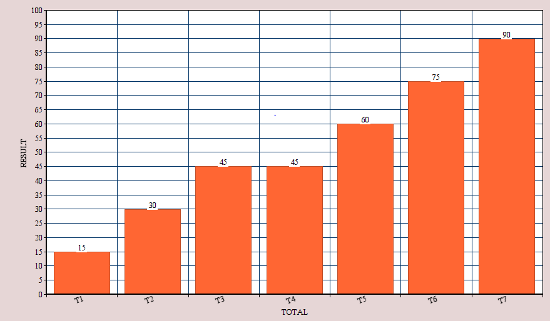

But, You can't consider Q6 and Q7 .Because these two are exceeding your total budget.

**Result:**

So, your priority chain will be T5 > T4 > T3 > T2 > T1. But, the result of T3 and T4 are equal (45).But, In this case we prefer T4.Because T4 has the combination of more than one product. This is the combination of A and B.On the other hand T3 contains only C product. So, using binary encoding method we also solve this problem. And there is also seeing a bridge of business and technology.

**Conclusion**

Digital technology (website, apk etc) has helped us solve some of the biggest problems we face in the business field. From helping us understand what's going on in the world with the Large Hadron Collider, to making space travel more affordable with SpaceX's self-landing rocket. Technology has been helping us to solve problems where human power alone just isn’t enough. In this article, we bring five incredibly common business problems that are solved with a little help from these paper techniques. These are:

* Faster Task Completion

* Content Discovery

* Lower Administrative Costs

* Remote Working

* Improved Customer Targeting

# References:

Berisha-Shaqiri, A. (2015). Impact of Information Technology and Internet in Businesses. Academic Journal of Business, Administration, Law and Social Sciences .Volume 1 ,Issue 1, pp 1-3.

Gamiao, J. S., & Viado, M. S. (2020). Structural Equation Model on Employee Engagement of Restaurants in Region XII . The International Journal of Business Management and Technology, Volume 4 ,Issue 2, pp 170-`180.

Ties Van Bommel; Edwin J. Nijssen; Ronald J. Mahieu (2019), Exploring the effectiveness of pursuing competing technologies in parallel projects during predevelopment, International Journal of Technology Management, Volume 81 pp 3-4.

Sihem Ben Mahmoud-Jouini & Florence Charue-Duboc,(2019),Establishing relationships with distant suppliers to explore discontinuous innovation, International Journal of Technology Management, Volume 81 , pp 3-4

Sandip U. Deshmukh, (2019), Impact of E-Business on Business Association, International Journal of Engineering and Management Research ,Volume- 9, Issue- 6, pp 2394-6962.

Feaster, Yvon & Ali, Farha & Hallstrom, Jason. (2012). Serious Toys: Teaching the Binary Number System. Annual Conference on Innovation and Technology in Computer Science Education, ITiCSE. 10.1145/2325296.2325358.

Schindler, L.A., Burkholder, G.J., Morad, O.A. et al (2017). Computer-based technology and student engagement: a critical review of the literature. Int J Educ Technol High Educ 14, 25 (2017). <https://doi.org/10.1186/s41239-017-0063-0>