THE SUSTAINABILITY OF A MODEL SOLAR PHOTOVOLTAIC INSTALLATION FOR POWER GENERATION

Engr Collins Erebi Sokore
School of Mechanical Engineering and Design,
University of Portsmouth United Kingdom
collins.sokore@myport.ac.uk
ABSTRACT
The focus of this paper is to establish the sustainability of the design and output parameters of a solar photovoltaic (PV) system installation developed as a living laboratory at the University of Portsmouth United Kingdom. Using a combination of secondary and primary data, it involves the projection of design and operating parameters over a period of twenty-five (25) years which is the useful life of the solar panels. It identifies the maximum power point (MPP), economic breakeven point and discusses the environmental implications. It recommends that for sustainability, a combination of storage and tie-in to grid is required to manage excess power during off-peak time.
Introduction
Solar photovoltaic (PV) systems are renewable energy systems which transforms the energy from the Sun into electricity using photovoltaic. These PVs also known as solar panels provide reliable green energy solution (Natalie Kunz, 2023).
Objective
- Analyze performance of a solar energy installation at the University of Portsmouth.
- Evaluate the expected annual solar panel electricity output.
- Evaluate annual output across the useful life of the panel as well as the cumulative output.
- Analyse the return on investment and wider financial implications of living lab.
- Analyze MPP and consideration of temperature coefficients
- Discuss environmental effects associated with the solar energy installation.
Methodology
Data collected during operation of the solar installation and primary data collected from visit to the site of the Eco lab were used for the evaluation and analysis. The Port-Eco House is a research facility consisting of an instrumented 3-bedroom household for research in energy efficiency and building performance.
The installation at the Port Eco-house consists of solar photovoltaic (PV) panels with a peak capacity of 5 kW. The panels are connected to a 5 kW inverter, which delivers the generated power to the AC electrical network of the house. A Tesla Powerwall 2 smart battery storage system was also installed and connected to the AC electrical network of the house. A number of common household appliances and computer equipment are connected to the AC network of the house and form the house’s electricity demand. On the monitoring side, a range of variables can be measured from individual PV panels, the inverter and the battery. In addition, there is a weather station nearby that provides useful environmental data that can be correlated with the energy production of the solar array (University of Portsmouth, 2022).
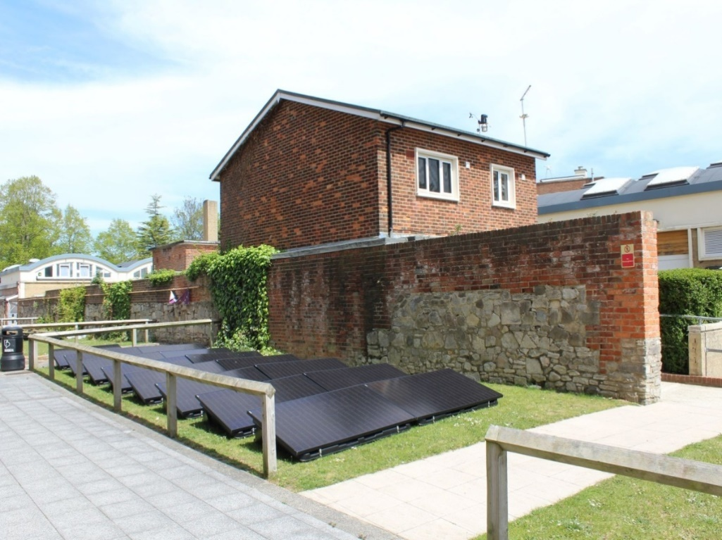
Figure 1: This image shows the installed 5kW photovoltaic solar array on the adjacent lawn by the Port-Eco House, which is shown to the right of the panels.
Results and Discussions
From the manufacturer’s manual, the efficiency of the module is 19.91% (0.1991). However, the efficiency based on the warranty profile is 97.50% of the rated module efficiency in the first year. This translates to 19.41%. From the manual and visit to the Eco lab site where the PV system is installed, the dimension of each panel is 1.689m x 0.996m. A total number of fifteen (15 Nos) panel gives a cell area of 1.6822m².
The expected solar radiation output is given by
P = ŋGA....................................................................... eqn 1
ŋ = efficiency
G = mean solar radiation
A = cell area
Where cell area = number of panel x Area of panels
Table 1 shows values of the expected solar radiation power output computed with eqn 1.
Table 1 The output and environmental condition of the Eco-lab
Time (hr) | Actual Output (kWh) | Expected Output (kWh) | Relative Humidity | Wind Speed
0000 | 0 | 0 | 82.8 | 1.74
0100 | 0 | 0 | 81.9 | 2.328
0200 | 0 | 0 | 82.2 | 2.121
0300 | 0 | 0 | 81.7 | 0.796
0400 | 0 | 0.0196 | 84.0 | 1.4
0500 | 0 | 0.3478 | 84.3 | 2.246
0600 | 0.1 | 0.9992 | 83.6 | 2.129
0700 | 0.2 | 1.7830 | 80.9 | 2.717
0800 | 0.3 | 2.5716 | 75.82 | 1.675
0900 | 0.4 | 3.2475 | 71.39 | 1.929
1000 | 1.1 | 3.7618 | 68.15 | 1.296
1100 | 2.7 | 4.1733 | 65.29 | 1.496
1200 | 3.9 | 4.3300 | 60.18 | 2.758
1300 | 4.5 | 4.2615 | 50.42 | 2.712
1400 | 4.5 | 3.9823 | 41.43 | 3.146
1500 | 1.4 | 3.4924 | 37.21 | 3.692
1600 | 0.2 | 2.0817 | 37.21 | 3.517
1700 | 0.1 | 1.2833 | 39.12 | 3.067
1800 | 0.1 | 0 | 41.88 | 1.992
1900 | 0 | 0 | 44.22 | 2.021
2000 | 0 | 0 | 51.92 | 2.221
2100 | 0 | 0 | 62.07 | 2.417
2200 | 0 | 0 | 67.58 | 1.888
2300 | 0 | 0 | 69.55 | 2.458
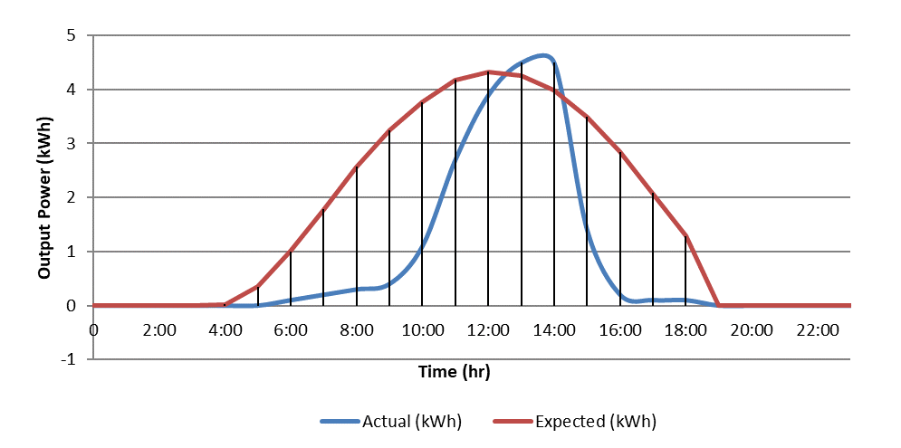
Figure 2: Comparison of actual to expected output
Weather Data and Solar Panel Output.
Figure 2 shows the pattern of the actual and expected output over 24 hours period on 31st May 2020. In the early hours of the day, the actual and expected outputs were zero. This is expected because between 12 midnight to 0400hrs the sun is yet to rise. The bell graph shows a steady increase in output as the day progresses. The peak outputs were recorded at 1300hrs and 1400hrs. The actual and expected outputs were 4.5kWh and 4.3kWh respectively. At this time, more rays from the sun are hitting the panels resulting in production of more energy. After this period, as the day wanes into sunset, both graphs exhibit the same reduced power output with zero output at sunset. The implication is that maximum electricity is generated when the solar rays are more intense.

Possible Reasons for the difference in the shape of the curves in figure 2.
- The installation is sandwiched between Dennis Sciama building and the fenced Eco lab building. These structures cast shadows on the panels at different times of the day and this could affect the intensity of the rays that hit the panels so all the panels may not produce the same power based on irradiance.
- High relative humidity in the early hours of 31st May could lead to collection of water droplets on the panels and refract sunlight away from the panels.
- The wind speed increasing from 1.704 m/s at 0000hrs to 3.146 m/s at 1400hrs is relatively higher at the peak output hours. Wind speed has the reverse effect that relatively humidity has on solar efficiency. Wind helps dry the water vapour and cools the panels down (Solar.com 2023).
- The efficiency of the panels at 19.40% is based on the assumption that the efficiency is the same throughout the whole day which is contrary to the operating condition on 31st May which was 25ºC and 1kW for cell temperature and irradiance respectively. Clearly, the mean irradiance on 31st May was lower than 1kW all hours within the day in addition to varying temperatures recorded between 0000hrs to 2300hrs.
- Temperature has an inverse effect on solar cell efficiencies. As temperature increases, the efficiency of the cell decreases. The temperature range is 11.4ºC – 21.76ºC
Battery Management
The energy consumption of the Eco house on 31st May was 8.2kWh while 4.7kW was stored in the Powerwall storage battery. This shows that 12.9kWh of electricity was consumed on 31st May while the unit produced 19.5kWh leaving an excess of 6.6kWh of electricity. The challenge arising from this, is that with storage capacity of the Powerwall storage is 13.7kWh. An efficient battery management strategy will be to upscale the capacity of the battery so that more loads can be introduced to the Eco lab. Another approach will be to transmit the excess load to the grid at off-peak.
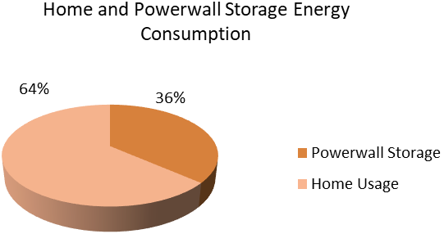
Figure 3: Power usage and storage in the Eco lab
Monthly Irradiation and Electricity Production
Using the National renewable Energy Laboratory (NREL) solar calculator, the average monthly output of the solar installation was generated as shown in Table 2. For this, a tilt angle of 15º and azimuth angle of 195º where used as baseline.
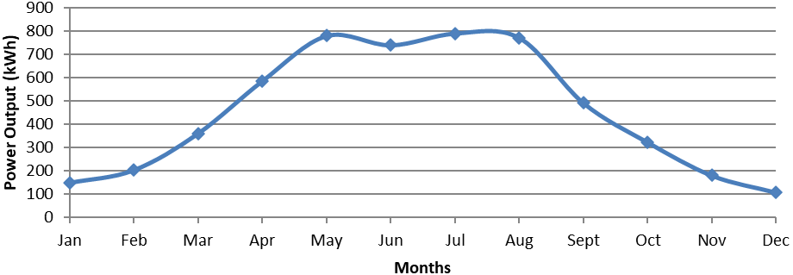
Figure 4 Graph showing the profile of power output from January to December
From figure 4, the summer period i.e. between May and August recorded the peak output. Expectedly, the lowest output was in autumn. December and January recorded the lowest amount of output.
Annual Output and Useful life of the Installation.
Based on the manufacturer’s manual, the useful life of the panels is twenty five years (25 yrs). Figure 3 shows the efficiency profile of the panels over its useful life. In the first year, the efficiency 97.50% of the nominal efficiency of 19.91%. The efficiency over its useful life is captured in table 2
Table 2: Efficiency and Energy Output of the Solar Installation at Eco Lab
Year | Efficiency | Annual Output (kWh) | Cumulative output (kWh)
1 | 0.1941 | 5428.495 | 5428.495
2 | 0.1897 | 5397.093 | 10825.59
3 | 0.1883 | 5365.691 | 16191.28
4 | 0.1878 | 5334.289 | 21525.57
5 | 0.1874 | 5302.888 | 26828.46
6 | 0.1868 | 5271.486 | 32099.94
7 | 0.1862 | 5240.084 | 37340.03
8 | 0.1858 | 5208.682 | 42548.71
9 | 0.1848 | 5177.281 | 47725.99
10 | 0.1838 | 5145.879 | 52871.87
11 | 0.1822 | 5114.477 | 57986.34
12 | 0.1802 | 5083.075 | 63069.42
13 | 0.1798 | 5051.674 | 68121.09
14 | 0.1776 | 5020.272 | 73141.36
15 | 0.1766 | 4988.87 | 78130.23
16 | 0.1762 | 4957.468 | 83087.7
17 | 0.1758 | 4926.066 | 88013.77
18 | 0.1746 | 4894.665 | 92908.43
19 | 0.1736 | 4863.263 | 97771.7
20 | 0.1718 | 4831.861 | 102603.6
21 | 0.1710 | 4800.459 | 107404
22 | 0.1696 | 4769.058 | 112173.1
23 | 0.1674 | 4737.656 | 116910.7
24 | 0.1666 | 4706.254 | 121617
25 | 0.1657 | 4674.852 | 126291.8

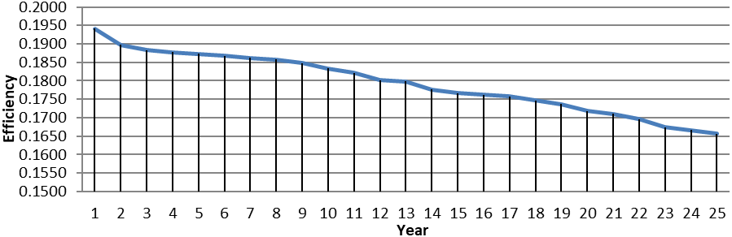
Figure 5: Efficiency profile of the solar unit at Eco lab
From table 3, there is drop in annual output for every succeeding year. Over the span of 25yrs, the output dropped from 5428.5kWh in the first year to 4674.3kWh in the 25th year. This represents a decrease of 13.88%. The total electricity production after 25 years is 126291kWh
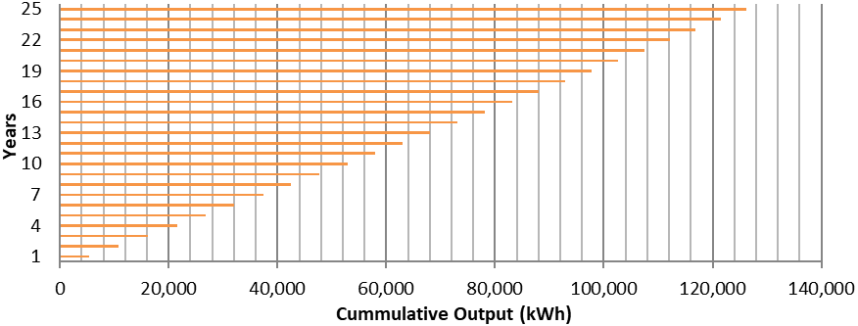
Figure 6: Cumulative Power Output over the useful life of the installation
Rate on Investment
The return on the investment of solar power is hugely dependent on the cost of electricity. According to Energy Trust 2023, the national average price for kWh in GBP is £0.34/kWh.
Since the price of electricity will not remain constant during the useful life cycle of the installation. Based on the fluctuations in price of electricity, different forecast and predictions were considered to establish the economic benefit of the installation. Figure 4 shows different scenarios of cost of investment and future prices of electricity.
Cornwall Insight predicts £0.19/kWh in three years time. Another prediction by Trading Economics is £0.64/kWh in four years time. The economic outlay based on these predictions is captured in figure 7 with different payback period.
Assumptions
- Time-value of the GBP was not considered in determination of the payback period of the project.
- Other technical information such as up scaling of the installation were not considered in the determination of the payback period
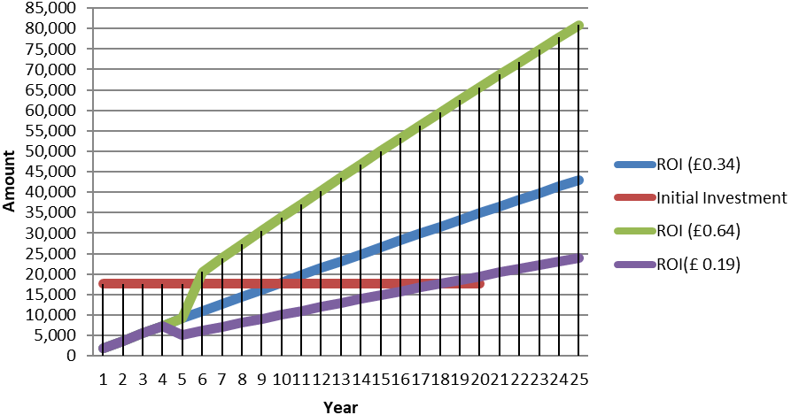
Figure 7: Forecast of Energy price and payback period
Figure 7 shows that interplay of the initial investment and forecasted energy prices. At £0.34/kWh of electricity, the payback period is 10 years. With the future increase of energy price to £0.64/kWh the payback period is 6 years. A reduction of price to £0.19/kWh, the payback period becomes 18 years.
Effect of MMP and Temperature Coefficients on Solar Output.
Maximum Power Point (MPP) represents the bias potential at which solar cell outputs the maximum net power. It is the point at which the product of the current and voltage equal the greatest value. Irradiation data in kWh/m²/dy is converted to W/m² to obtain the MPP.
Table 3 Global Irradiance and MPP Parameters
Month | Irradiance (W/m2) | Current (A) | Voltage (V) | Power (W)
January | 487.1429 | 5.0 | 34.0 | 170
February | 502.6506 | 5.1 | 34.4 | 175.44
March | 620 | 6.2 | 34.8 | 215.76
April | 665 | 6.8 | 35.0 | 238
May | 741.1163 | 7.4 | 35.2 | 260.48
June | 716.5877 | 7.2 | 35.1 | 252.72
July | 727.5225 | 7.3 | 35.2 | 256.96
August | 698.9904 | 7.1 | 35.0 | 248.5
September | 674.4966 | 7.0 | 35.0 | 245
October | 584.3363 | 5.9 | 34.6 | 204.14
November | 479.2208 | 4.8 | 34.0 | 163.2
December | 407.5926 | 4.1 | 33.8 | 138.58

The panels produce the largest power of 260.5 W and 257W in May and July respectively. Assuming a Normal Operating Cell Temperature (NOCT) of 50ºC, the cell temperatures were calculated based on average temperatures of Portsmouth (World Weather Online 2023).

Table 4 MPP & Effect of Temperature Coefficient.
Month | Power (W) | Temperature (°C) | Cell Temperature (°C) | Power after temperature Coefficient (W)
January | 170 | 8 | 26.2 | 169.286
February | 175.44 | 8 | 26.8 | 174.3347
March | 215.76 | 10 | 33.2 | 209.5677
April | 238 | 12 | 36.9 | 228.0873
May | 260.48 | 15 | 42.7 | 244.3433
June | 252.72 | 17 | 43.8 | 236.091
July | 260.48 | 20 | 47.2 | 240.2407
August | 248.5 | 20 | 46.2 | 230.0613
September | 245 | 18 | 43.3 | 229.3078
October | 204.14 | 15 | 36.9 | 195.6376
November | 163.2 | 11 | 28.9 | 160.9723
December | 138.58 | 9 | 24.2 | 138.968

Design Considerations and Improvements
Mounting the panels on the ground in a built up area exposes them to shades from buildings that are close. If they are mounted on roof top, the intensity of solar rays hitting the panels will be higher resulting in more irradiation.
Reconfiguring the azimuth to face south as shown in table 6 may increase the output at the first year from 5428.5kWh to 5437.4kWh. Also, there is a slight improvement in the cumulative ooutput over the useful life from 126191.8kWh to 126499kWh. Another strategy will be to adjust the tilt angle all year round (Solar Electricity Handbook 2023). By this, the first year annual output will change from 5428.5kWh to 6429.9kWh while the cumulative will increase by 18.4% from 126291.8kWh to 149589.5kWh.
Table 5: Average Monthly Irradiation and Facing of the Solar Panels
Month | Azimuth = 195, tilt = 15° (kwh/m²/day) | South, 15° tilt (kwh/m²/day) | South, angle adjusted all year (kwh/m²/day)
January | 0.99 | 1 | 1.54
February | 1.49 | 1.5 | 2.46
March | 2.38 | 2.39 | 3.28
April | 3.99 | 4 | 4.61
May | 5.14 | 5.13 | 5.34
June | 5.04 | 5.04 | 5.73
July | 5.21 | 5.21 | 5.41
August | 4.69 | 4.69 | 5.1
September | 3.35 | 3.35 | 3.84
October | 2.13 | 2.15 | 2.74
November | 1.23 | 1.23 | 1.85
December | 0.71 | 0.72 | 1.22

Environmental Effects Associated with Eco lab Installation
Solar energy systems offer significant environmental benefits in comparison to the conventional energy sources. They have wide range of impacts on the environment. According to the United Kingdom Greenhouse Gas Reporting, 0.1934kg of CO² is released per kWh of grid electricity (GOV.UK 2023). The power output of the solar installation over its useful life is 126291.8kWh. The implication is a savings of 24422.3kg of CO₂ which would have being released into the environment if fossil fuel is use to generate the power.
However, thin-film panels are manufactured using dangerous heavy metals such as Cadmium Telluride. There is a lack of transparent data to compute the emission levels during their production. The installation provides an environmental benefit of reducing the carbon footprint. In addition, noise pollution is not associated with the installation.
The Renusol ground mounting console is thermoplastic and it may be an area of environmental concern. However, the determination of the carbon footprint is not within the scope of this report.
The removal of the vegetation at the installation site of the panels would greatly affect the soil flora and fauna. Also, the use of polythene-like material to cover the ground surrounding the panel site will lead to withering of the plants underneath and Recycling Dilemma
Currently, the recycling of solar panels faces a big issue. Specifically, there aren’t enough locations to recycle old solar panels and there aren’t enough non-operational solar panels to make recycling them economically attractive. According to (2021), about 95% of the glass used in manufacture of solar panels can be reused while 85% of silicon and 95% of semiconductors used for thin film based solar panels are recyclable.
Conclusion and Recommendations
Conclusion
Solar remains cheaper than all other source of energy and specifically those generated using oil, gas and coal. The Eco-house solar system is technically and economically viable. Clearly, the sustainability of solar PVs for source of energy is hugely dependent on the price of energy which is not dependent on only solar but other sources of energy. For the Eco-lab at the University of Portsmouth, The payback period of the installation is eleven years (11yrs) given the useful life output of 126291.8kWh of electricity and current electricity price of £0.34/kWh.
Recommendations
- The system should be connected to the grid so that excess power can be wheeled into the grid when there is no battery storage capacity.
- The perimeter fences around the solar panels seem inadequate and should be reworked to ensure access control around the panels mounted on the ground.

REFERENCES
Eco House Component Spec, School of Engineering and Design, University of Portsmouth. Retrieved from www.moodle.port.ac.uk.
Edwards, T. (2022). Cornwall Insight. Retrieved from Cornwall Insight: https://www.cornwall-insight.com/press/energy-prices-to-remain-significantly-above-average-up-to-2030-and-beyond/
GOV.UK. (2023). GOV.UK. Retrieved from GOV.UK: https://www.gov.uk/government/publications/greenhouse-gas-reporting-conversion-factors-2023
JA Solar. (2022). JA Solar. Beijing, Fengtai District, China. Retrieved from JA Solar.www.solar.com
Living lab Course School of Engineering and Design Material University of Portsmouth Retrieved from www.moodle.port.ac.uk
Natalie, K (2023); www.greenmatch.co.uk/solarenergy/photovoltaic system
Solar Electricity Handbook. (2022). Solar Electricity Handbook. Retrieved from Solar Electricity Handbook: http://www.solarelectricityhandbook.com/solar-irradiance.html
Trading Economics. (2022). Trading Economics. Retrieved from Trading Economics: https://tradingeconomics.com/united-kingdom/electricity-price
University of Portsmouth (2022), Output 5.3 Living Lab Pilot (uop). Retrieved from https://www.interregsolarise.eu/wp-content/uploads/2022/01/SOLARISE-Output-O5.3-Living-Lab-Pilot-UoP-1.pdf
Vekony, A. T. (2021). Green Match. Retrieved from Green Match: https://www.greenmatch.co.uk/blog/2017/10/the-opportunities-of-solar-panel-recycling
weather and climate. (2022). weather and climate. Retrieved from weather and climate: https://weather-and-climate.com/portsmouth-gb-January-averages-fahrenheit
World Weather Online. (2022). World Weather Online. Retrieved from World Weather Online: https://www.worldweatheronline.com/portsmouth-weather-averages/hampshire/gb.aspx

