CONDITIONS OF AC MOTOR IN ELECTRICAL LABORATORY

Chukwuka Loveday Onita¹, Zino Bright Ogoro², Osazee Emmanuel Ogbeifun³
^{12&3}Department of Electrical Electronics Engineering
Federal Polytechnic Ekowe, Bayelsa State, Nigeria.
chukwuka.onita1@ust.edu.ng

ABSTRACT
To ascertain the conditions of three phase ac motors requires many approach such as virtual inspection of the motor, shaft checking to ensure smooth rotation and bearing situation then proceeding to insulation resistance and winding resistance tests. Meggar instrument was used for the insulation test while digital Multimeter was used for the Winding test. The first test carried out was insulation resistance test using megger. The motor (1) has an insulation resistance of 8 Megaohms across the ground to phase recorded reading and 10 Megaohms across the phase to phase. The recorded megger reading value is higher than the calculated insulation resistance value of 1.38 Megaoms signifying the 3 phase ac motor has a high insulation resistance to accomplish safety rules of operation. The motor (2) has an insulation resistance of 1 Megaohms across the ground to phase and the phase to phase which is equal to the calculated 1.22 Megaoms signifying the 3 phase ac motor has a low insulation resistance and bad. Hence, the motor under went maintenance to increase the insulation resistance by heating the windings via ovum. The insulation value increased to 1.7 Gigaohms. For the winding test, the motors phase reading result is zero signifying no contact of the winding to the frame. For the open circuit test of continuity shows the (U1-U2, V1-V2 and W1-W2) recorded a 0.5ohms and 0.6 ohms across the two ac motors. For the short circuit test between the phases recorded zero hence, there is no short circuit across the phases. Therefore, the conditions of the three phase ac motors were ascertain and recommended for use.
Background of the work
An AC motor is a motor that convert alternating current into mechanical power. It’s a viable power sources for a range of applications due to their flexibility, efficiency and quiet operations. The projects are to ascertain the health condition of the AC motor in electrical/electronic laboratory because the failure of AC motors insulation may cause a short circuit, electric shock as well as causes fire hazard when energized.
According to Tavner & Penman (1987), Motors testing assesses the integrity of a motor through the use of computer-supported equipment or tools that monitor trends within the motor. The main objective of motor testing is to reveal hidden problems and prevent unnecessary failure. Specific to electric motors, motor testing evaluates static parameters like insulation, wire damage and electrical current leakage, as well as more dynamic parameters such as distortion, temperature fluctuations and balance. Mechanical motor testing includes things like looking into the cracks of a motor's rotor and lamination sheet makeup. While each motor test applies to most alternating current (AC) or direct current (DC) motors, each testing method depends on the construction and application of the motor in question.
Motor testing with a preventive maintenance program can test motors while they're operating in their normal environment under normal loads to confirm they're running at acceptable or optimum limits. Motor testing often alludes to issues before visual inspection makes them apparent. Making motor testing a part of a maintenance program is important because once a motor endures damage, it is often irreversible (referred to as core damage); this leads to the motor not running with the same efficiency as it once did, if at all.
Motor Testing Multiple Benefits
According to Weminck (1979), motor testing lends itself to multiple benefits, including:
- Increased uptime. Identifying defective motors before they reach a point of failure ensures your system(s) remain up and running.
- Cost savings. Motor testing gives you a clear picture of the real-time condition of the motors within your assets, limiting potential collateral damage due to failures and reducing maintenance costs.
- Energy conservation. Motor current analysis (MCA) testing can help identify conditions within a motor that lead to increased power consumption.
- Improved safety. Motor testing can also detect faulty electrical connections in a circuit that may not be picked up with regular infrared testing, reducing the risk of a fire.
While the ins and outs of motor testing can be intimidating and a bit complex, knowing the basics along with using modern motor testing tools and equipment can greatly simplify the task of testing motors.

Motor Testing Tools
According to Stone et al. (1984), Motor testing tools are as follows:
- Digital multimeter (DMM) - A DMM measures multiple electrical quantities, such as voltage (volts), resistance (ohms) or current (amps). DMMs are used for testing for power loss from blown fuses, excessive current levels from overloaded circuits and improper resistance from damaged insulation or equipment.
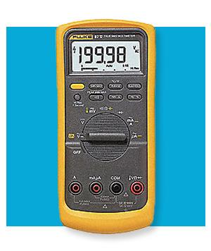
Figure 1: Digital Multimeter
- Clamp-on ammeter: A clamp-on ammeter measures the current in a circuit by assessing the strength of the magnetic field around a conductor. The majority of clamp-on ammeters measure AC, but some assess both AC and DC. The hinged "jaws" on the meter allow technicians to clamp the jaws around a wire, cable or other conductor in an electrical system. This enables the technician to measure the current without disconnecting or de-energizing the system.
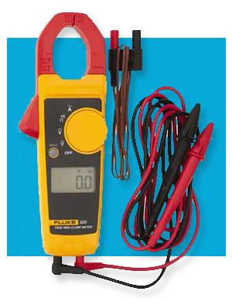
Figure 2: Clamp-on ammeter
- Megohmmeter: Often referred to as a megger. It is used to measure the electrical resistance of insulators. It determines the condition of the insulation on wires and motor windings. They do this by introducing a high-voltage, low-current DC charge and by assessing the resistance to identify whether there is current leakage or damage to the insulation.
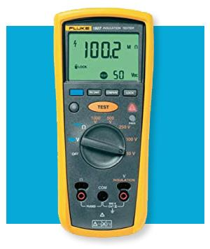
Figure 3: Megohmmeter
- Non-contact thermometer - A non-contact thermometer or spot thermometer is a motor testing tool that measures temperature at a single point from a safe distance. They're used for measuring thermal radiation on hard-to-reach assets or assets operating under extreme conditions. Spot thermometers work by using field of view (FOV) and distance-to-spot ratio (D:S). The D:S is the ratio of the distance to the object you're measuring and the diameter of the temperature measurement area.
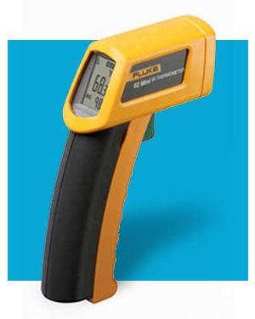
Figure 4: Non-contact thermometer
- Power quality analyzer: Functions of power analyzers may include; measuring all three phases and neutral, capturing dips, swells and inrush currents; and analyzing software integration and compatibility.
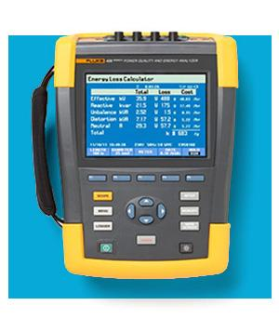
Figure 5: Power quality analyzer

Types of Motor Tests
There are numerous motor testing techniques, especially when it comes to electrical motor testing. According Natarajan (1989), most of these fall under one of two categories: online or offline testing, or static or dynamic testing.
- Online dynamic testing: is done while the motor is running. It gives technicians data on the power quality and operating condition of the motor. This includes power condition, voltage level, voltage imbalance and harmonic distortions, current levels and imbalances, load levels, torque and rotor bar signatures, etc.
- Offline static testing: this is used on a regular basis to determine how the components within a motor (windings, rotor bar, etc.) are functioning as well as to perform a current and voltage analysis. Static testing often finds problems like broken or loose rotor bars, issues with end rings, an unequal air gap between the rotor and stator (eccentricity), and misalignment. Static testing assesses things like resistance/insulation resistance, high-potential (HiPot) tests, polarization, surge tests and more.
According to Thomson (1986), some of the most common of this offline static test include:
- Electric motor impulse testing: Impulse testing helps you understand how an electrical system can withstand sudden overvoltage caused by weather (lightning strikes), regular duty situations like when low- or high-voltage equipment changes operations, or high-voltage variations in AC-DC inverter output.
- Electric motor rotation testing: Testing for rotational direction is crucial before you connect a motor to its load so you don't damage the load or cause confusion for the operator. Proper rotational testing is done with a phase rotation meter.
- Wound rotor electric motor testing: Testing with a wound rotor allows you to isolate the three basic components (stator, rotor and resistor bank) to identify the root cause quicker. Any issues on the stator are reflected on the rotor circuit.
- Insulation resistance testing: A megohmmeter can provide high DC voltage (usually 500V to 15kV) at a predetermined current capacity to test insulation strength. Its best practice to use a megger test with other forms of testing, as it isn't capable of detecting all potential faults inside a motor's winding.
- Winding resistance testing: Winding resistance testing brings to light dead shorts, loose connections and open circuits. Measuring the resistance of windings ensures all circuits are properly wired and all connections are secured. All coiled windings should have a predetermined resistance specified by the manufacturer for the motor to operate correctly. This resistance let’s just the right amount of current to flow through the coil. This test is typically done using a digital multimeter.
- Polarization index (PI) testing: The PI gives you an idea of how much dirt or moisture buildup there is the insulation integrity and how well the motor operates. For this test, the applied voltage should be kept constant for 10 minutes, with an insulation resistance reading taken at one minute and a second insulation resistance reading taken at 10 minutes. The ratio between the one-minute and 10-minute measurements gives you the polarization index.
- DC step voltage test: Step voltage testing is another way to evaluate the insulation integrity of a motor or system. It's typically done after a successful PI test by starting with the same voltage used in the PI test. As the name implies, as the step voltage test progresses, the voltage applied to the insulation system increases every 60 seconds, which is predetermined by the technician. As the voltage is increased, the current is plotted on a graph. Upon completion of the test, if a non-linear graph presents itself, this usually alerts you to insulation issues.
- HiPot test: high potential test checks for good isolation or that no current flows from one point to another point. Think of this as the opposite of a continuity test (where current flows easily from one point to another). The HiPot test verifies that insulation is adequate for the regularly occurring over-voltage transient. This test is ideal for identifying things like nicked or crushed insulation, stray wires, braided shielding, conductive or corrosive contaminants, and spacing problems, among others.
- Automated tests: Most modern motor testing equipment uses automatic testing and fault diagnosis equipment to eliminate the chance for operator error when interpreting results. Automated testing can detect micro-arcs and stop the test automatically if needed. Automated testing equipment comes with software that holds all test output data, so historical readings can be built up over time and reports of that data can be generated. You can find automated testers that combine all static electrical tests in one portable device.

The Voltage Drop Test: Analyzing Resistance in High-Amperage Circuits
Voltage drop test is among the quickest, easiest, and potentially most valuable, allowing for easy evaluation of the quality and efficiency of your circuit’s operation. A voltage drop test can be readily performed with a basic load and a digital voltmeter (DVM). Once the load is applied, the DVM can measure the live connection for a voltage drop in the circuit under load. Because electric current will arc in the path of least resistance, excess current will naturally flow to the DVM and create a reading. And, if the circuit was previously broken, the DVM can create a temporary flow to attempt to isolate the area of dropped power.

The Core Loss Test: Ensuring Quality and Reliability
A core loss tester can indicate the difference between a motor’s input and output power, and these statistics can then be charted against acceptable levels and industry standards. While some loss is normal, a significant loss can reveal repairable problems before they become serious. It can also be a strong indicator of motors in need of replacement, helping to ensure that even a rewound motor is maintaining its ideal performance and efficiency.

Testing a Three-Phase AC Motor
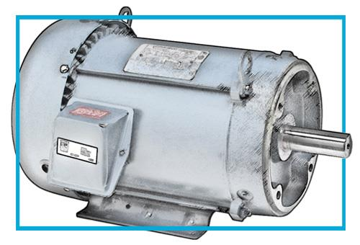
Figure 6: Three-Phase AC Motor
Ensuring the health of a three-phase motor puts into practice many of the testing methods are as follows (Innes, 1996):
- Earth continuity and resistance test: Using a multimeter, measure the resistance between the body of the motor and the ground. Expected reading of 0.5 ohms or less. Some standards may specify 0.1 ohms.
- Power supply test: The expected voltage for a 230/400V system is 230V phase to neutral and 400V between each of the three-phase lines. Power supply test is done using a multimeter by checking to confirm the correct voltage is applied to the motor. Verify that the connection type is in good condition. For three-phase motors, the connection type is either star(Y) or delta.
- AC motor winding continuity test: Multimeter is the instrument used for checking of the motor winding continuity test from each phase. If any phase fails the continuity test, you could have a burned-out motor. U, V or W may be used for terminals.
- AC motor winding resistance test: Multimeter or ohmmeter instrument is applied for phase-to-phase terminal winding resistance testing. This would be U1 to V1, V2 to W2 and W2 to U2. The reading for each winding ought to be (or close to the same).
- Insulation resistance testing: In three-phase motors, insulation resistance typically is measured between each motor winding and phase and between each motor phase and the motor frame (earth). Using a megger or insulation tester set the voltage of the tools to 500V and checks from phase to phase and from phase to the motor frame (earth). Generally, a bad reading is anything less than 2 megohms, while an excellent reading would be 100 megohms or greater.
- Running amps’ test: Finally, with the motor running, you can check the full load amps with a tool such as a clamp-on meter.
- Polarization index test (PI): Sometimes called a 10 min to 1 min insulation resistance test, the PI checks the insulation resistance. It also monitors the health of the motor and determines if there is excessive moisture present.
Materials and Methods
Materials Used for the Work
- Megger
- Multimeter
- Electrical Tools
- Three phase AC motors
- Clap ammeter
Method Utilized
- Earth continuity testing using Multimeter
- Winding resistance testing using Multimeter
- Winding continuity testing using Multimeter
- Insulation resistance testing using megger (set 500 volt scale of 1000v DC)

Testing of Three Phase AC Motors Utilized Procedures
(i) Manually rotated the shaft to check the bearing condition such as free and smooth rotation.
(ii) Earth to Phase continuity testing; (E to U, E to V and E to W).
(iii) Winding Phase to Phase continuity testing; (U1 to U2, V1 to V2 and W1 to W2).
(iv) Winding Phase to Phase resistance testing; (U to V, U to W and V to W).
(v) Insulation Earth resistance testing; ( E to U, E to V and E to W)
(vi) Insulation resistance phase-to-phase testing; (U to V, V to W, W to U)
(vii) With the motor running, amps of the motor was checked Clamp on meter.
(viii) Direction of rotation was also checked.
Insulation Resistance Calculation
Calculation to verify the minimum reading for Insulation Resistance tests (Howard, 2020):
(3.1)
Since voltage across a resistor is applied and then measured the consequential current flow, hence, equation (3.2) is used to calculate the resistance of the insulation.
(3.2)
Allowable lower limit for insulation resistance.
The one mega-ohm rule establishes the allowable lower limit of insulation resistance. The one mega-ohm rule state that there will be approximately one mega-ohm resistance for every 1000 volts of operating voltage.
If the equipment is rated for 6600 volts, the minimum insulation resistance value should be:
Hence, this rule was applied during the testing processes to ascertain the level of insulation resistance in the three phase ac motor.
Results and Discussion
Minimum Insulation resistance calculation
To ascertain the minimum insulation values of the ac motors required for safe operation under the ac motor safety operation rule is calculated using equation (3.1) as giving below.
(1) First ac motor with the following ratings:
V= 220/380v, I= 10A, Speed=2800rpm, 2HP
(2) Second ac motor with the following ratings:
V= 220v, I= 10A, Speed=2800rpm, 2HP
Insulation Resistance Testing Result
The instrument used in carrying out this test is megger and the measured values are in table 4.1:

Table 4.1: Insulation Resistance Testing Resulting
S/N | AC Motor Rating | Earth Resto Phase Test |  |  |  | Phase to Phase Test
 | MEGAOHMS | G  -  G | G  -  U | G  -  V | G  -  W | U1  -  V1 | U1  -  W1 | V1  -  W1 | U2  -  V2 | V2  -  W2
1. | V= 220/380v  I= 10A  Speed=2800rpm  2HP | 10 | 8.69 | 8.69 | 8.69 | 10.79 | 10.89 | 10.91 | 10.78 | 10.90
2 | V= 220v  I= 10A  Speed=2800rpm  2HP | 10 | 1.8 | 1.2 | 1.8 | 1.98 | 1.97 | 1.96 | 1.97 | 1.96

Table 4.1 shows that the motor (1) has an insulation resistance of 8 Megaohms across the ground to phase reading and 10 Megaohms across the phase to phase. The recorded megger reading value is higher than the calculated insulation resistance value of 1.38 Megaoms signifying the 3 phase ac motor has a high insulation resistance to accomplish safety rules of operation.
Table 4.1 also shows that the motor (2) has an insulation resistance of 1 Megaohms across the ground to phase reading and 1 Megaohms across the phase to phase. The recorded megger reading value is almost the same with the calculated insulation resistance value of 1.22 Megaoms signifying the 3 phase ac motor has a low insulation resistance and bad to accomplish safety rules of operation. Hence, the motor under went maintenance by cleaning the stator with ultimeg 2000 to penetrate the slots and increase the insulation resistance. After the varnish process, the ac motor was barked in the ovum for 2 hours to dry water and moisture content in the windings of the stator. The temperature was set up to 45 degree resistance 1 and 2 put ON and the stator positioned horizontally so it can achieve total dryness. When the motor was brought out and retested, the insulation value increased to 1.7 Gigaohms.
Table 4.2: Insulation Resistance Testing After Ovum Heating
S/N | AC Motor Rating | Earth to Phase Test
 | GIGAOHMS | G  -  G | G  -  U | G  -  V | G  -  W | U1  -  V1 | U1  -  W1 | V1  -  W1 | U2  -  V2 | U2  -  W1 | V2  -  W2
1. | V=220 volt  Speed =2840rpm  I= 10 A  1.5kw (2.0HP) | 10 | 1.21 | 1.25 | 1.24 | 1.71 | 1.72 | 1.72 | 1.71 | 1.72 | 1.74

Table 4.2 shows that the motor has a high insulation resistance of 1.2 Gigaohms across the ground to phase recorded reading which is far higher than the calculated value of 1.22 Megaohms signifying the three phase ac motor has high insulation resistance to accomplish safety rules of operation and improved insulation resistance after the maintenance process..
Three Phase AC Motor Winding Testing
Digital Multimeter was used to ascertain this three phase ac motor winding test and the resultant values depicted in table 4.3.
Table 4.3: Winding Testing Resulting
S/N | AC Motor Rating | Earth to Phase Test |  |  |  | Phase to Phase Test
 | OHMS | G  -  U | G  -  V | G  -  W | U1  -  U2 | V1  -  V2 | W1  -  W2 | U  -  V | U  -  W | V  -  W
1. | V= 220v / 380v  I= 10A  Speed=2800rpm  2HP | 0 | 0 | 0 | 0.5 | 0.5 | 0.5 | 0 | 0 | 0
2 | V= 220v  I= 10A  Speed=2800rpm  2HP | 0 | 0 | 0 | 0.6 | 0.6 | 0.6 | 0 | 0 | 0

Table 4.3 shows that the motor is not grounded as earth to phase reading result is zero signifying no contact of the winding to the frame of the motor. This means the motor is okay via earth to phase test.
For the open circuit test of continuity shows that there is no open circuit in any of the winding (U1-U2, V1-V2 and W1-W2) as the winding continuous from the start terminal to the end terminal by giving a 0.5ohms and 0.6 ohms across the two three phase ac motors which means this particular winding is good.
For the short circuit test between the phases recorded zero result across the phases signifying there is no short circuit across the phases.
Discussion of Result
The first test carried out was insulation resistance test using megger. The motor (1) has an insulation resistance of 8 Megaohms across the ground to phase recorded reading and 10 Megaohms across the phase to phase. The recorded megger reading value is higher than the calculated insulation resistance value of 1.38 Megaoms signifying the 3 phase ac motor has a high insulation resistance to accomplish safety rules of operation.
The motor (2) has an insulation resistance of 1 Megaohms across the ground to phase reading and 1 Megaohms across the phase to phase. The recorded megger reading value is almost the same with the calculated insulation resistance value of 1.22 Megaoms signifying the 3 phase ac motor has a low insulation resistance and bad to accomplish safety rules of operation. Hence, the motor under went maintenance by cleaning the stator with ultimeg 2000 to penetrate the slots and increase the insulation resistance. After the varnish process, the ac motor was barked in the ovum for 2 hours to dry water and moisture content in the windings of the stator. The temperature was set up to 45 degree, resistance 1 and 2 put ON and the stator positioned horizontally so it can achieve total dryness. When the motor was brought out and retested, the insulation value increased to 1.7 Gigaohms.
For the winding test, the motors recorded a good reading of not being grounded as earth to phase reading result is zero signifying no contact of the winding to the frame of the motor.
For the open circuit test of continuity shows that there is no open circuit in any of the winding (U1-U2, V1-V2 and W1-W2) as the winding continues by giving a 0.5ohms and 0.6 ohms across the two ac motors. For the short circuit test between the phases recorded zero across the phases signifying there is no short circuit. Therefore, the conditions of the three phase ac motors were ascertain and recommended for use.

REFERENCES
Howard, P. (2020). Report of large motor reliability survey of industrial and commercial installations, IEEE Transactions on Industry Applications, 21(4), 853-862.
Innes A. G. (1996) Condition Monitoring of Induction Motors: The Detection of Broken Rotor Bars in Variable Speed Induction Motor Drivers, PhD Thesis, University of Tasmania, Australia,
Natarajan R. (1989) Failure identification of induction motors by sensing unbalanced stator currents, IEEE Transactions on Energy Conversion, 4(4), 585-590.
Stone G. C., Gupta B. K., and Kurtz M., (1984) Investigation of turn insulation failure mechanisms in large AC motors, IEEE Transactions on Power Apparatus and System, 103(9), 2588-2593.
Tavner P. J., and Penman J. (1987) Condition monitoring of electrical machines, Research Studies International Journal, 13(5), 76-88.
Thomson W. T. (2014) On-line diagnostics of large induction motors, Catholic University of Leuven Publication. 16(3), 91-106.
Weminck E. H. (1986) Electric Motor Handbook, McGraw-Hill, Great Britain,

