INFLUENCE OF COST OF BUILDING MATERIALS ON RENTAL VALUES OF RESIDENTIAL PROPERTIES IN UYO, AKWA IBOM STATE, NIGERIA

AKPAN, Kufre¹, UDOSEN, Victor² and USORO, Ubon³
¹²³Department of Estate Management and Valuation, Akwa Ibom State Polytechnic, Ikot Osurua, Ikot Ekpene, Akwa Ibom State
Correspondence E-Mail: kufre4sucez@yahoo.com
ABSTRACT
The study delved into the correlation between building materials costs and rental values of residential properties in Uyo. It aimed to scrutinize the price trends of construction materials and rental values from 2008 to 2022, investigating whether building materials expenses serve as a determinant of rental values. Employing a correlational research design, secondary data from estate firms provided rental value insights, while data on building materials costs (including cement, sharp sand, and chippings), interest rates, and inflation rates were gathered from annual reports of the National Bureau of Statistics and the Central Bank of Nigeria Statistical Bulletin. Graphical representations and linear equations depicted the trends in these variables, while multiple regression analysis was conducted to assess the impact of building materials costs, year, interest rates, and inflation rates on rental values. The analysis revealed a consistent upward trajectory for both building materials costs and rental values. Surprisingly, the cost of cement, sharp sand, and chippings which had P-values of 0.777, 0.521 and 0.589 respectively, showed no significant influence on rental values, with P-values above the 0.05 threshold for significance. Similarly, the interest rate did not exhibit a notable impact, as evidenced by its P-value of 0.387. However, year and inflation rate, with P-values of 0.000 and 0.018 respectively, emerged as significant factors affecting rental values. Consequently, the study concluded that building materials costs do not wield a significant influence on the rental values of residential properties. To align rent more closely with building materials costs, the recommendation proposes that investors avoid lengthy lease agreements to enable rental values to better mirror the fluctuations in building materials costs. We also recommend that both government and stakeholders promote the utilization of local building materials, aiming to lower overall construction costs.
KEYWORDS: Building materials, Costs, Influence, Rental values, Residential properties.
Introduction
Literature reviews consistently highlight the alarming escalation of building material costs in Nigeria. A 50kg bag of cement, for instance, surged from N1, 800 in 2013 to N5,500 in 2023, marking a staggering 306% increase. This trend extends to other essential materials like sharp and gravel, pivotal regardless of construction type. Oke and Akanni (2012) foresaw these escalating prices hindering the nation's efforts to provide adequate shelter and infrastructure for its people, potentially rendering the idea of quality housing an elusive dream. The relentless surge in building material costs implies exorbitant property development expenses. Considering that rental income constitutes real estate returns, the correlation between rising rental values and investors recovering their substantial investments becomes a pressing concern. Nwanekezie (1996) emphasized the role of building material costs in determining rental rates, while Okoronkwo (2008) suggested that high capital outlays in real estate development could perpetuate incessant rental value hikes. Akinyode (1989) emphasized developers' drive for profits, grounded in the disparity between investment costs and anticipated returns. Dabara, Omotehinshe, Uwaezuoke, Soladoye, and Chikuzie (2018) documented a consistent correlation between escalating building material costs and rising rental values. However, Dabara et al. (2021) presented findings suggesting that while building material prices and house rents correlate, this relationship might lack significant influence. This discrepancy raises concerns about whether the substantial costs of real estate development, including building materials, genuinely impact rental rates, as suggested by Dabara et al. (2021).
Despite existing studies in various Nigerian regions, including the North-Central, South-West, and South-East, exploring the influence of building material costs, an investigation into Uyo, situated in the South-South of Nigeria, becomes imperative. Uyo, a burgeoning city characterized by tranquility, favorable terrain, vast undeveloped land, and a growing population, presents promising prospects for real estate investment. Consequently, this study aims to scrutinize the impact of building material costs on rental values in Uyo, offering guidance to real estate investors contemplating ventures in this region.
Objectives of the Study
The aim of this study is to examine the correlation between building materials costs and rental values of residential properties in Uyo. To achieve this aim, we set these objectives:
- to scrutinize the price trends of construction materials and rental values of residential properties in Uyo from 2008 to 2022
- to examine the influence of cost of building materials as a determinant of rental values of residential properties in Uyo.
Review of Related Literature
Nwanekezie (1996) emphasized the pivotal role of building material costs in determining rental values. This notion implies that, all else being equal, the cost of these materials can directly impact the rental pricing of a property, suggesting a potential fixation of rent as a proportion of building material costs.
In a study by Dabara et al. (2018), a consistent correlation emerged between escalating building material costs and increased rental values of residential properties. While this aligns with the upward trajectory of both costs and rents, the study lacked evidence demonstrating a significant influence of building material costs on rent hikes.
Contrarily, Dabara et al. (2021) found that although both building material costs and rental values were on the rise, the escalating prices of materials did not wield statistically significant influence on residential property rents.
Bello, Mohammed, Muhammad, and Adekunle (2020) argued that bank lending rates and inflation significantly hindered property ownership. This suggests that high cost of finance and rising cost of building materials affect real estate ownership.
Okoronkwo (2011) echoed concerns about high costs incurred by developers, their eagerness to swiftly recover investments, and the desire for profits, all contributing to heightened rental expectations.
Abdulrahim's findings (2016) in Malaysia highlighted the increasing cost of building materials as a significant factor impacting real estate development expenses, emphasizing its status as a major cost component in this sector.
Murungi (2014) underscored the dominant influences of persistent land demand and building material costs on housing prices in Nairobi. Oyeniyi (2016) attributed the relentless rise in building material prices to interest rates, inflation, and importation costs.
Similarly, Ofurum and Ihuah's research (2021) in Nigeria identified inflation, import duties, taxes, petroleum product prices, raw material shortages, and transportation costs as primary contributors to the soaring expenses of building materials within the country.
Research Methodology
This study aimed to explore how the cost of building materials affected rental values in Uyo. Using a correlational research design, we investigated how building materials costs relate to rental values while considering additional factors like interest and inflation rates that might impact rental values. We gathered time series data on rental values from estate firms in Uyo and obtained building materials prices from the National Bureau of Statistics (NBS), while the Central Bank of Nigeria (CBN) annual report provided data on interest and inflation rates. Our study spanned 15 years (2008-2022), and we employed descriptive analysis, including graphs to visualize trends, and conducted multiple regression analysis to assess how independent variables influence rental values, our dependent variable.
Data Presentation and Analysis
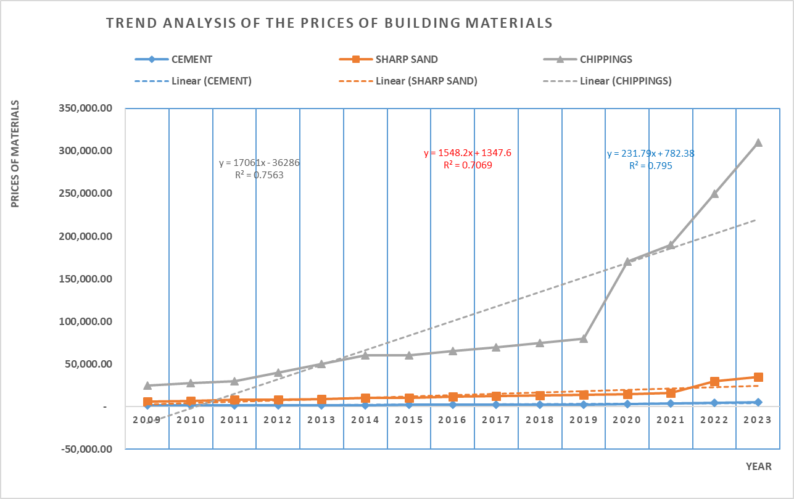
Fig 1: Trend Analysis of Cost of Building Materials, Interest Rate and Inflation Rate
Figure 1 displays the trend analysis for the prices of key building materials, encompassing cement, sharp sand, and chippings. On the y-axis are the prices of these materials while the x-axis displays the years. The R² value of 0.76 indicates that the year accounts for 76% of the variation in chippings' prices. The linear equation, y = 17,061x - 36,286, illustrates an annual increase of N17,061 in chippings' prices from a baseline of N36,286. This model holds potential for forecasting future chippings prices. For sharp sand, the linear function Y = -1,548.2x + 1,347.6 and an R² of 0.71 signify an annual increment of N1,548 with a starting point at N1,348, while changes in the year explain 71% of the price fluctuations in sharp sand. Regarding cement, the linear equation Y = -231.79x + 782.38 and an R² of 0.795 suggest that the year accounts for 80% of the price changes, with an annual increase of N232 from a baseline of N782 in cement prices.
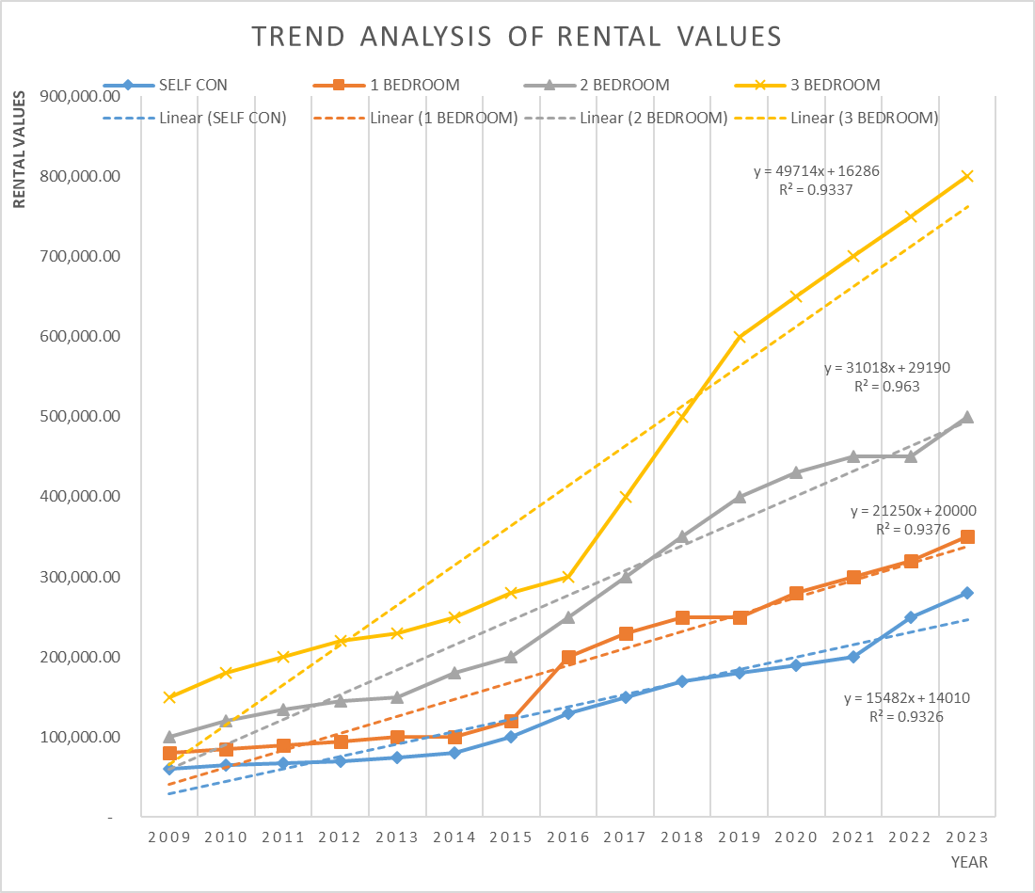
Fig 2: Trend Analysis of Rental Values of Residential Properties.
Figure 2 illustrates the trend analysis of rental values across various residential property types: self-contained units, 1-bedroom bungalows, 2-bedroom bungalows, and 3-bedroom bungalows. The trend in rental values for 3-bedroom bungalows followed a linear equation of y=49,714 + 16,286, with an R² of 0.93. This indicates an annual increase of N49,714, starting from a base of N16,286. Approximately 93% of this rise in rental values could be attributed to the passing years. For 2-bedroom bungalows, the linear function was y=31,018 + 29,190, yielding an R² of 0.96. This suggests an annual increment of N31,018, beginning at N29,190, where about 96% of this growth in rental values was due to year-on-year changes. Regarding 1-bedroom bungalows, the linear equation was y=21,250 + 20,000, demonstrating an R² of 0.94. This implies that 94% of the annual increase of N21,250, starting from N20,000, was attributed to the passage of time. The self-contained units followed a linear model represented by y=15,482 + 14,010, with an R² of 0.9. This showcases an annual rise of N15,482, commencing from N14,010, where approximately 90% of this surge in rental values was influenced by yearly changes.
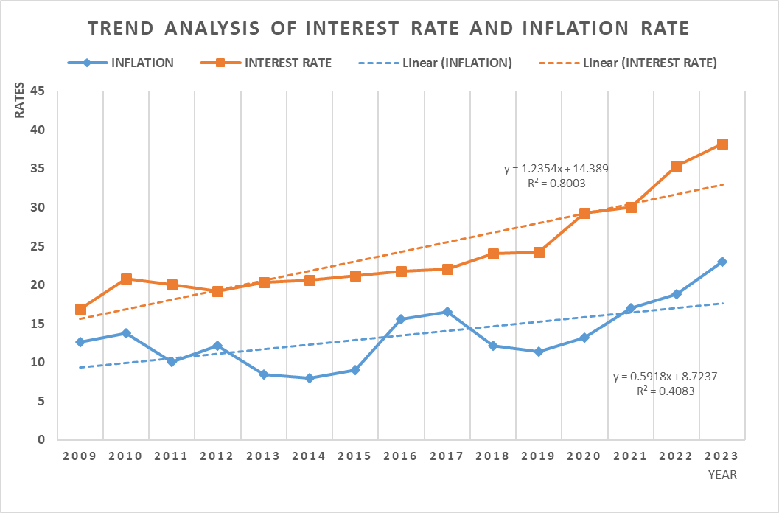
Fig 3: Trend Analysis of Interest Rate and Inflation Rate
Figure 3 displays the trends of two macroeconomic variables: inflation rate and interest rate. The interest rate was represented by a linear function of y=1.2354 + 14.389, with an R² of 0.8. This indicated an annual increase of 1.24%, starting from a base of 14.39%. About 80% of this uptick in interest rates could be attributed to year-on-year changes. Regarding the inflation rate, the model equation was y=0.5918 + 8.7237, yielding an R² of 0.41. This revealed an annual increase of 0.59%, commencing from 8.72%. The passage of time accounted for 41% of the fluctuations in the inflation rate.
Table 1: Model Summary of the Dependent and Independent Variables
Model | R | R Square | Adjusted R Square | Std. Error of the Estimate
1 | .988ª | .977 | .960 | 19647.3495
a. Predictors: (Constant), Interest rate, Inflation, Year, Sharp sand, Cement, Chippings
Table 1 provides a summary of the predictive model assessing the impact of building material costs, year, interest rate, and inflation rate on rental values. The model exhibited an R² value of 0.977, indicating its strong statistical fitness by explaining 98% of the variability in rental values, the dependent variable.

Table 2: Analysis of Variance (ANOVA)
Model |  | Sum of Squares | df | Mean Square | F | Sig.
1 | Regression | 131761853266.534 | 6 | 21960308877.756 | 56.889 | .000^{b}
1 | Residual | 3088146733.466 | 8 | 386018341.683
1 | Total | 134850000000.000 | 14
a. Dependent Variable: Rental Values
b. Predictors: (Constant), Interest rate, Inflation, Year, Sharp sand, Cement, Chippings.

Table 2 presents the result of the analysis of variance (ANOVA). The result in table 2 shows a P-value of 0.000 which shows that the model is statistically significant.
Table 3: Influence of Cost of Building Materials, Year, Interest Rate and Inflation on Rental values of Residential Properties
Model |  | Unstandardized Coefficients |  | Standardized Coefficients | t | Sig.
 |  | B | Std. Error | Beta | t | Sig.
1 | (Constant) | -40794828.745 | 6442439.804 |  | -6.332 | .000
1 | YEAR | 20254.969 | 3232.535 | .923 | 6.266 | .000
1 | CEMENT | -10.984 | 37.558 | -.130 | -.292 | .777
1 | SHARP SAND | -1.688 | 2.516 | -.142 | -.671 | .521
1 | CHIPPINGS | -.281 | .500 | -.251 | -.562 | .589
1 | INFLATION | 7163.368 | 2402.477 | .312 | 2.982 | .018
1 | INTEREST RATE | 5564.933 | 6080.871 | .345 | .915 | .387
a. Dependent Variable: Rental Values
Table 3 outlines the impact of independent variables—cost of building materials, year, interest rate, and inflation rate—on the dependent variable, rental values. The analysis revealed a p-value of 0.000 for the variable "year," indicating its statistically significant influence on residential property rental values at a significance level of 0.05.
The cost of cement exhibited a p-value of 0.777, indicating an insignificant influence on rental values as it surpasses the significance threshold of 0.05. Similarly, both the cost of sharp sand (p-value: 0.521) and clippings (p-value: 0.589) demonstrated statistical insignificance in affecting rental values.
Conversely, the inflation rate showed a p-value of 0.018, suggesting a significant impact on rental values, falling below the 0.05 significance level. However, the interest rate exhibited a p-value of 0.387, surpassing the 0.05 threshold, indicating its lack of significant influence on rental values.
This outcome highlights that only year and inflation rate significantly impact rental values. The significance of year can be understood in the context of landlords collecting two years' rent from tenants. When building material prices rise within this tenure, immediate rent adjustments may not be feasible, influencing rental values. Additionally, higher inflation rates reduce purchasing power, potentially driving more individuals to opt for rented accommodations, thereby increasing rental demand and subsequently, rental values. These findings align with the conclusions drawn by Dabara et al (2021). These findings suggest a parallel between the cost of building materials and rental values akin to Hooke's Law, indicating a proportional relationship within the material's elastic limit. However, beyond this threshold lies a breaking point where the elasticity fails to proportionately respond, mirroring a scenario where tenants, constrained by limited funds, reach a stage where they cannot match escalating rents due to increased building material costs. Consequently, there comes a juncture where the cost of building materials ceases to be the primary determinant of rental values.
Conclusion
This research delved into how the cost of building materials impacts residential rental values in Uyo. Our findings revealed a rising trend in both building materials prices and rental values. However, upon analysis, we found that variables like changes in year and inflation rates had a notable impact on rental values, whereas the cost of building materials and interest rates did not significantly influence rental values. Thus, we conclude that the cost of building materials did not exert a significant influence on rental values.
Recommendations
Landlords are advised to opt for shorter leases on their properties, enabling them to regularly reassess rent in response to fluctuations in building material prices. We also recommend that both government and stakeholders promote the utilization of local building materials, aiming to lower overall construction costs. Real estate investors are encouraged to diversify their investment portfolios to mitigate the impact of rental values not keeping pace with the costs of building materials. We recommend further research to investigate the relationship between cost of building materials and the rental values of other classes of real estate investments to guide investors in their portfolio construction.

REFERENCES
Akinyode, A. O. (1989). Problems of private developers in a depressed economy. The Estate Surveyors and Valuers, 13(1), 10-17.
Bello, H.T, Mohammed, M. I. Huhammad, M. S. & Adekunle, U. (2020). Effect of inflation on residential property development in Bauchi Metropolis. Specialty Journal of Accounting and Economics, 6(1), 1-13.
Dabara, D. I., Chiwuzie, A. Joshua, G., Asa, O. A. & Omotehinshe, J. O. (2021). Housing construction materials and house rent trends in Ede, Nigeria. Pacific Rim Property Research Journal, 27 (3), 205-2016.
Dabara, D. I., Omotehinshe, O. J., Uwaezuoke, N., & Sooladoye, J. O. (2018). Building Material prices and the rental values of residential properties in Ede, Nigeria. Conference paper presented at the 18th AFRES Annual Conference on 15th September, 2013-233.
Murungi, R. K. (2024). An Investigative Study on the factors causing price changes of Residential Houses in Nairobi. A research project presented in partial fulfillment of the requirements for award of Bachelor’s Degree in Real Estate, Department of Real Estate and Construction Management, University of Nairobi, Kenya
Nwanekezie, O. F (1996). Principles and Practice of Estate Management. Avan Global Publications, Owerri, Imo State, Nigeria.
Ofurum, C. G. & Ihuah, P. W. (2021). An analysis of the trend in cost of building materials on property development in Owerri Urban, Imo State, Nigeria. International Journal of Circuit, Computing and Networking, 2(2), 30 - 35
Oke, A. E. & Akanni, P. O. (2012). An assessment of trend in the cost of building materials in Nigeria. Environment Research Digest, 8(2), 6-18
Okoronkwo, N. S. N. (2011). Influence of building costs on rents of residential property in Owerri, Nigeria. International Journal of Development and Management Review, 6, 202 - 215.
Okoronkwo, N.S.N (2008). The effects of inflation/trends on housing delivery in Nigeria. Environment Research and Development Journal 1 (1), 23-30.
Oyeniyi, K. (2016). Trend in Building Materials Inflation of Construction Project in Kaduna. Being a project presented in partial fulfillment of the requirement for the award of Bachelor’s Degree in the Department of Building, University of Kaduna.

