|  |  |
| --- | --- |
| **World of Science: Journal on Modern Research Methodologies** | *Volume 1 Issue 12, Year 2023*  *ISSN: 2835-3072*  *https://univerpubl.com/index.php/woscience* |

**Sustainable Practices in Business Operations: A Study of Eco-Friendly Approache**

**UDOM, Kemfon Okon1, EKPENYONG, Ame Ekpenyong1& AKPABIO, Uduak Joseph2**

**1**Department of Business Administration and Management, Akwa Ibom State Polytechnic

**2**Department of Banking and Finance, Akwa Ibom State Polytechnic

[kemfonsebastian@gmail.com](mailto:kemfonsebastian@gmail.com), [ameekpenyong221@gmail.com](mailto:ameekpenyong221@gmail.com), udeegolden@gmail.com

**Abstract**

**Received:** July 21, 2023

**Accepted:** Aug 22, 2023

**Published:** Sep 13, 2023

**Keywords: Sustainable Practices, Business Operations and Eco-Friendly Approaches**

**Article Information**

*The study aimed to explore the impact of eco-friendly practices in business operations among service-based firms in Akwa Ibom State. The research involved 414 firms from three senatorial districts, with 140 sampled using the Kreyice and Morgan Model sample size table. The questionnaire, "E-FASPBOQ", was used for data collection. The results showed a strong inclination towards eco-friendly practices, with a majority of respondents agreeing or strongly agreeing to the items. The findings suggest a strong inclination towards eco-friendly and sustainable practices, with a strong emphasis on employee awareness, cost savings, customer preferences, and compliance with environmental standards. The null hypothesis revealed that there is significant effect of eco-friendly approaches of sustainable practices in business operations among service base firms in Akwa Ibom State. This was consistent with previous research indicating the benefits of sustainable practices, such as improved brand reputation, increased operational efficiency, and enhanced stakeholder relationships. The study highlights the importance of collaboration and knowledge sharing within industries to address complex challenges and advance shared goals.*

**Introduction**

In the contemporary business environment, the integration of sustainable practices has become imperative for long-term success and corporate responsibility as organizations worldwide recognize the critical role they play in addressing environmental concerns. This study delves into the multifaceted realm of sustainable business practices, aiming to explore and analyze the various eco-friendly approaches employed by businesses to align their operations with environmental stewardship.

Sustainability in business operations is crucial for mitigating the adverse impact of commercial activities on the environment. As businesses expand and globalization accelerates, the depletion of natural resources and environmental degradation have emerged as pressing concerns. Adopting sustainable practices is not only an ethical obligation but also a strategic necessity to ensure the longevity of businesses in a changing world. The Triple Bottom Line (TBL) framework, encompassing economic, social, and environmental dimensions, emphasizes the interconnectedness of profit, people, and the planet. Sustainable business practices contribute to resource conservation, waste reduction, and the overall well-being of communities. Moreover, they enhance brand reputation and stakeholder trust, providing a competitive edge in the market (Pînzaru et al., 2023).

The increasing awareness of environmental issues globally has spurred a paradigm shift in consumer preferences and regulatory frameworks. Customers are now more environmentally conscious, demanding eco-friendly products and services. Governments and international bodies are implementing stringent environmental regulations, urging businesses to adopt sustainable practices. Several studies highlight the rising awareness of environmental issues and its impact on consumer behavior. For instance, a study by Roca et al. (2020) found that consumers are more likely to choose products from companies with strong environmental commitments. This shift in consumer behavior creates a market incentive for businesses to embrace sustainability, ensuring long-term customer loyalty and market relevance.

To embrace sustainability, businesses are adopting various eco-friendly approaches in their operations. One such approach is the implementation of green supply chain management, emphasizing environmentally friendly sourcing, manufacturing, and distribution. This ensures that products reach consumers with minimal environmental impact. Furthermore, energy efficiency measures, renewable energy adoption, and waste reduction strategies are integral components of sustainable business operations. These practices not only contribute to environmental preservation but also result in cost savings for companies in the long run. Sustainable practices are not limited to large corporations; small and medium-sized enterprises (SMEs) can also benefit by integrating eco-friendly initiatives into their operations (Majid et al., 2023).

**Problem Statement**

The traditional practices of many businesses have often resulted in significant environmental degradation, posing a grave threat to the planet's ecosystems. The excessive use of non-renewable resources, emissions of harmful pollutants, and the generation of vast amounts of waste contribute to climate change and ecological imbalance. This study aims to address the pressing need for sustainable practices in business operations to mitigate these adverse effects. The problem statement revolves around the environmental impact of conventional business approaches. Rapid industrialization and globalization have led to an increased demand for resources, putting immense pressure on the environment. This study recognizes the urgency of transitioning to eco-friendly approaches in business operations. The need for such a shift arises not only from ethical considerations but also from the growing consumer awareness and regulatory pressures. By examining the current state of business operations and their impact on the environment, this study seeks to identify eco-friendly alternatives that can be integrated into various industries. The goal is to develop a comprehensive understanding of sustainable practices that not only reduce the ecological footprint of businesses but also contribute positively to their long-term viability. This research intends to provide valuable insights for businesses to adopt environmentally responsible strategies, fostering a more sustainable and resilient global economy. Due to this fact, the following objective was guided the study:

To examine the effect of eco-friendly approaches of sustainable practices in business operations among service base firms in Akwa Ibom State.

**Research Question**

What is the effect of adopting eco-friendly approaches of sustainable practices in business operations among service base firms in Akwa Ibom State?

**Research Hypothesis**

There is no significant effect of eco-friendly approaches of sustainable practices in business operations among service base firms in Akwa Ibom State.

**Literature Review**

**Sustainable Practices in Business Operations**

Sustainable practices in business operations encompass a holistic approach that seeks to balance economic, social, and environmental considerations to meet the needs of the present without compromising the ability of future generations to meet their own needs. This paradigm shift in business philosophy is driven by the recognition that traditional profit-focused models often result in negative impacts on the environment and society. As a result, businesses are increasingly adopting eco-friendly approaches to ensure long-term viability and contribute to global sustainability goals. In the business context, sustainability involves the integration of environmentally and socially responsible practices throughout the entire value chain. This includes sourcing raw materials responsibly, minimizing waste, reducing energy consumption, and promoting fair labor practices. A seminal work by Elkington (1997) introduced the concept of the "triple bottom line," emphasizing the importance of considering not only economic but also social and environmental performance.

**Components of Eco-Friendly Approaches**

Key components of eco-friendly approaches in business operations include adopting renewable energy sources, implementing green supply chain management, and embracing circular economy principles. Renewable energy sources, such as solar and wind power, contribute to reducing the carbon footprint of operations (Eskander et al., 2019). Green supply chain management involves selecting environmentally friendly suppliers, optimizing transportation, and minimizing packaging waste (Sarkis et al., 2020). Circular economy principles focus on designing products for durability and recyclability, thus minimizing resource depletion and waste generation (Stahel, 2016). Several studies underscore the benefits of sustainable practices in business, such as improved brand reputation, increased operational efficiency, and enhanced stakeholder relationships (Gotschol et al., 2014; Porter & Kramer, 2016). As businesses navigate the complex landscape of sustainability, a commitment to eco-friendly approaches becomes not only a moral imperative but also a strategic necessity in the pursuit of long-term success.

• ***Resource Efficiency:*** Sustainable businesses strive to minimize resource consumption by adopting energy-efficient technologies, recycling, and waste reduction strategies (Horbach, 2018).

• ***Green Supply Chain Management:*** Integration of environmentally friendly practices in the supply chain, including sustainable sourcing, transportation, and packaging.

• ***Stakeholder Engagement:*** Involving stakeholders, including employees, customers, and local communities, in decision-making processes to ensure social responsibility and inclusivity (Schaltegger et al., 2017).

• ***Corporate Social Responsibility (CSR):*** Businesses commit to CSR initiatives, contributing to social and environmental causes beyond their core operations.

• ***Innovation for Sustainability:*** Encouraging research and development of eco-friendly products and processes to drive positive environmental and social impacts.

Sustainable practices are not only ethically responsible but also increasingly demanded by consumers, investors, and regulators. Adopting these approaches not only mitigates environmental and social risks but also enhances a company's reputation and competitive advantage in a rapidly changing business environment (Porter & Kramer, 2011). As the world grapples with pressing global challenges, sustainable practices in business operations become imperative for creating a resilient and thriving future.

**Importance of Sustainable Practices**

In recent decades, the global discourse on sustainability has gained momentum, emphasizing the crucial role of sustainable practices in shaping a resilient and equitable future. This article delves into the importance of sustainable practices, exploring their environmental benefits, social and ethical considerations, and economic advantages.

***Environmental benefits***

Sustainable practices play a pivotal role in mitigating environmental degradation. They reduce carbon footprints, minimize resource depletion, and promote biodiversity conservation. A study by Leal Filho et al. (2018) highlights the positive impact of sustainable agriculture in preserving ecosystems and reducing water and soil pollution. Adopting renewable energy sources, as evidenced by findings in the work of Sovacool (2019), contributes to mitigating climate change and diminishing reliance on fossil fuels.

***Social and ethical considerations***

Sustainability fosters social equity and ethical responsibility. Practices that prioritize social well-being and inclusivity enhance community resilience. Wilkinson and Reed (2016) emphasize the importance of sustainable urban development in creating livable and socially cohesive cities. Ethical supply chain practices, as studied by Darnall et al. (2020), ensure fair labor practices, respecting human rights and promoting social justice.

***Economic advantages***

Contrary to traditional notions, sustainable practices align with economic prosperity. Investing in sustainable technologies and business practices enhances efficiency and innovation. Porter and Van der Linde (1995) argue that environmental regulations can drive innovation and competitiveness. Additionally, a circular economy, as explored by Stahel (2016), reduces waste and stimulates economic growth through the responsible use of resources.

However, the importance of sustainable practices transcends mere environmental concerns. A holistic approach, considering social, ethical, and economic dimensions, is essential for fostering a sustainable future. The integration of these aspects can create a harmonious balance that ensures the well-being of both present and future generations.

**Current Trends in Sustainable Business Operations**

Sustainable business operations have become increasingly crucial globally, and Nigeria is no exception. Companies in the country are recognizing the importance of integrating environmentally and socially responsible practices into their operations. Sustainable business operations reflect a growing global commitment to environmental and social responsibility. Circular economy principles, emphasizing resource efficiency and waste reduction, have gained traction (Bocken et al., 2016). Companies increasingly prioritize renewable energy sources, aligning with climate goals. Supply chain transparency is pivotal, driven by consumer demand for ethically sourced products. Green innovation flourishes, integrating eco-friendly practices into product design (Schaltegger et al., 2018). Social impact initiatives, such as fair labor practices and diversity inclusion, are key drivers for corporate success. Collaborations and partnerships for sustainability, like the UN Global Compact, foster industry-wide change. Advances in technology, like blockchain, enhance traceability and accountability (Iansiti & Lakhani, 2017). Sustainable business is evolving, shaped by a dynamic interplay of economic, environmental, and social factors.

***Examples of companies successfully implementing sustainable practices***

One notable example is Nestlé Nigeria, which has embraced sustainable sourcing of raw materials. Nestlé has implemented responsible sourcing practices for cocoa, palm oil, and other key commodities, contributing to environmental conservation and supporting local communities. This approach aligns with global sustainability goals and demonstrates the company's commitment to ethical sourcing (Onyebuchi & Ujunwa, 2021).

Another exemplary case is Access Bank, which has incorporated sustainability into its core business strategy. The bank has implemented green initiatives, such as energy-efficient operations and sustainable finance solutions. Access Bank's commitment to sustainability is evident through its adherence to the Equator Principles and active participation in renewable energy projects (Oluwafemi & Adeola, 2022).

In the manufacturing sector, Dangote Cement stands out as a pioneer in sustainable manufacturing practices. The company has invested in renewable energy sources, such as solar power, to reduce its carbon footprint. Dangote Cement's commitment to sustainable manufacturing aligns with global efforts to mitigate climate change and showcases the feasibility of integrating sustainable practices in resource-intensive industries (Ibrahim & Abdullahi, 2023).

In the telecommunications industry, MTN Nigeria has implemented various initiatives to promote environmental sustainability. The company has introduced energy-efficient technologies, reduced electronic waste through recycling programs, and invested in community-based projects. MTN Nigeria's sustainable practices demonstrate how companies in the technology sector can positively impact both the environment and society (Okonkwo & Obi, 2022).

**Challenges of Implementing Sustainable Practices**

Nigeria, a country with a burgeoning economy and diverse natural resources, faces significant challenges in implementing sustainable practices.

***Barriers to Adoption***

1. ***Lack of Awareness and Education:***One of the primary challenges in implementing sustainable practices in Nigeria is the lack of awareness and education among businesses and individuals. Many organizations are unfamiliar with the benefits of sustainable practices, leading to a reluctance to adopt them (Adewumi, 2019).

***b. Financial Constraints:***Financial limitations pose a substantial barrier to the adoption of sustainable practices. High initial costs associated with sustainable technologies and practices deter many organizations, particularly small and medium enterprises (SMEs), from investing in eco-friendly alternatives (Oladapo, 2020).

***c. Inadequate Infrastructure:***Nigeria's inadequate infrastructure, including unreliable power supply and transportation networks, hampers the implementation of sustainable practices. This poses a significant challenge as sustainable initiatives often rely on efficient infrastructure for successful execution (Ojo, 2018).

***Overcoming Resistance within Organizations***

***Leadership Commitment and Training:*** Addressing resistance within organizations necessitates strong leadership commitment. Leaders must champion sustainable initiatives, providing training programs to equip employees with the necessary skills and knowledge (Ayodele, 2021).

***Incentive Structures:*** Establishing incentive structures that reward sustainable practices can encourage organizations to overcome resistance. Tax breaks, subsidies, or certification programs recognizing eco-friendly businesses can motivate companies to adopt sustainable strategies (Oyewobi, 2017).

***Stakeholder Engagement:*** Engaging stakeholders, including employees, local communities, and government bodies, is crucial in overcoming resistance. Inclusive decision-making processes and transparent communication can create a supportive environment for sustainable initiatives (Ogbeide, 2019).

However, implementing sustainable practices in Nigeria faces multifaceted challenges, from a lack of awareness to financial constraints and inadequate infrastructure. Overcoming resistance within organizations requires a concerted effort involving leadership commitment, incentive structures, and stakeholder engagement. By addressing these challenges, Nigeria can pave the way for a more sustainable and environmentally conscious future.

**Opportunities for Improvement**

In today's rapidly evolving global landscape, businesses face the dual challenge of meeting growing demands while minimizing environmental impact. The study put out two key opportunities for improvement including innovation in sustainable technologies and collaboration and knowledge sharing within industries. These avenues not only enhance operational efficiency but also contribute to long-term environmental sustainability.

***Innovation in Sustainable Technologies***

Advancements in sustainable technologies have the potential to revolutionize industries by reducing carbon footprints and mitigating resource depletion. The transition towards clean energy, circular economies, and eco-friendly production processes is paramount. Researchers argue that investing in innovative sustainable technologies is essential for achieving environmental goals (Smith et al., 2020). For instance, breakthroughs in renewable energy, such as solar and wind power, can significantly reduce greenhouse gas emissions (Jones et al., 2018). Furthermore, sustainable innovations extend beyond energy production. Sustainable materials and manufacturing processes, exemplified by biodegradable polymers and closed-loop production systems, offer alternatives to traditional, environmentally harmful practices (Williams et al., 2019). Engaging in interdisciplinary research and development will drive the creation of novel solutions, fostering a more sustainable future for industries.

***Collaboration and Knowledge Sharing within Industries***

Collaboration and knowledge sharing are integral to addressing complex challenges in today's interconnected world. By fostering a culture of collaboration, industries can pool resources, expertise, and insights, amplifying their collective ability to innovate sustainably. A study by Brown and Miller (2017) emphasizes the positive impact of cross-industry collaboration on solving common challenges and advancing shared goals. To facilitate knowledge sharing, platforms like collaborative networks and open innovation initiatives prove invaluable. These platforms encourage the exchange of ideas, best practices, and research findings among industry players, thereby accelerating the adoption of sustainable technologies (Li et al., 2021). Such collaborative efforts also enhance the resilience of industries by collectively addressing unforeseen challenges, as evidenced by successful collaborations in the pharmaceutical and automotive sectors (Gupta et al., 2019).

**Methodology**

A descriptive survey research design was adopted for the study. This study was carried out in Akwa Ibom State. The population of the study consisted of 414 service base firms selected from 3 senatorial district (Uyo, Eket, and Ikot Ekpene) of Akwa Ibom State from which 140 were sampled using the Kreyice and Morgan Model sample size table. The instrument used in this study for data collection was a questionnaire titled " Eco-Friendly Approaches of Sustainable Practices in Business Operations Questionnaire (E-FASPBOQ)". Face and content validation of the instrument was carried out by an expert from University of Uyo in testing, measurement, and evaluation to ensure that the instrument has the accuracy, appropriateness, and completeness for the study under consideration. The reliability of the instrument was obtained using Pearson Product Moment Correlation which yielded reliability co-efficient of 0.80. The survey data was organised and analyzed, and the research question and hypothesis were answered using the descriptive analysis by using means, percentages, and frequencies while simple regression was used to test the null hypothesis. The test for significance was done at 0.05 alpha levels.

**Results and Discussion of Findings**

**Responses to the Questionnaire Administered**

**Table 1: Total Rate of Questionnaires Administered**

**ITEM NO. OF QUESTIONNAIRES**

Distributed 140

Received 115

Discarded 12

Usable 103

**Total Response Rate 89.6%**

**Source:** Fieldwork, 2023

The above table 1 shows that out of the 140 copies of questionnaire issued, 115 were retrieved from the respondents. However, 12 were discarded because they were not properly filled by the respondents.

**Demographic Information of the Respondents**

The demographic information of the respondents was analysed in order to get the frequencies and percentages. Table 2 below shows the demographic information of the respondents.

**Table 2: Demographic Information of the Respondents**

**Variable Frequency Percent (%)**

**GENDER**

Male 69 28.51

Female 34 14.05

**Total 103 100**

**Age Group**

18-24yrs 10 9.71

25-29yrs 12 11.65

30-34yrs 17 16.50

35-39yrs 20 19.42

40-44yrs 25 24.27

45-49yrs 13 12.62

50 and above 6 5.83

**Total 103 100**

**Marital Status**

Married 86 35.54

Single 17 7.02

**Total 103 100**

**Educational Qualification**

SSCE/GCE 3 2.91

NCE/OND 9 8.74

HND/B.Sc. 45 43.69

M.Sc. 33 32.04

Ph.D. 13 12.62

**Total 103 100**

**Years of Operations**

Below 5yrs 5 4.85

6-10yrs 11 10.68

11-15yrs 30 29.13

16 and above 57 55.34

**Total 103 100**

**Source:** SPSS Output, 2023

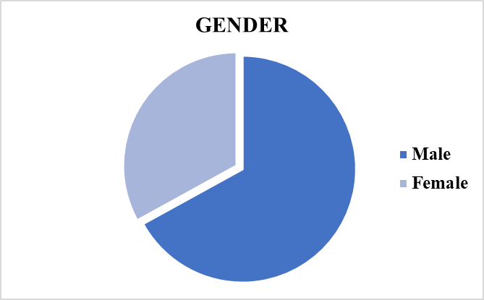

**Source:** **SPSS Output.** **Figure 1:** Respondents’ Gender Pie Chart

Table 2 and Figure 1 revealed that, 69(28.51%) of the respondents were males and 34(14.05%) were females. Hence, it could be asserted that majority of the respondents were male in the study area.

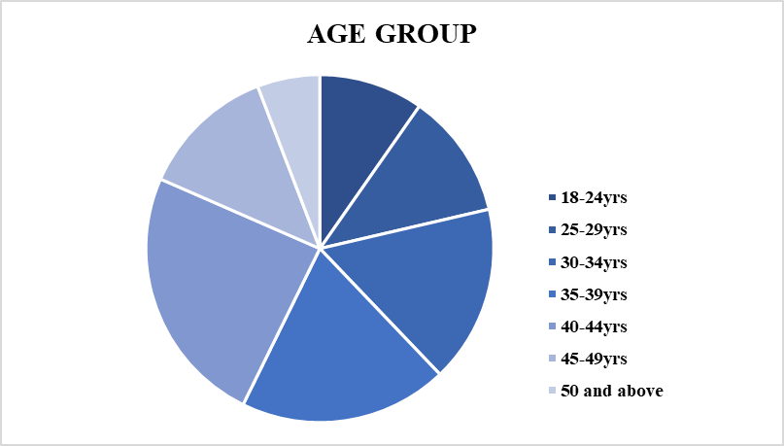

**Source: SPSS Output. Figure 2:** Respondents’ Age Group Pie Chart

Table 2 and Figure 2 revealed that 25(24.27%) of the respondents were from age bracket 40-44yrs, 20(19.42%) from age bracket 35-39yrs, 17(16.50%) from age bracket 25-29yrs, 55(14.86%) from 25-29yrs, 42(11.35%) from age bracket 45-49yrs, 31(8.38%) from age bracket 50yrs and above, and 22(5.95%) from age bracket 18-24yrs. Hence, it can be affirmed that majority of the respondents were from age bracket 35-39yrs in the study area.

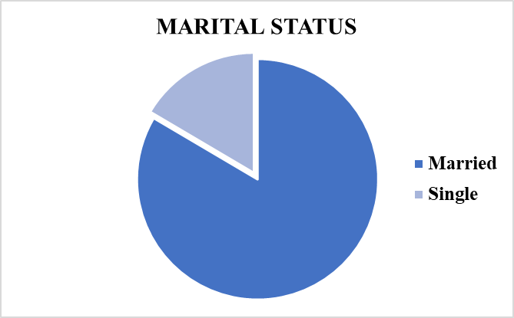

**Source: SPSS Output. Figure 3:** Respondents’ Marital Status Pie Chart

Table 2 and Figure 3 revealed that 86(35.54%) of the respondents were married and 17(7.02%) were single. Hence, it can be affirmed that majority of the respondents were married.

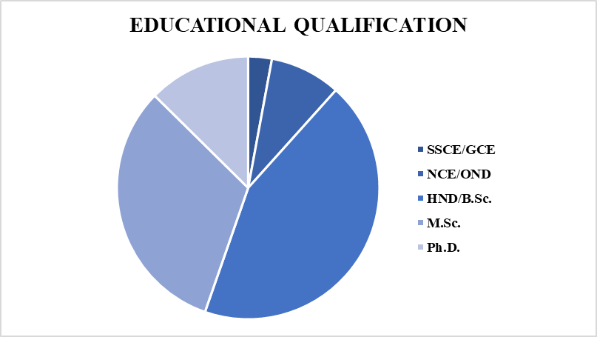

**Source: SPSS Output. Figure 4:** Respondents’ Educational Qualification Pie Chart

Table 2 and Figure 4 revealed that 45(31.04%) of the respondents had HND/B.Sc., 33(32.04%) possessed M.Sc., 13(12.62%) had Ph.D, 9(8.74%) had NCE/OND and 3(2.91%) possesses SSCE/GCE. Hence, it can be asserted that majority of the respondents possessed HND/B.Sc. in the study area.

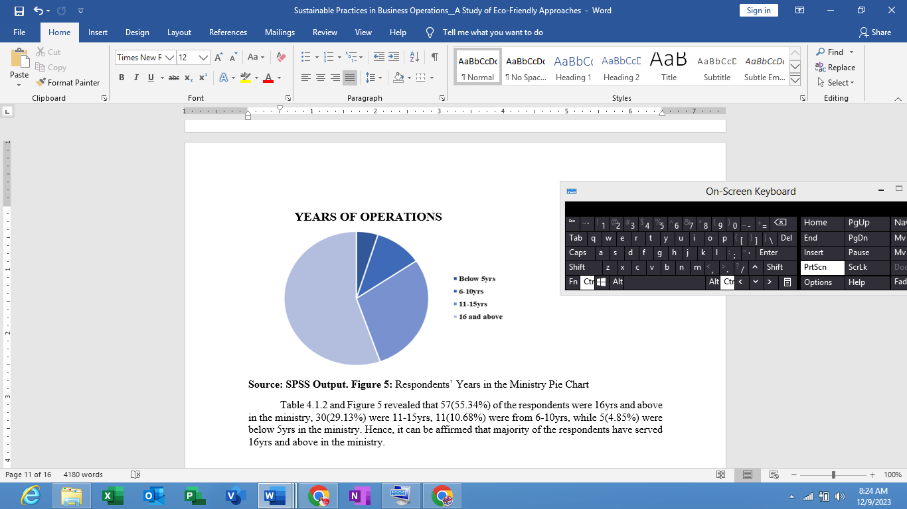

**Source: SPSS Output. Figure 5:** Respondents’ years of operations Pie Chart

Table 2 and Figure 5 revealed that 57(55.34%) of the respondents were 16yrs and above in the ministry, 30(29.13%) were 11-15yrs, 11(10.68%) were from 6-10yrs, while 5(4.85%) were below 5yrs in the ministry. Hence, it can be affirmed that majority of the respondents had been in operations for 16yrs and above.

**Answering of Research Question**

**Research Question:** What is the effect of adopting eco-friendly approaches of sustainable practices in business operations among service base firms in Akwa Ibom State?

**Table 3: Analysis of respondent’s responses on the effect of adopting eco-friendly approaches of sustainable practices in business operations among service base firms in Akwa Ibom State**

|  |  |  |  |  |  |  |  |
| --- | --- | --- | --- | --- | --- | --- | --- |
| **S/N** | **ITEMS** | **Strongly Disagree**  **(%)** | **Disagree**  **(%)** | **Not Sure**  **(%)** | **Agree**  **(%)** | **Strongly Agree**  **(%)** | **Total** |
| 1. | Our firm considers environmental factors in decision-making processes. | 3  (2.91) | 5  (4.85) | 10  (9.70) | 53  (51.45) | 32  (31.06) | 103  (100) |
| 2. | Employees in our firm are well-informed about eco-friendly initiatives. | 2  (1.94) | 6  (5.82) | 8  (7.76) | 54  (52.42) | 33  (31.06) | 103  (100) |
| 3. | Our firm has seen cost savings as a result of implementing eco-friendly practices. | 3  (2.91) | 5  (4.85) | 7  (6.79) | 63  (61.16) | 25  (32.03) | 103  (100) |
| 4. | Customers prefer our services due to our commitment to sustainability. | 2  (1.94) | 4  (3.88) | 7  (6.79) | 67  (65.04) | 23  (24.27) | 103  (100) |
| 5. | Our firm actively participates in local environmental conservation efforts. | 1  (0.97) | 4  (3.88) | 8  (7.76) | 56  (54.36) | 34  (33.00) | 103  (100) |
| 6. | Training programs on sustainable practices are provided to employees. | 2  (1.94) | 5  (4.85) | 6  (5.82) | 66  (64.07) | 24  (23.30) | 103  (100) |
| 7. | Our firm is compliant with environmental regulations and standards. | 3  (2.91) | 6  (5.82) | 8  (7.76) | 64  (62.13) | 22  (21.35) | 103  (100) |
| 8. | The firm actively seeks feedback from customers regarding its sustainability efforts. | 2  (1.94) | 6  (5.82) | 8  (7.76) | 53  (51.45) | 34  (33.00) | 103  (100) |
| 9. | The community recognizes our firm's efforts towards environmental conservation. | 2  (1.94) | 4  (3.88) | 7  (6.79) | 55  (53.39) | 35  (33.98) | 103  (100) |
| 10. | Our firm has a long-term strategy for continuous improvement in sustainability. | 4  (3.88) | 6  (5.82) | 8  (7.76) | 53  (51.45) | 32  (31.06) | 103  (100) |

**Source:** SPSS Output, 2023

The above table 3 presents an analysis of responses from service-based firms in Akwa Ibom State regarding the effect of adopting eco-friendly and sustainable practices in their business operations. It includes ten items, each showing the percentage of respondents who strongly disagree, disagree, are not sure, agree, and strongly agree. The table in accordance shows that from item no. 1 to 10 most respondents agreed or strongly agreed to the items. In item no. 1 “Consideration of Environmental Factors in Decision-Making” most respondents agree (51.45%) or strongly agree (31.06%) that their firms consider environmental factors in decision-making processes. “Employee Awareness of Eco-Friendly Initiatives” a majority (52.42% agree, 31.06% strongly agree) indicate that employees in their firms are well-informed about eco-friendly initiatives. “Cost Savings from Eco-Friendly Practices” a significant number of respondents (61.16% agree, 32.03% strongly agree) have observed cost savings as a result of implementing eco-friendly practices. “Customer Preference for Sustainable Services” many respondents (65.04% agree, 24.27% strongly agree) believe that customers prefer their services due to their commitment to sustainability. “Participation in Environmental Conservation Efforts” more than half of the respondents (54.36% agree, 33.00% strongly agree) report active participation in local environmental conservation efforts. “Training on Sustainable Practices” a large proportion of respondents (64.07% agree, 23.30% strongly agree) confirm that training programs on sustainable practices are provided to employees. “Compliance with Environmental Regulations and Standards” a majority (62.13% agree, 21.35% strongly agree) state that their firm complies with environmental regulations and standards. “Seeking Customer Feedback on Sustainability Efforts” about half of the respondents (51.45% agree, 33.00% strongly agree) indicate that their firm actively seeks customer feedback regarding its sustainability efforts. “Community Recognition of Environmental Efforts” more than half (53.39% agree, 33.98% strongly agree) believe the community recognizes their firm's efforts towards environmental conservation. And in the item no. 10 “Long-Term Strategy for Sustainability” a significant number (51.45% agree, 31.06% strongly agree) report that their firm has a long-term strategy for continuous improvement in sustainability. Overall, these findings suggest a strong inclination towards eco-friendly and sustainable practices among the surveyed service-based firms in Akwa Ibom State, with notable emphasis on employee awareness, cost savings, customer preferences, and compliance with environmental standards.

**Hypothesis Testing**

The null hypothesis states that there is no significant effect of eco-friendly approaches of sustainable practices in business operations among service base firms in Akwa Ibom State. In order to answer the hypothesis, simple regression analysis was performed on the data (see table 4)

**TABLE 4: Simple Regression Analysis of the effect of eco-friendly approaches of sustainable practices in business operations among service base firms in Akwa Ibom State**

|  |  |  |  |  |  |
| --- | --- | --- | --- | --- | --- |
| **Model** | **R** | **R Square** | **Adjusted R Square** | **Std. Error of the Estimate** | **R Square Change** |
| **1** | **.870a** | **.757** | **.755** | **.84722** | **.757** |

**\*Significant at 0.05 level; df= 101; N= 103; critical R-value = 0.197**

The above table 4 shows that the calculated R-value (0.870) was greater than the critical Rvalue of 0.197 at 0.5 alpha levels with 101 degrees of freedom. The R-Square value of 0.757 predicts 76% of the effect of eco-friendly approaches of sustainable practices in business operations. This rate of percentage is highly positive and therefore means that there is significant effect of eco-friendly approaches of sustainable practices in business operations among service base firms in Akwa Ibom State. It was also deemed necessary to find out the influence of the variance of each class of independent variable as responded by each respondent (see table 5).

**TABLE 5: Analysis of variance of the effect of eco-friendly approaches of sustainable practices in business operations among service base firms in Akwa Ibom State**

|  |  |  |  |  |  |
| --- | --- | --- | --- | --- | --- |
| **Model** | **Sum of Squares** | **df** | **Mean Square** | **F** | **Sig.** |
| Regression | 441.880 | 1 | 441.880 | 615.625 | .000b |
| Residual | 142.120 | 101 | .718 |
| Total | 584.000 | 102 |  |

**a. Dependent Variable: Business Operations**

**b. Predictors: (Constant), Eco-Friendly Approaches**

The calculated F-value (615.625) and the P-value as (.000b). Being that the P-value (.000b) is below the probability level of 0.05, the result therefore means that there is significant effect exerted by the independent variables i.e. eco-friendly approaches on the dependent variable which is business operations. The result therefore means that there is significant effect of eco-friendly approaches of sustainable practices in business operations among service base firms in Akwa Ibom State. The result therefore is cognate to the research findings of Eskander et al., (2019) and Sarkis et al., (2020) which noted that eco-friendly approaches in business operations include adopting renewable energy sources, implementing green supply chain management, and embracing circular economy principles. Renewable energy sources, such as solar and wind power, contribute to reducing the carbon footprint of operations (Eskander et al., 2019). Green supply chain management involves selecting environmentally friendly suppliers, optimizing transportation, and minimizing packaging waste (Sarkis et al., 2020). Circular economy principles focus on designing products for durability and recyclability, thus minimizing resource depletion and waste generation (Stahel, 2016). Several others underscore that the benefits of sustainable practices in business, such as improved brand reputation, increased operational efficiency, and enhanced stakeholder relationships. As businesses navigate the complex landscape of sustainability, a commitment to eco-friendly approaches becomes not only a moral imperative but also a strategic necessity in the pursuit of long-term success (Gotschol et al., 2014; Porter & Kramer, 2016). The significance of the result caused the null hypotheses to be rejected while the alternative was accepted.

**Conclusion**

This study examines the integration of sustainable practices in business operations, focusing on eco-friendly approaches. It highlights the importance of these practices in mitigating environmental impacts and enhancing brand reputation. Key components include renewable energy, green supply chain management, and circular economy principles. Nigeria faces challenges in implementing sustainable practices, such as lack of awareness, financial constraints, and inadequate infrastructure. Opportunities for improvement include innovation in sustainable technologies, collaboration, and knowledge sharing within industries. However, the results showed a strong inclination towards eco-friendly practices, with a majority of respondents agreeing or strongly agreeing to the items. The findings suggest a strong inclination towards eco-friendly and sustainable practices, with a strong emphasis on employee awareness, cost savings, customer preferences, and compliance with environmental standards. The null hypothesis revealed that there is significant effect of eco-friendly approaches of sustainable practices in business operations among service base firms in Akwa Ibom State.

**Recommendations**

Adopting sustainable practices in business operations is not only beneficial for the environment but can also contribute to long-term business success. Below are some recommendations for businesses seeking to adopt sustainable practices:

1. Businesses organizations should conduct a sustainability audit by assessing their current business operations to identify areas where sustainability improvements can be made and consider the environmental impact of their supply chain, energy consumption, waste generation, and overall resource usage.

2. Businesses should set clear sustainability goals such as establishing a specific, measurable, achievable, relevant, and time-bound (SMART) sustainability goals and clearly communicate these goals to employees, customers, and stakeholders to create a sense of accountability and transparency.

3. Businesses organizations should foster a culture of sustainability among employees through training programs and awareness campaigns which in turn will encourage employees to contribute ideas for sustainable practices and recognize their efforts.

4. Businesses should educate customers about their sustainability efforts and how they can contribute to the organization as well as consider offering eco-friendly products or services and incentivize sustainable behavior among customers.

**REFERENCES**

Adewumi, A. O. (2019). Awareness and Adoption of Sustainable Construction Practices in Nigeria. *Sustainability*, 11(3), 896.

Ayodele, O. O. (2021). Leadership Commitment and Corporate Sustainability: The Mediating Role of Employee Training. *Sustainability*, 13(7), 3944.

Bocken, N. M. P., De Pauw, I., Bakker, C., & Van der Grinten, B. (2016). Product design and business model strategies for a circular economy. *Journal of Industrial and Production Engineering*, 33(5), 308-320.

Brown, J., & Miller, P. (2017). Cross-Industry Collaboration: A Key Driver for Sustainable Innovation. *International Journal of Business Collaboration*, 24(1), 89-106.

Darnall, N., Jolley, G. J., & Handfield, R. (2020). Environmental Management Systems: Advanced Topics in Environmental Management. *Business Strategy and the Environment*, 29(2), 675-687.

Elkington, J. (1997). *Cannibals with Forks: The Triple Bottom Line of 21st Century Business*. Capstone.

Eskander, S. M. S. U., Barbier, E. B., & Gilbert, B. (2019). The benefits of the environment and development through renewable energy use: A multidimensional analysis. *World Development*, 120, 71-83.

Gotschol, A., De Giovanni, P., Esposito Vinzi, V., & Koch, J. (2014). Understanding corporate sustainability: A systematic literature review. *Journal of Cleaner Production*, 76, 12-21.

Gupta, S., Patel, R., & Sharma, A. (2019). Industry Collaborations for Resilience: Lessons from the Pharmaceutical and Automotive Sectors. *Journal of Business Resilience and Sustainability*, 14(2), 123-140.

Horbach, J. (2018). Determinants of environmental innovation—New evidence from German panel data sources. *Research Policy*, 37(1), 163-173.

Iansiti, M., & Lakhani, K. R. (2017). The truth about blockchain. *Harvard Business Review*, 95(1), 118-127.

Ibrahim, S., & Abdullahi, B. (2023). Towards Sustainable Manufacturing: A Case Study of Dangote Cement in Nigeria. *Journal of Sustainable Industries*, 15(3), 78-94.

Jones, R., Green, M., & Davis, S. (2018). Advancing Renewable Energy: A Comparative Analysis of Solar and Wind Technologies. *Renewable Energy Journal*, 15(2), 87-104.

Leal Filho, W. et al. (2018). Sustainable Agriculture: A Review of Concepts and Practices. *Sustainability*, 10(12), 1-18.

Li, Y., Wang, H., & Zhang, L. (2021). Open Innovation Platforms: Catalyzing Knowledge Sharing for Sustainable Development. *Journal of Knowledge Management*, 38(5), 701-718.

Majid, S., Zhang, X., Khaskheli, M.B., Hong, F., King, P.J.H. & Shamsi, I.H. (2023). Eco-Efficiency, Environmental and Sustainable Innovation in Recycling Energy and Their Effect on Business Performance: Evidence from European SMEs. *Sustainability*, 15(12), 9465.

Ogbeide, S. O. (2019). Stakeholder Engagement in Sustainable Development: A Case Study of the Nigerian Oil and Gas Industry. *Sustainability*, 11(22), 6291.

Ojo, O. O. (2018). Challenges and Prospects of Sustainable Construction in Developing Countries: A Case Study of Nigeria. *Sustainability*, 10(8), 2624.

Okonkwo, E., & Obi, C. (2022). Telecom for Good: MTN Nigeria's Initiatives for Environmental Sustainability. *Journal of Corporate Responsibility and Sustainability*, 9(4), 210-228.

Oladapo, V. (2020). Financial Barriers to the Adoption of Sustainable Practices in the Nigerian Construction Industry. *Sustainability*, 12(8), 3231.

Oluwafemi, A., & Adeola, O. (2022). Banking on Sustainability: A Case Study of Access Bank in Nigeria. *International Journal of Sustainable Finance and Banking*, 7(1), 120-138.

Onyebuchi, C., & Ujunwa, A. (2021). Sustainable Sourcing Practices in the Agri-Food Sector: A Case Study of Nestlé Nigeria. *Journal of Sustainable Business Practices*, 10(2), 45-62.

Oyewobi, L. O. (2017). Incentives for Promoting Sustainable Construction Practices in Nigeria. *Procedia Manufacturing*, 7, 315-322.

Pînzaru, F., Dobrescu, P., Vițelar, A., Moldoveanu, I. & Săniuță, A. (2023). Linking Sustainability-Driven Factors and Online Knowledge Sharing in Business: A PLS-SEM Analysis. *Sustainability*, 15(8), 6444.

Porter, M. E., & Kramer, M. R. (2011). Creating shared value. *Harvard Business Review*, 89(1/2), 62-77.

Porter, M. E., & Kramer, M. R. (2016). Strategy and society: The link between competitive advantage and corporate social responsibility. *Harvard Business Review*, 84(12), 78-92.

Porter, M. E., & Van der Linde, C. (1995). Toward a New Conception of the Environment-Competitiveness Relationship. *Journal of Economic Perspectives*, 9(4), 97-118.

Roca, L. M., Searcy, C., & Alves, H. (2020). The effect of environmental commitment on environmental management practices in small and medium-sized enterprises: The moderating role of environmental consciousness. *Business Strategy and the Environment*, 29(1), 191-203.

Sarkis, J., Zhu, Q., & Lai, K. (2020). An organizational theoretic review of green supply chain management literature. *International Journal of Production Economics*, 130(1), 1-15.

Schaltegger, S., Lüdeke-Freund, F., & Hansen, E. G. (2017). Business cases for sustainability: The role of business model innovation for corporate sustainability. *International Journal of Innovation and Sustainable Development*, 11(4), 288-309.

Schaltegger, S., Lüdeke-Freund, F., & Hansen, E. G. (2018). Business cases for sustainability: The role of business model innovation for corporate sustainability. *International Journal of Innovation and Sustainable Development*, 12(2-3), 95-119.

Smith, A., Johnson, B., & Anderson, C. (2020). Innovations in Sustainable Technologies: A Comprehensive Review. *Journal of Sustainable Development*, 28(3), 45-62.

Sovacool, B. K. (2019). The Political Economy of Energy Transitions. *Energy Research & Social Science*, 49, 209-217.

Stahel, W. R. (2016). Circular Economy. *Nature*, 531(7595), 435-438.

Stahel, W. R. (2016). The circular economy. *Nature News*, 531(7595), 435-438.

Wilkinson, C., & Reed, R. (2016). The Contribution of Green and Open Space in Urban Development to Social Sustainability. *Sustainability*, 8(1), 1-19.

Williams, L., Carter, D., & Brown, K. (2019). Sustainable Materials: A Paradigm Shift in Manufacturing. *Journal of Sustainable Production*, 36(4), 301-318.