**Evaluation of Assets and Liabilities Management on the Profitability of Deposit Money Banks in Nigeria**

**Dada, O. S.**

Department of Accounting, Federal University of Technology, Akure, Nigeria

*Author email: dadaolakunle@gmail.com*

Adeyemo, F. H.

Department of Management Science, Bamidele Olumilua University of Education, Science and Technology, Ikere, Nigeria

*Corresponding author email:* [*adeyemo.foluke@bouesti.edu.ng*](mailto:adeyemo.foluke@bouesti.edu.ng)*;* [*fhadeyemo@gmail.com*](mailto:fhadeyemo@gmail.com)

Faleye, O. C.

Department of Management Science, Bamidele Olumilua University of Education, Science and Technology, Ikere, Nigeria

*Author email: faleye.olubunmi*@*bouesti.edu.ng*

Olayeye, F. F.

Department of Accounting, Federal University of Technology, Akure, Nigeria

*Author email: olayeyeff@gmail.com*

***Abstract:*** This study evaluates the effect of Assets and Liability Management (ALM) on the Profitability of some selected Deposit Money Banks in Nigeria. The profitability of deposit money banks is vital for the smooth operation of the financial system of a country. Return on asset (ROA), which is a measure of profitability was employed was utilized in this work. ROA was calculated as net profit after tax divided by total assets. A sample of ten (10) banks was selected for the study that covered a period of ten (10) years, from 2008 to 2017. A purposive sampling technique method was used in the selection of the sample. The data analysis was done using correlation and panel regression analysis. The study finds that ALM position negatively affects bank profitability (ROA) (β = -0.003, z = -0.02, p > 0.05). A unit increase in the ALM proportion necessitated by either an increase in advances or a decrease in deposits results into a decline in the ROA by up to 0.003 (0.3%). The findings revealed that loan to customers’ deposit have significant effect on profitability of selected deposit money banks in Nigeria. It was observed that the asset-liability management has significant effect on profitability of Deposit Money Banks in Nigeria. Finally, the study recommends that banks need to improve credit administration, monitoring and improve on credit quality. Risks should be timely identified and mitigated in order to secure trading funds. Banks should also focus on improving their capital levels to improve their financial performance

***Keywords;*** Assets; Banks; Evaluation; Liabilities; Profitability

**Introduction**

Banks are financial institution whose business involves the management of monetary assets and liabilities. World Savings and Retail Banking Institute (WSBI) (2022) establishes that banks play a key role in allocating finances for the functioning of the economy. Unlike other business organizations such as the manufacturing firms that stock tangible goods as inventory, the stock of the banking industry is money; this means that banks trade on money. Asset-liability management basically refers to the process by which an institution manages its statements of financial position in order to allow for alternative interest rate and liquidity scenarios (Corporate Finance Institute, 2022) Banks face a number of challenges within internal and the external business environment, the operation of banks is associated with risks which include credit risk, market risk, interest rate risk, default risk, operational risk, exchange rate risk and liquidity risk . As opined by Carmona, Climent and Momparler(2019), the risk-taking approaches that are taken into consideration are found to get increased due to liquidity risk factors. Credit risk is determined as the risk of default that is faced on a debt when all requirements are not fulfilled. It is seen that loss of principal, interest, and collection costs are considered under credit risk factors and thus, these need to be complete or fulfilled in partial profits. Afriyie and Akotey (2018) The management of assets and liabilities is defined as the strategic management of the Statements of financial position for risk optimization of liabilities and assets of banks considering all market risks (Isaac and Akinwumi 2018) World Savings and Retail Banking Institute (WSBI) (2022) establishes that banks play a key role in allocating finances for the functioning of the economy. The following objectives will be followed in this study; (a) assess the effect of asset and liability management on profitability of selected deposit money banks in Nigeria, (b) evaluates the effect of customers’ deposit on profitability of selected deposit money banks in Nigeria and (c) determine the effect of loans to customers on the profitability of selected deposit money banks in Nigeria. As per the views of Abbas and Masood (2020), large commercial banks are responsible for adjusting their capital ratios in order to have an empirical outcome in their banking growth. Apart from that, an ALM framework is applied to determine non-performing assets and lost assets which are present within the financial sector.

**Methodology Research Design**

The study is an analytical research design where panel regression was employed by the researcher, to understudy the financial statement of the banks selected. Sample of ten (10) banks were selected out of the population based on the criteria that the banks must have been quoted since 2004 by The Nigerian stock exchange when the initial Share capital of Nigeria banks was increased to N25 billion minimum capital bases and maintain its name till date. The selection considered both old and new generation banks. A purposive sampling method was used in the selection of the sample. The ten Banks selected represent forty-five percent (45%) of the licensed Deposit Money banks in Nigeria and this sample is assumed to be a true representation of the licensed banks in Nigeria. Secondary data were used throughout of this study. Data were collected in relation to loans (assets), liabilities (deposits) and profitability (profit after tax) for all the Deposit Money Banks that form the sample size for the period under study (2008-2017). The annual reports provided necessary data in respect of Assets and liabilities of the banks selected for the study. Also, the profitability of the Banks was also obtained from the financial statement of relevant years. The data collected from the published financial statements of the selected banks were already submitted to the Nigerian Stock Exchange Commission and Central Bank of Nigeria (CBN) before being published. The CBN also publishes the banking Survey as an annual publication which contains the annual financial statement of all banks in Nigeria. Descriptive, correlations and regression analysis were applied to the study and to compare the effect of independent variables on the dependent variable.

**Study Area and Population**

The study was carried out on selected banks in Nigeria. Banks in Nigeria mostly have their corporate headquarters in Lagos, Nigeria, but have branches located in different parts of the country. Nigerian Stock Exchange which was established in 1960 as Lagos Stock Exchange is the regulatory body empowered to register companies that meet the criteria of registration for their shares to be traded openly on the floor of the Nigeria stock exchange The population of this study comprised all licensed (22) Deposit Money Banks (DMBs) by Central Bank of Nigeria but also been listed on the Nigeria Stock Exchange as at 31stDecember 2004. The populations would consider 22 licensed Deposit Money Banks in Nigeria. Sample of ten (10) banks were selected out of the population based on the criteria that the banks must have been quoted since 2004 by The Nigerian stock exchange when the initial Share capital of Nigeria banks was increased to N25 billion minimum capital bases and maintain its name till date. The selection considered both old and new generation banks. A purposive sampling method was used in the selection of the sample. The ten Banks selected represent forty-five percent (45%) of the licensed Deposit Money banks in Nigeria and this sample is assumed to be a true representation of the licensed banks in Nigeria.

The sample was based on the following criteria: The availability of consistent data set over the 10 year-period, licensed by the Central Bank of Nigeria, Listed on The Nigerian Stock Exchange since 2004 banking reform for N25 billion capital base Functional accessibility on the internet for data retrieval and information gathering. The selected banks consist of small, medium and large banks to show representation of the sector.

**Results and Discussion**

The study sought to assess the effect of asset and liability management on profitability of selected deposit money banks in Nigeria. Presentation of the findings from the data analysis in line with the research objectives is done in this chapter

Table 1 shows the descriptive statistics of the entire datasets Skewness and Kurtosis values of the datasets indicate that the values are not symmetrical, which confirms the existence of a trend in the datasets. Furthermore, shown on Figures 1 - 4 are the summaries of loan to deposit ratio (LDR), asset quality ratio (AQR), liquidity ratio (LR), and return on asset (ROA) of the selected banks. Figure 1 shows that FCMB had the highest LDR within the period studied while Union Bank had the least LDR. Also, Figure 2 shows that Ecobank had the highest AQR and UBA had the least AQR. Figures 3 and 4 shows that First Bank had the highest LR while GTB had the highest ROA.

**Table 1: Summary of Statistics of Dependent and Independent Variables**

|  |  |  |  |  |
| --- | --- | --- | --- | --- |
|  | LDR | AQR | LR | ROA |
| Mean | 0.635483 | 0.057033 | 0.273228 | 0.037311 |
| Median | 0.636907 | 0.036809 | 0.178871 | 0.015889 |
| Maximum | 1.752221 | 0.5906 | 1.855699 | 2.465143 |
| Minimum | 0.10304 | -0.41833 | 0.022232 | -0.29643 |
| Std. Dev. | 0.207397 | 0.099667 | 0.332323 | 0.249 |
| Skewness | 1.258478 | 1.425253 | 2.882647 | 9.381367 |
| Kurtosis | 10.01051 | 17.05996 | 11.65446 | 92.25177 |
| Jarque-Bera | 231.1765 | 857.5331 | 450.5763 | 34658 |
| Probability | 0.000 | 0.000 | 0.000 | 0.000 |
| Sum | 63.54829 | 5.703312 | 27.32283 | 3.731072 |
| Sum Sq. Dev. | 4.258347 | 0.983414 | 10.93344 | 6.138101 |
| Observations | 100 | 100 | 100 | 100 |

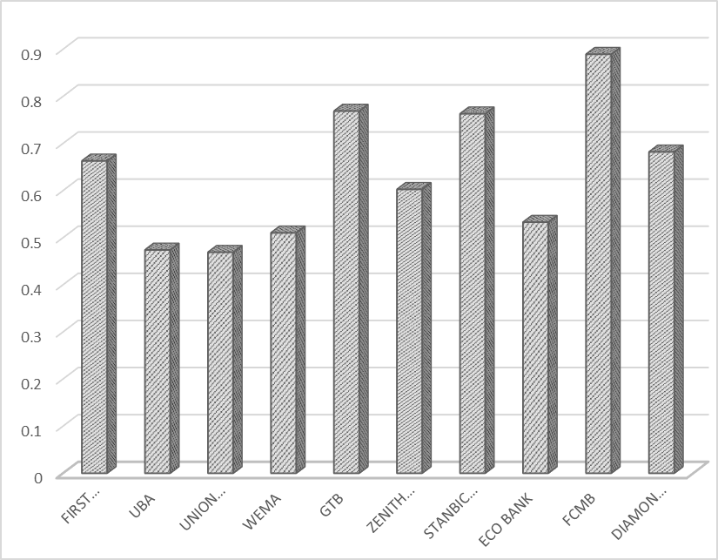

**Figure 1: Summary of Loan to Deposit Ratio (LDR)**

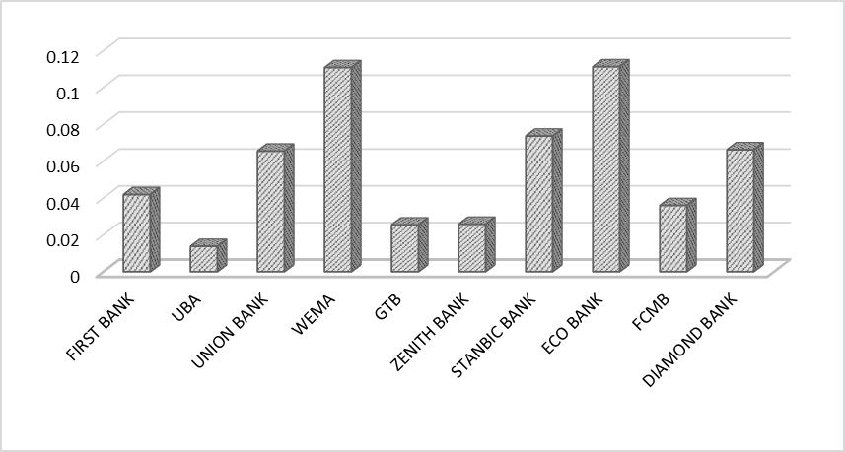

**Figure 2: Summary of Asset Quality Ratio (AQR)**

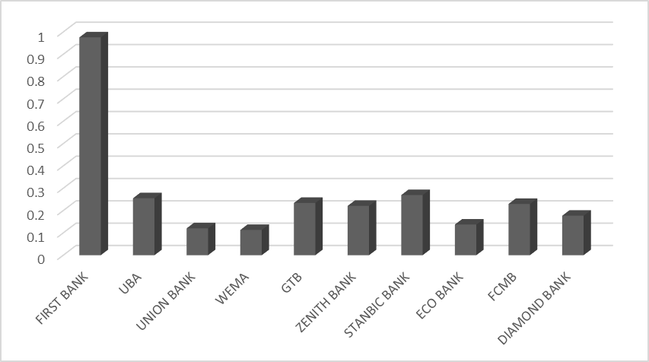

**Figure 3: Summary of Liquidity Ratio (LR)**

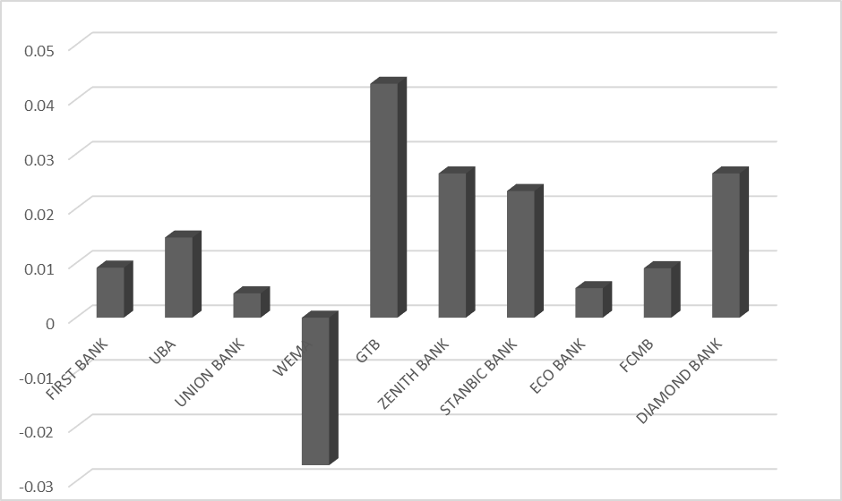

**Figure 4: Summary of Return On Asset (ROA)**

## Effect of asset and liability management on profitability of selected deposit money banks in Nigeria

Table 2 presents the relationship between asset and liability management (ALM) and profit after tax of the selected deposit money banks. The asset-liability management (ALM) is a concept that deals with the optimal investment of assets in view of meeting current goals and future liabilities. According to Hosna, manzura and juanjuan (2019) asset-liability management is the process that is concerned with strategic management of assets (uses of funds) and liabilities (sources of funds) of banks against various risks such as liquidity. It was revealed that the assets-liability management of all the selected banks have a positive relationship with the respective profit after tax of the banks respectively Onaolapo and Adegoke (2020)

This implied that the profit after tax of each of the deposit money banks increases with increase in the practice of assets-liability management. This suggests that there are gains in practicing assets-liability management by the Deposit Money Banks since it covers all prudential component management of all possible risks. Although, a positive relationship was observed between the asset-liability management of the banks and their respective profits after tax, however, these relationships were not significant contrary to a priori expectation. This can be associated to the fact that asset-liability management involves the process of managing the use of assets and cash flows to meet the bank’s obligations in order to reduce the risk of loss from not paying a liability on time. Therefore, if assets-liability management is properly handled, the banks can significantly increase profits in agreement with the findings of Adegbite and Dada (2018). It is therefore appropriate for these Deposit Money Banks to focus on asset-liability management when they face financial risks of different types.

## Table 3 shows the effect of customers deposit on profitability of selected deposit money banks in Nigeria. The profitability of deposit money banks is vital for the smooth operation of the financial system of a country. To get a picture of the profitability of the banks, ROA, which is a measure of profitability, has been employed. ROA reﬂects the ability of a bank’s management to generate profits from the bank’s assets and was calculated as net profit after tax divided by Total assets.

## Table 4 shows the relationship between customers deposit and profitability of selected deposit money banks. It was revealed that a positive relationship was found between the asset quality of the selected Deposit Money Banks and their profit. This is indications that increase in the asset quality of the Deposit Money Banks increases their profitability and vice versa. It was further shown that the relationship between the asset quality and profitability of Zenith bank (r = .696*) and Stanbic bank (r = .696*) is significant. This suggests that these two banks have high quality assets which significantly increase their profitability. However, apart from Zenith bank and Stanbic IBTC bank, the relationship between the asset quality and profitability of other selected banks were not found to be significant. This suggests that the potentials of asset quality have not been fully tapped into by the other selected banks in improving their profitability. It is however necessary for the other Deposit Money Banks to explore this since poor asset quality has been identified as one of the major causes of bank failures in the past.

**Table 2: Correlations of Asset-Liability Management and Profitability of Selected DMBs in Nigeria**

|  |  |  |  |  |  |  |  |  |
| --- | --- | --- | --- | --- | --- | --- | --- | --- |
|  | | First Bank Profit after Tax | UBA Profit after Tax | Union Bank Profit after Tax | - | ECOBANK Profit after Tax | FCMB Profit after Tax | DIAMOND Profit after Tax |
| First Bank Asset liability management (loan to deposit ratio) | Pearson Correlation | **.595** | -.443 | .023 | - | -.301 | -.127 | 0.209 |
| Sig. (2-tailed) | **.070** | .200 | .950 | - | .431 | .726 | 0.562 |
| N | **10** | 10 | 10 | - | 9 | 10 | 10 |
| UBA Asset liability management (loan to deposit ratio) | Pearson Correlation | -.065 | **.008** | .070 | - | .108 | .158 | 0.007 |
| Sig. (2-tailed) | .858 | **.982** | .849 | - | .782 | .663 | 0.985 |
| N | 10 | **10** | 10 | - | 9 | 10 | 10 |
| Union Asset liability management (loan to deposit ratio) | Pearson Correlation | -.226 | .436 | **.071** | - | .098 | .558 | 0.283 |
| Sig. (2-tailed) | .529 | .208 | **.846** | - | .802 | .093 | 0.428 |
| N | 10 | 10 | **10** | - | 9 | 10 | 10 |
| WEMA Asset liability management (loan to deposit ratio) | Pearson Correlation | .073 | .548 | .115 | - | .245 | .486 | 0.154 |
| Sig. (2-tailed) | .842 | .101 | .751 | - | .525 | .154 | 0.672 |
| N | 10 | 10 | 10 | - | 9 | 10 | 10 |
| Sig. (2-tailed) | .402 | .525 | .407 | - | .947 | .884 | 0.667 |
| N | 10 | 10 | 10 | - | 9 | 10 | 10 |
| - | - | - | - | - | - | - | - | - |
| - | - | - | - | - | - | - | - | - |
| ECOBANK Asset liability management (loan to deposit ratio) | Pearson Correlation | -.144 | .314 | .338 | **-** | **.394** | .241 | -0.054 |
| Sig. (2-tailed) | .692 | .377 | .340 | **-** | **.294** | .502 | 0.883 |
| N | 10 | 10 | 10 | **-** | **9** | 10 | 10 |
| FCMB Asset liability management (loan to deposit ratio) | Pearson Correlation | .235 | .163 | .070 | - | -.088 | **.093** | -0.127 |
| Sig. (2-tailed) | .513 | .653 | .847 | - | .821 | **.797** | 0.726 |
| N | 10 | 10 | 10 | - | 9 | **10** | 10 |
| DIAMOND Asset liability management (loan to deposit ratio) | Pearson Correlation | -.035 | -.160 | .499 | - | -.585 | -.379 | **0.428** |
| Sig. (2-tailed) | .925 | .658 | .142 | - | .098 | .281 | **0.217** |
| N | 10 | 10 | 10 | - | 9 | 10 | **10** |

**Table 3: Random-effects GLS regression of the effect of asset and liability management on profitability of selected DMBs in Nigeria**

|  |  |  |  |  |  |  |
| --- | --- | --- | --- | --- | --- | --- |
| Random-effects GLS regression | | |  |  | Number of obs = 100 | |
| Group variable: bank | | |  |  | Number of groups = 10 | |
| R-sq: |  |  |  |  | Obs per group: | |
|  | within = 0.0031 | |  |  |  | min = 10 |
|  | between = 0.0456 | |  |  |  | avg = 10 |
|  | overall = 0.0000 | |  |  |  | max = 10 |
|  |  |  |  |  | Wald chi2(1) = 0.00 | |
|  |  |  |  |  | Prob > chi2 = 0.9806 | |
| ROA | Coef. | Std. Err. | z | P>z | [95% Conf. | Interval] |
| LDR | -0.003 | 0.12423 | -0.02 | 0.981 | -0.2465 | 0.24046 |
| _cons | 0.03924 | 0.08337 | 0.47 | 0.638 | -0.1242 | 0.20264 |
| sigma_u | 0.03182 |  |  |  |  |  |
| sigma_e | 0.24896 |  |  |  |  |  |

**Table 4: Correlations of Asset Quality and Profitability of Selected Deposit Money Banks in Nigeria**

|  |  |  |  |  |  |  |  |  |
| --- | --- | --- | --- | --- | --- | --- | --- | --- |
|  | | First Bank Profit after Tax | UBA Profit after Tax | Union Bank Profit after Tax | WEMA bank Profit after Tax | ECOBANK Profit after Tax | FCMB Profit after Tax | DIAMOND Profit after Tax |
| First Asset Quality (Ratio of Non-performing loans to total loans) | Pearson Correlation | **.067** | .049 | .452 | -.377 | -.441 | .072 | -.307 |
| Sig. (2-tailed) | **.853** | .893 | .190 | .282 | .235 | .844 | .389 |
| N | **10** | 10 | 10 | 10 | 9 | 10 | 10 |
| UBA Asset Quality (Ratio of Non-performing loans to total loans) | Pearson Correlation | -.508 | **.527** | -.116 | -.689* | -.455 | -.157 | -.266 |
| Sig. (2-tailed) | .133 | **.118** | .749 | .027 | .219 | .666 | .458 |
| N | 10 | **10** | 10 | 10 | 9 | 10 | 10 |
| Union Asset Quality (Ratio of Non-performing loans to total loans) | Pearson Correlation | -.484 | -.540 | **.267** | -.771** | -.315 | -.104 | -.287 |
| Sig. (2-tailed) | .156 | .107 | **.455** | .009 | .408 | .774 | .421 |
| N | 10 | 10 | **10** | 10 | 9 | 10 | 10 |
| WEMA Asset Quality (Ratio of Non-performing loans to total loans) | Pearson Correlation | -.618 | -.576 | .005 | **.102** | -.286 | -.149 | .117 |
| Sig. (2-tailed) | .057 | .081 | .990 | **.779** | .456 | .681 | .747 |
| N | 10 | 10 | 10 | **10** | 9 | 10 | 10 |
| Sig. (2-tailed) | .427 | .180 | .866 | .038 | .148 | .429 | .257 |
| N | 10 | 10 | 10 | 10 | 9 | 10 | 10 |
| - | - | - | - | - | - | - | - | - |
| - | - | - | - | - | - | - | - | - |
| ECOBANK Asset Quality (Ratio of Non-performing loans to total loans) | Pearson Correlation | .193 | -.451 | -.361 | -.396 | **.058** | -.480 | -.300 |
| Sig. (2-tailed) | .593 | .191 | .305 | .257 | **.882** | .161 | .399 |
| N | 10 | 10 | 10 | 10 | **9** | 10 | 10 |
| FCMB Asset Quality (Ratio of Non-performing loans to total loans) | Pearson Correlation | -.680* | .022 | -.062 | -.700* | -.438 | **.375** | -.003 |
| Sig. (2-tailed) | .031 | .952 | .865 | .024 | .238 | **.285** | .993 |
| N | 10 | 10 | 10 | 10 | 9 | **10** | 10 |
| DIAMOND Asset Quality (Ratio of Non-performing loans to total loans) | Pearson Correlation | -.324 | -.475 | -.437 | -.275 | .096 | -.114 | **.262** |
| Sig. (2-tailed) | .360 | .165 | .207 | .442 | .805 | .753 | **.465** |
| N | 10 | 10 | 10 | 10 | 9 | 10 | **10** |
| *. Correlation is significant at the 0.05 level (2-tailed). | | | | | | | | | |
| **. Correlation is significant at tailed). | | | | | | | | | |

As shown on Table 5, the study adopted a panel regression model to assess the effect of customers’ deposit (measured using loan ratio) on profitability of selected deposit money banks in Nigeria. Using 100 observations from 10 deposit banks, the study finds that customers deposit positively affects bank profitability (ROA) (β= 0.015, z = 0.192, p > 0.05). A unit increase in the customers deposit proportion necessitated by either an increase in advances or a decrease in deposits results into an increase in the ROA by up to 0.015 (1.5%). The results indicated that there is a positive but insignificant relationship between Loans Ratio and ROA. The coefficient of determination (R squared) was 0.0002, which was found to be insignificant. A Wald chi2 value of 0.04 (<0.05) indicates a good model.

This finding was supported by Belete (2018) who found a regression coefficient of 3.551 (p value=0.022) between loan ratio (LR) and return on asset (ROA). The findings agree with those in Bologna (2011) who noted that deposits play a pivotal role in bank’s funding, as a predominant portion of deposit money bank’s assets are usually financed through customer deposit. The main expense by any deposit money bank is the interest expense and therefore for a deposit money bank to be profitable, it must be able to raise deposits at reasonable rates in order to on lend to the customers. This therefore implies that a bank that can generate more deposits cheaply will be able to supply more loans competitively and hence make more profits if all other factors are held constant.

Furthermore, the findings agree with in Ajibola and Olowolaju (2017) who provided evidence that the best performing banks are those who maintained a high level of deposit accounts. The findings also agree with those in Ochung (1999) who focused on the deposit portfolio as a determinant of deposit money bank profitability and found a positive correlation between deposit portfolio and bank profitability.

Table 6 shows the relationship between asset quality and profitability of the selected banks using the Pearson Product Moment Correlation Coefficient. The quality of assets held by a bank depends on exposure to specific risks, trends in non-performing loans, and the health and profitability of bank borrowers Hosna, Manzura and Juanjuan (2019). Hence, the extent of the credit risk depends on the quality of assets held by an individual bank. According to Obaleye (2018), profitability of a bank depends on its ability to foresee, avoid, and monitor risks, possibly to cover losses brought about by risks arisen. Hence, in making decisions on the allocation of resources to asset deals, a bank must consider the level of risk to the assets. It was revealed that a positive relationship was found between the asset quality of the selected Deposit Money Banks and their profit. This is indications that increase in the asset quality of the Deposit Money Banks increases their profitability and vice versa.

Table 7 AQR have an insignificant negative effect on the profitability of deposit money banks in Nigeria as shown by statistical values of (β=-0.047, z = -0.19, p > 0.05). The results obtained from random effect panel regression analysis, no significant negative effect is found between ROA indicating the bank profitability and asset quality ratio indicating loans to customers.

**Table 5: Random-effects GLS regression of the effect of customers’ deposit on profitability of selected DMBs in Nigeria**

|  |  |  |  |  |  |  |
| --- | --- | --- | --- | --- | --- | --- |
| Random-effects GLS regression | | |  |  | Number of obs = 100 | |
| Group variable: banknum | | |  |  | Number of groups = 10 | |
| R-sq: |  |  |  |  | Obs per group: | |
|  | within = 0.0035 | |  |  |  | min = 10 |
|  | between = 0.0115 | |  |  |  | avg = 10 |
|  | overall = 0.0002 | |  |  |  | max = 10 |
|  |  |  |  |  | Wald chi2(1) = 0.04 | |
|  |  |  |  |  | Prob > chi2 = 0.8490 | |
| ROA | Coef. | Std. Err. | z | P>z | [95% Conf. | Interval] |
| LR | .0149754 | .0786536 | 0.19 | 0.849 | -.1391829 | .1691337 |
| _cons | .033219 | .0346967 | 0.96 | 0.338 | -.0347852 | .1012233 |
| sigma_u | .0356713 |  |  |  |  |  |
| sigma_e | .2489192 |  |  |  |  |  |

**Conclusion and Recommendation**

The study concluded that the total assets of each of the selected banks have a positive relationship with the profit after tax of the banks in agreement with *a priori* expectation. It was also revealed that the total liabilities of each of the selected banks have a positive relationship with the profit after tax of the banks.

**Conclusion**

It was concluded that the assets-liability management of all the selected banks have a positive relationship with the respective profit after tax of the banks respectively. It was revealed that a positive relationship was found between the asset quality of the selected Deposit Money Banks and their profit, which suggests that increase in the asset quality of the Deposit Money Banks increases their profitability and vice versa. However, it was concluded that an inverse relationship exists between the ratio of the selected banks and their profitability in the study area. This is an indication that profitability reduces as liquidity ratio increases, and vice versa.

**Recommendations**

From the findings of this study, the following recommendations were made to improve the performance of the deposit money banks in Nigeria: a. Nigerian deposit money banks should invest in attracting deposits. This is because deposits play a pivotal role in bank’s funding, as a predominant portion of commercial bank’s assets are usually financed through customer deposit b. The study also recommends that Nigerian deposit money banks need to monitor the interest on deposits carefully c. management of Nigerian deposit money banks should enhance their capacity in credit analysis, appraisals and loan administration. Clear credit policies and lending guidelines should be established. Management also is required to make sure that the terms and conditions are adhered to in loans approval.

**Table 6: Relationship between Asset Quality Ratio and Profitability of Selected DMBs**

**in Nigeria**

|  |  |  |  |  |  |  |  |  |
| --- | --- | --- | --- | --- | --- | --- | --- | --- |
|  | | First Bank Profit after Tax | UBA Profit after Tax | Union Bank Profit after Tax | WEMA bank Profit after Tax | ECOBANK Profit after Tax | FCMB Profit after Tax | DIAMOND Profit after Tax |
| First Asset Quality (Ratio of Non-performing loans to total loans) | Pearson Correlation | **.067** | .049 | .452 | -.377 | -.441 | .072 | -.307 |
| Sig. (2-tailed) | **.853** | .893 | .190 | .282 | .235 | .844 | .389 |
| N | **10** | 10 | 10 | 10 | 9 | 10 | 10 |
| UBA Asset Quality (Ratio of Non-performing loans to total loans) | Pearson Correlation | -.508 | **.527** | -.116 | -.689* | -.455 | -.157 | -.266 |
| Sig. (2-tailed) | .133 | **.118** | .749 | .027 | .219 | .666 | .458 |
| N | 10 | **10** | 10 | 10 | 9 | 10 | 10 |
| Union Asset Quality (Ratio of Non-performing loans to total loans) | Pearson Correlation | -.484 | -.540 | **.267** | -.771** | -.315 | -.104 | -.287 |
| Sig. (2-tailed) | .156 | .107 | **.455** | .009 | .408 | .774 | .421 |
| N | 10 | 10 | **10** | 10 | 9 | 10 | 10 |
| WEMA Asset Quality (Ratio of Non-performing loans to total loans) | Pearson Correlation | -.618 | -.576 | .005 | **.102** | -.286 | -.149 | .117 |
| Sig. (2-tailed) | .057 | .081 | .990 | **.779** | .456 | .681 | .747 |
| N | 10 | 10 | 10 | **10** | 9 | 10 | 10 |
| - | - | - | - | - | **-** | - | - | - |
| - | - | - | - | - | **-** | - | - | - |
| ECOBANK Asset Quality (Ratio of Non-performing loans to total loans) | Pearson Correlation | .193 | -.451 | -.361 | -.396 | **.058** | -.480 | -.300 |
| Sig. (2-tailed) | .593 | .191 | .305 | .257 | **.882** | .161 | .399 |
| N | 10 | 10 | 10 | 10 | **9** | 10 | 10 |
| FCMB Asset Quality (Ratio of Non-performing loans to total loans) | Pearson Correlation | -.680* | .022 | -.062 | -.700* | -.438 | **.375** | -.003 |
| Sig. (2-tailed) | .031 | .952 | .865 | .024 | .238 | **.285** | .993 |
| N | 10 | 10 | 10 | 10 | 9 | **10** | 10 |
| DIAMOND Asset Quality (Ratio of Non-performing loans to total loans) | Pearson Correlation | -.324 | -.475 | -.437 | -.275 | .096 | -.114 | **.262** |
| Sig. (2-tailed) | .360 | .165 | .207 | .442 | .805 | .753 | **.465** |
| N | 10 | 10 | 10 | 10 | 9 | 10 | **10** |
| *. Correlation is significant at the 0.05 level (2-tailed). | | | | | | | | |
| **. Correlation is significant at the 0.01 level (2-tailed).s | | | | | | | | |

**Table 7: Random-effects GLS regression of the effect of loans to customers on profitability of selected DMBs in Nigeria**

|  |  |  |  |  |  |  |
| --- | --- | --- | --- | --- | --- | --- |
| Random-effects GLS regression | | |  |  | Number of obs = 100 | |
| Group variable: banknum | | |  |  | Number of groups = 10 | |
| R-sq: |  |  |  |  | Obs per group: | |
|  | within = 0.0002 | |  |  |  | min = 10 |
|  | between = 0.0032 | |  |  |  | avg = 10 |
|  | overall = 0.0004 | |  |  |  | max = 10 |
|  |  |  |  |  | Wald chi2(1) = 0.03 | |
|  |  |  |  |  | Prob > chi2 = 0.8519 | |
| ROA | Coef. | Std. Err. | z | P>z | [95% Conf. | Interval] |
| AQR | -.047152 | .2525767 | - 0.19 | 0.852 | -.5421935 | .447889 |
| _cons | .04 | .0308705 | 1.30 | 0.195 | -.0205052 | .1005051 |
| sigma_u | .0362562 |  |  |  |  |  |
| sigma_e | .2493229 |  |  |  |  |  |

**Acknowledgments**

The authors appreciate the management and staffs of different banks who allowed the use of their data for this work.

**References**

Abbas, F. and Masood, O., (2020). How do large commercial banks adjust capital ratios:

empirical evidence from the USA. *Economic Research-Ekonomska Istraživanja*,

*33*(1), pp.1849-1866.

Adegbie, F.F., Dada, O. T. (2018). Risk Assets Management, Liquidity Management and Sustainable Performance in Nigeria Deposit Money Banks. *International Journal of Accounting Research.* DOI: 10.35248/2472-114X.18.6.178. 2.

Afriyie, H. & Akotey, J. (2018). Credit risk management and profitability of selected rural banks in Ghana. Catholic University College of Ghana. 1-18

Ajibola, J. O. and Olowolaju, P. S (2017): The Influence of Assets Management on

Financial Performance of Some Selected Nigeria Deposit Money Banks, *Account*

*and Financial Management Journal 2456-3374, April 2017, Volume 2,45*

Belete, T. (2018). Asset liability management and commercial banks profitability in Ethiopia. Res J Fin Account, 4(10) 77–91

Carmona, P., Climent, F. and Momparler, A., 2019. Predicting failure in the US banking

sector: An extreme gradient boosting approach. *International Review of Economics*

*& Finance*, *61*, pp.304-323.

Corporate Finance Institute (2022). Asset liability management in corporate organizations. Retrieved from https://corporatefinanceinstitute.com /resources/management/asset-and-liability-management-alm/ on 18th June, 2022.

Hosna, A., Manzura, B., & Juanjuan, S. (2019). Credit risk management and profitability in commercial banks in Sweden. rapport nr.: Master Degree Project 2009: 36.

Isaac, E.O., Akinwunmi, O.A., (2018). A comparative study of Assets and Liabilities framework in Nigeria Banking Industry.

Nyamador, Y. (2021). Effect of liquidity management on the financial performance of banks listed on the Ghana Stock Exchange (Doctoral dissertation, University of Cape Coast).

Sheela, P. and Bastray, R. (2014): Effect of Asset-Liability Management on Deposit Money Banks Profitability in Indian Financial Market – A case study of two public sector banks, Research Paper, GITAM Institute of Management – GITAMU university. Society of Actuaries (SOA). 2003. \Professional Actuarial Specialty Guide: Asset-Liability Management." Available at<www.soa.org/library/rofessionalactuarial-specialtyguides/professional-actuarialpecialtyguides/2003/September/spg0308alm.pdf

Society of Actuaries (SOA) (2003): Professional Actuarial Specialty Guide: Asset- Liability Management." Available at <www.soa.org/library/professional-actuarial-

specialtyguides/professional-actuarial-specialtyguides/2003/september/spg0308almpdf.

Shrestha, S. (2019). Asset liability management and commercial banks’ profitability in Nepal. *Academic Voices: A Multidisciplinary Journal, 5, 40-47*

Obaleye, O. J. (2018). Relationship between liquidity, asset Quality, and profitability of mortgage banks in Nigeria (Doctoral dissertation, Walden University).

Ochung, D.O. (1999) An empirical analysis of the relationship between deposit portfolio and profitability: the case of Publicly quoted banks and financial institutions in Kenya. Unpublished MBA Thesis. University of Nairobi

Onaolapo, A.A. & Adegoke, K.A. (2020). Asset liability management and performance of listed deposit money banks in Nigeria*. Asian Journal of Economics, Financial Management,* 2(4), 41-43.

World Savings and Retail Banking Institute (WSBI) (2022). The role of banking in transitioning to a sustainable economy. Keynote Speech – World Congress, Paris. July.