**STRATEGIES TO MAINTAIN CUSTOMER SATISFACTION AND INCREASE TRUST LEVEL ON ELECTRONIC SHOPPING**

**Ceazar Jose H. Leyba**

AMA School of Graduate Studies

**Dr. Leonora T. Malibiran**

AMA Online Education

**Dr. Richard Oliver F. Cortez**

Quezon City University,

AMA Online Education, Villagers Montessori College,

Quezon Colleges of the North

**ABSTRACT**

One of the most important things to perform in the process of guaranteeing clients' delight and higher trust level is to develop a marketing plan for electronic shopping. The owners of businesses must devise strategies to get a competitive edge over rivals. Reducing the occurrence of the many dangers that online buyers face is one of the techniques to be used.

The goal of the study was to identify the variables that influence consumers' willingness to engage in online purchasing. These were taken into account when devising tactics to boost levels of satisfaction and trust. It specifically attempted to achieve the following goals: 1.) To display demographic profiles by age, gender, and kind of employment. 2.) To learn how frequently respondents experience usability of the various factors in online shopping 3.) To learn how frequently the respondents encounter financial risk, product risk, convenience risk, non-delivery risk, and safety and security risk 4.) To see if there is a significant difference in the respondents' encounters as to frequency of occurrence for all types of risks across age groups, gender, and nature of work groups. 5. To pinpoint the issues limiting client pleasure and trust in online shopping services. 6.) To create techniques for use in electronic shopping services that will raise consumer satisfaction and trust levels.

In this study, the descriptive methodology was used. The main tool utilized to get data from the 102 respondents was a structured questionnaire. In order to supplement the responses provided on the survey questionnaires, interviews were conducted at random with the chosen employed, businessmen, professionals, students, and unemployed respondents. The percentage, weighted mean, Likert scale, ranking, analysis of variance (ANOVA), and t-test using computed and tabular t-values are the statistical tools used to present, analyze, and interpret the data.

The following were the most important findings: 1.) The cost of shipping is the most frequent financial risk. Sometimes the weight of the goods is excessive for the prices being paid. The prices are not uniform; certain items have greater pricing than usual due to the packaging rather than the real value of the goods. 2.) Online buyers occasionally worry about faulty goods, delivery expenses, credit card fraud, and other issues that come up as a result of their transaction. 3.) The possibility of having trouble locating the product occasionally arises since it is tiring to search through the many product lines. Customers stop buying altogether as a result. Customers shop at online retailers, yet they want the merchandise quickly. 4. Because merchants make sure that the products are delivered to their consumers in the best condition possible, the risk of damaged goods occurs infrequently. They are correctly, safely, and appropriately sized and packed. 5. It is extremely rare for personal information to be disclosed to third parties. It is prohibited by law to reveal consumer data, such as personal information, to third parties. As a result, the sellers' transactions become more reliable. 7.) All online shoppers, when grouped according to age, gender, and line of work, have the same frequency of encountering all forms of dangers. This is because some shopping sites provide facilities for recommendations and reviews. They have all hardly ever encountered those risks while shopping for technological items. 8.) The main cause of customers' dissatisfaction with their purchases is the high delivery costs imposed by online retailers. Customers who believe that merchants are only interested in making a profit and not the satisfaction of their customers will have less faith in them. 9.) The respondents' responses to questions about encounter frequency, encounter frequency for usability attributes, and interview results form the basis for formulating strategies to raise customer happiness and trust in online buying.

**INTRODUCTION**

Electronic marketing represents a major transformation in the age of globalization. The majority of commercial organizations have adapted to technological transformation over the past ten years. Technology is used for improved marketing results in online purchasing and marketing. Retailers are busy coming up with tactics to satisfy the demands of online buyers, and this is true of everyone on the web, not just retailers. Retailers are working hard to understand how people shop online. Everyone was anxious to get their hands on the data that could be utilized to determine how consumers felt about internet purchasing (Forsythe et al.,2013)

Although purchasing everything you desire with the click of a mouse is now a frequent occurrence, it wasn't always the case. We have counted on e-commerce to get items to our doors, contact-free and quickly, whether we need groceries, books, beauty products, or inflatable children's pools as the pandemic continues. These items range from necessities to less-than-essentials. Online customers who were stranded at home were buying sitar strings, trampolines for the kids, and canned quail eggs. The next significant development in the online shopping sector is thought to have happened in 1994, following this early grocery delivery service when Daniel M. Kohn, a computer whiz who was 21 at the time, created the online marketplace NetMarket. It was described as "a new enterprise that is the equivalent of a shopping mall in cyberspace," and it also represented the first safe transaction via the internet. From that point forward, the dial-up sounds of the early internet entered people's homes. And at the beginning, only a few companies committed to an e-commerce strategy, whereas today almost all large corporations are online (Lufkin, 2020)

Web-based buying is the process by which customers properly and gradually acquire goods, services, and so forth from a vendor over the internet without the use of a middleman (Jayasubramanian et al., 2015) It is the method for acquiring goods and businesses from online vendors. Since the advent of the Internet, vendors have sought to market their goods to online browsers. Customers can browse online shops while relaxing in their homes and making purchases while seated in front of personal computers. Customers buy a variety of products from internet retailers (Forsythe et al.,2013)

Online purchasing is a rapidly expanding trend today. Online shopping is becoming more and more popular among consumers, who use it to make purchases, research products, or even just to pass the time. As a result, creating a pleasant, helpful, and easy-to-use shopping environment for customers is crucial to the overall interaction between markets and their customers (Purthi et al.,2017).

The purpose of this study was to investigate methods for boosting consumer trust and involvement with internet businesses. Engagement of customers is crucial essential the success of any internet business. Increased and repeat sales may result from loyal and engaged customers. Engaged customers can also spread the word about your online business and serve as brand ambassadors. This study seeks to stand out and demonstrate to customers why the goods or services of your internet business are perfect for them. This study addressed many strategies for encouraging consumer engagement at the correct frequency, at the right time, and through the appropriate media.

**The Research Objectives**

The researcher specifically intends to accomplish the following objectives:

To show the demographic profiles of the respondents

To know how often do online shoppers encounter the following risk and difficulty in website services: a.) Financial Risk b.) Product Risk c.) Convenience Risk d.) Non-delivery e.) Safety and Security Risk

To find out how frequent the respondents experience usability of the following factors in online shopping: a.) Application is easy to use b.) Navigation is easy to use c.) Pictures and details of the products are displayed properly d.) Fast loading time e.) Searching is easy

To determine if there is significant difference in the respondents' encounters as to frequency of occurrence for all types of risks across age groups, gender and nature of work groups.

To identify the challenges that limit the satisfaction and trust level of customers in online shopping services.

To gather the recommendations from the respondents on how to avoid the risks and improve customer satisfaction

To develop strategies that can be employed in electronic shopping services in order to increase satisfaction and trust level of consumers

**Selected Literature Review**

Vietnamese customers' loyalty and trust in online businesses are influenced by a few factors (one explicit organization). It examines various factors that are communicated in terms of product offer and price as well as administration quality measurements, such as usability, web architecture, responsiveness, customization, and confirmation (Nguyen 2014)

To test the four hypotheses developed in this study, a total of 407 electronic survey arrangements were gathered, and the data was analyzed using the Pearson Relationship Coefficient. The findings show that, of the three statistic factors taken into account—sex, age, and training level—the last is a measurably significant factor influencing customers' satisfaction and trust in an online business. Consumer loyalty and trust are positively correlated with incentives in terms of product offer and price as well as administrative quality metrics in terms of usability, web composition, responsiveness, customization, and confirmation (Nguyen 2014)

Client practices have reportedly been observed in a lot of studies. Studies have looked into topics like administration quality, client practices that emphasize warmth, and various other topics. However, in electronic trade, site quality is also important and assurance about driving factors on customer satisfaction and loyalty, in each general public and each business, are so crucial. The focus of the paper is on identifying the essential elements of successful electronic trade. To determine whether certain factors are important in electronic shopping or not, a binominal test was used. Finally, results show that, for electronic consumer loyalty, item highlights and site quality must be seen as a whole (Tabaei,2011)

Consumer discernment affects how people shop. With this information, the study was able to determine whether there is a significant relationship between consumer awareness and online shopping behavior among students at the Mindanao College of Science and Innovation. 200 respondents were subjected to non-arbitrary, purposeful testing across the College's four different schools. Three aspects of observation—comfort, benefits, and relaxation—were gauged through an overview poll drawn from three different prior studies. Three additional conduct elements are also included: accommodation, security, and recreation. It has been found that the respondents' perceptions of and behaviors related to online shopping are both very positive. Their convictions and behavior had a high critical relationship, with a degree of hugeness of.05, according to correlational analysis (Tagam et al., 2016)

Managing unfavorable customer perceptions online is crucial to improving marketing strategies for online stores. A clear understanding of consumers' worries, needs, and wants is essential. Customers' main objection to online shopping is that they worry about the quality of the goods. As a result, online retailers enhance the designs of their online stores, streamline their online business processes, and enhance customer support services (Aziz et al., 2018)

Non-online shoppers are also concerned about privacy security in addition to product quality. Internet privacy, security, and risk perceptions have been identified as problems for online shoppers, particularly for students in higher education. It is admirable that online merchants make the effort to display information about their privacy policies in order to use privacy protection as a selling point. Understanding the reasons behind and obstacles to online shopping is also crucial for online retailers, especially when it comes to enhancing their digital marketing strategy. Utilizing digital marketing tools like company websites, mobile applications, and social media company pages effectively will help businesses reach potential customers and foster customer relationships. If not, online merchants must follow rapidly evolving digital marketing to develop effective strategy going forward (Aziz et al., 2018)

**Theoretical Framework**

In recent years, purchasing electronic goods has grown significantly as a source of income. It is the practice of making online purchases of goods or services. Since this essentially involves purchasing goods online, convenience is typically what draws clients. Customers and sellers alike stand to gain greatly from it, including price and time advantages. It offers time savings, a wider selection of products, privacy, and increased income. Despite several drawbacks like the inability to physically inspect the products, fraud, and delivery delays, many consumers still prefer it to in-person shopping (Business Dictionary, 2018).

Its rapid growth over the past few years is attributable to the fact that it is a more cost-effective and worthwhile alternative to traditional retail. However, this contemporary technique of purchasing made customers worry about the following issues: the leaking of personal information, fraud, the discrepancy between the quality of the bought product and the desired quality, and failed delivery. Due to consumers learning to appreciate the advantages, these problems are now far less frequent. There are several reasons why people make online purchases. They can shop whenever they want without having to stand in line. Customers can locate the same goods for less money by conducting simultaneous searches across multiple websites or applications. When speaking with a store directly, customers want to not feel rushed. They want to avoid traffic on their way to the store, etc. (Moon et al.,2017)

**Conceptual Framework**

Increasing customer satisfaction and degree of trust is a crucial step to take when beginning a business. Customers are questioning how they may develop effective and marketable tactics because so many internet businessmen place so much emphasis on customer service. It goes without saying that the company will profit if it can reduce the dangers associated with internet buying for clients. While branding is important, it is merely a way of portraying a company**.** The process of developing a plan to satisfy electronic shoppers is complex and can disclose a lot about the company through its offerings, convenience, and delivery. As a starting point for creating effective methods to raise consumer satisfaction and trust levels in the online shopping platform, the study will concentrate on evaluating various elements involved in raising consumer satisfaction and trust levels in Metro Manila.

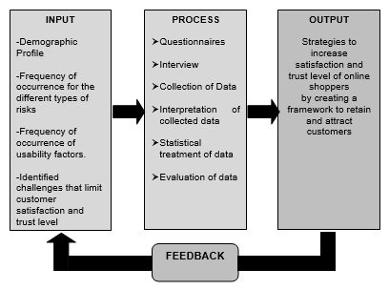

**Figure 1. Paradigm of the Study**

The Figure illustrates the paradigm of the study using the **INPUT-PROCESS-OUTPUT** model.

The first box, labelled INPUT, had a Demographic Profile, occurrence rates for various risk kinds, occurrence rates for usability aspects, and obstacles that are known to lower consumer happiness and confidence levels. The intervening variable was contained in the second box, which was designated PROCESS. It includes of questionnaires, interviews, data collection, data interpretation, statistical processing of the data, and data evaluation. The OUPUT, or result, is displayed in the third box. By developing a framework that can be used to both retain and attract customers, these strategies to raise online shoppers' pleasure and trust level make up the independent variable. The FEEDBACK, or data on responses to the guide, is contained in the little box at the bottom and was created to serve as a foundation for improvement.

**METHODOLOGY**

As the primary data source for this study, questionnaires were used in the descriptive method of research. This approach was chosen because the researcher thought it provided a comprehensive analysis and report on the creation of strategies that would raise user satisfaction and trust levels in online shopping.

**Respondents of the Study**

The 102 online shoppers who participated in this study represented a variety of industries and age groups as respondents. The researcher is confident that the respondents provided the trustworthy and important data required for this study. These respondents were chosen at random from the businessmen, working professionals, private employees, students, and unemployed groups.

Age, gender, and type of work were used to categorize the respondents' profiles. The age range of the study's target population was the 16 and older group, primarily because this age range corresponds to the Philippines' legal age of consent. The breakdowns of the respondents by age level are shown in the tables below.

Majority of the customers are young people or in their 30s. This indicates that younger generations or young professionals continue to favor online shopping, particularly during pandemics. The age groups of 31–40 and 41–50 are still viable markets for online retailers, as these consumers are beginning to understand the advantages of doing business online for more than just shopping. However, the adult market, or people aged 40 and over, also accounts for 19 percent of total sales.

**Data Gathering Instruments**

The researcher combed through various works of literature and studies pertinent to the study as she prepared the instrument. The identified studies and writings served as the foundation for efficiently creating and drafting the instrument. Then, the researcher used the following tools to collect the necessary data:

**Documentary analysis.** The researcher made use of many related literature and study that contributed to the analysis of the data gathered from other research instruments.

**Questionnaire.** The survey questionnaire is the tool the researcher uses to gather data. It aims to determine how frequently various risks—including financial risk, product risk, convenience risk, non-delivery risk, safety and security risk, and usability factors in electronic shopping—occur. It also aims to pinpoint the issues limiting customers' satisfaction and trust in online shopping services. To create guidelines to raise customer satisfaction and trust levels, the information gathered from the respondents was analyzed, arranged, and interpreted.

**Interview.** In order to supplement the questionnaire responses and learn more about the participants' thinking, the researcher conducted an unstructured interview. This was done informally and personally to supplement the interviewees' questionnaire responses and shed some light on some topics they hadn't quite addressed. The interview was conducted as a methodical way of speaking and listening to the respondents and as an additional way to gather information from them orally. Data was gathered from the interviewee using open-ended questions from the researcher. The researcher must keep in mind the interviewer's opinions regarding the dangers of online shopping because they are crucial. The respondents were regarded as the study's primary data because speaking with them is a way to gather data and learn about them, particularly regarding their perceptions of the risk involved that limits customer satisfaction levels.

**RESULTS**

**Objective 2. On the how often do online shoppers encounter the risks and difficulty in website services as to the given factors**

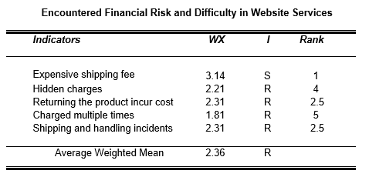

As illustrated on the table, "Expensive shipping fee" is Rank 1 and has a weighted mean of 3.14, which is verbally equivalent to "Sometimes." Once Customers occasionally view it as more financially risky because the greater the distance between them and the seller, the higher the cost of shipping will be. They are aware that the price of the items they are ordering will vary depending on how much they weigh; the heavier the item, the more expensive the shipping will be. Then respondents assert that occasionally the item weights are out of line with the prices they are paying. The prices are not uniform; some items have higher prices than usual due to the packaging rather than the actual value of the products. They also think that shipping will be more expensive the quicker their items are delivered. Unfortunately, that is not always the case since the packages frequently are late arriving but the shipping costs are still very high

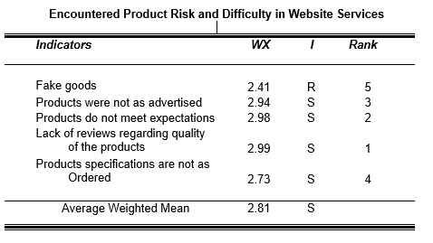

The table shows that "Lack of reviews regarding the quality of the products" is Rank 1 with a weighted mean of 2.99, or verbal interpretation "Sometimes." The respondents are on neutral ground in this situation; they think that neither always nor never happens when it comes to product risk.

Online product reviews, in their opinion, are one of the most beneficial advantages an online store can offer potential customers. This is unfortunate because a large number of retailers do not provide these reviews and do not recognize their value. Website product reviews are directly correlated with online sales. Nowadays, online buyers are hesitant to trust sellers because they worry about receiving a defective item back if their purchase is unsuccessful. Additionally, they are concerned about the price of shipping, credit card fraud, and other potential issues with their purchase.

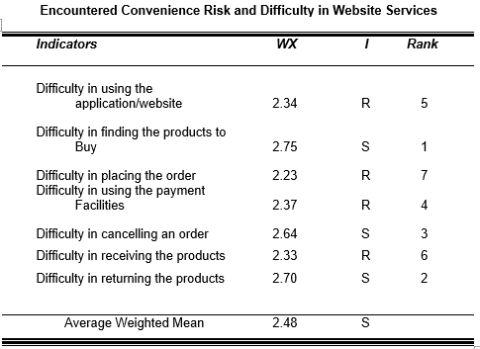

You should be aware that "Difficulty in finding the products to buy" has a weighted mean of 2.75, which is verbally equivalent to "Sometimes."

According to respondents, this convenience risk does not always occur and never occurs, either. Because the respondents think that sellers have a wide range of products to control the market, they occasionally encounter this risk. However, for the buyer, having to pick from a vast array of product lines can be demoralizing. There is a chance that shoppers won't buy anything at all once they are worn out from looking for products. Nowadays, a lot of customers shop online, but they want their purchases quickly. While these customers are drawn to user-friendly websites, they are also easily worn out by frequent site navigation, a lot of options, and pointless information.

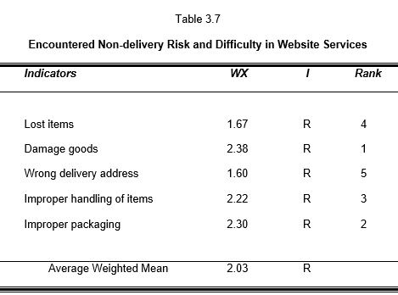

The table provides the weighted mean and respondents' perceptions of how frequently they experience non-delivery risk and difficulty with website services.

The respondents claimed that this risk hardly ever occurs because, firstly, online retailers ensure that their products are delivered to customers in the best condition possible. The table shows that "Damage goods" is ranked first with a weighted mean of 2.38, which is verbally equivalent to "Rarely." They also ensure that the boxes are the appropriate size for the items and can safely protect them during packing. For instance, they use sturdy, insulated boxes for fragile items. Sellers make sizeable investments in premium packaging materials so that customers can feel confident that their packing materials are of acceptable quality, even if they select budget options

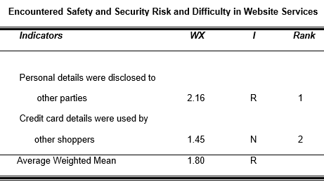

The Table presents the weighted mean and the corresponding perceptions of the respondents on how often they encounter Safety and security risk and difficulty in Website Services.

According to the table, the statement "Personal details were disclosed to other parties" comes in at number one with a weighted mean of 2.16, which is verbally equivalent to "Rarely." According to the respondents, this risk only occasionally materializes or, if it does, the seller wasn't intending for it to. Because it is required by law, data like customer personal information cannot be disclosed to outside parties. The "Data Privacy Act of 2012," also known as Republic Act 10173, now protects private information. Online retailers and businesses are now very cautious when handling their customers' personal information. Customers are also given privacy notices from businesses informing them that the data they provide will only be used for business purposes and won't be shared with third parties. In order to protect their personal information, customers are also being extra cautious when providing it to sellers. This further lowers the risk involved in providing personal information to third parties.

**Objective 3. To find out how frequent the respondents experience usability of the following factors in online shopping**

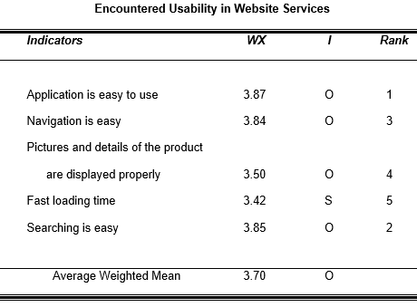

The top ranking statement, "Application is easy to use," has a weighted mean of 3.87, which translates verbally to "Often," as shown in the table. Due to features like recommendations and reviews on some shopping websites, the respondents frequently encounter this usability factor. The app will assist users in their search if they are unsure of which product or brand they will purchase. These user-friendly applications generate suggestions for related products based on an analysis of the browsing patterns and orders of previous customers. There are features for image recognition in some applications. It makes it easier for customers to find products by using images rather than keywords. The app will display the same list of items if you simply take pictures of or upload one of the desired items using this feature

**Objective 4. To determine** **if there is significant difference in the respondents' encounters as to frequency of occurrence for all types of risks across age groups, gender and nature of work groups.**

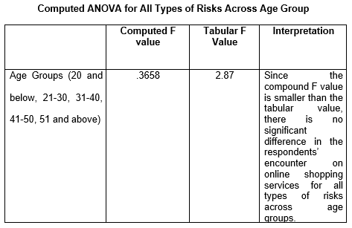

According to the table, the numerator is the degree of freedom (df) between treatments, which is 4, and the denominator is the degree of freedom (df) within treatments, which is 20. The next step is to search for where they intersect. They collide in this instance at 2.87. Next step is to compare the computed F and tabular F. Since the computed F (.3658) is smaller than the Tabulated figure (2.87), this means that the computed value fell inside the acceptable region, and the Null Hypothesis (Ho) will be accepted. Therefore, it can be interpreted that the hypothesis of the study - ***There is no significant difference in the respondents encounter on online shopping services for all types of risks across age groups*** - is accepted as there were no significant difference identified on the evaluation of the respondents from the selected electronic shopping websites. For the full computation of ANOVA, this paper presents in the Appendices the Critical Values of the F distribution (5% level of significance).

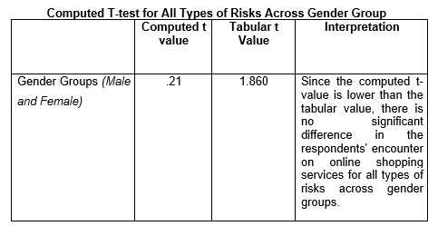

According to the table, the computed degrees of freedom (df), which are 8 in this case, become the denominator and the alpha given (.05) becomes the numerator. The next step is to locate the point where the alpha and df intersect. They collide here at 1.860.

The computed t-statistic and the table's critical value were then put side by side. The null hypothesis (Ho) will be accepted because the computed t (.21) is less than the critical value (1.860). Consequently, it can be inferred that the study's hypothesis ***There is no significant difference in the respondents encounter on online shopping services for all types of risks across gender groups*** - is accepted as there were no significant difference identified on the evaluation of the respondents from the selected electronic shopping websites. For the full computation of T-test, this paper presents in the Appendices the Critical Values of the F distribution (5% level of significance).

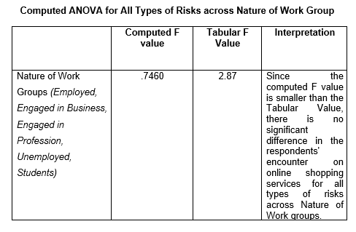

The table contains the tabulated value, which is based on the F Distribution table and has a significance level of 0.05. When using the table, the numerator is the degrees of freedom (df) between treatments (4), and the denominator is the degrees of freedom (df) within treatments (20). The next step is to search for where they intersect. In this instance, they collide at 2.87.

The Next step to be done is to compare the computed F and tabular F. Since the computed F (.7460) is smaller than the Tabulated figure (2.8 7), this means that the computed value fell inside the acceptable region, and the Null Hypothesis (Ho) will be accepted. Therefore, it can be interpreted that the hypothesis of the study - ***There is no significant difference in the respondents encounter on online shopping services for all types of risks across Nature of Work groups*** - is accepted as there were no significant difference identified on the evaluation of the respondents from the selected electronic shopping websites. For the full computation of ANOVA, this paper presents in the Appendices the Critical Values of the F distribution (5% level of significance).

**Objective 5. To identify the challenges that limit the satisfaction and trust level of customer's in online shopping services.**

As shown in the table, every obstacle stands in the way of customers being satisfied with online shopping services. "Expensive shipping fee" is first in Rank 1 with a weighted mean of 3.14. This one impedes a seamless shopping experience, even though respondents who shop online did not always experience it. Internet users pay exorbitant shipping fees, which are occasionally more expensive than the items they order. The truth is that a lot of people prefer to purchase goods from online retailers in the belief that doing so will enable them to save money and avoid standing in lines at physical stores. Additionally, these shops provide customers with a variety of convenient payment options, including bank transfers, electronic wallets, and cash on delivery. Unfortunately, since consumers search for multiple items online rather than just one and because these items come from various merchants, they must pay separate shipping costs for each item they buy.

**Objective 6. To develop strategies that can be employed in electronic shopping services in order to increase satisfaction and trust level of consumers.**

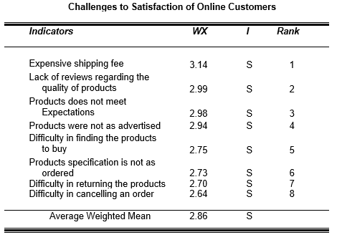

**CJL THEORY OF ELECTRONIC SHOPPING**

**Financial Operation Theory**

The shipping cost ought to be fairly affordable In relation to the item's weight. Instead of the value of the packaging, it ought to be based on the actual value of the items that were purchased. The price should also take delivery time into account; the quicker a product is delivered, the more expensive it becomes.

The customers should be given a refund for the actual amount they paid, and the return policy, including prescription period and official receipts of the store, should be more lenient. The application for a refund also needs to be simplified and made more straightforward.

The damage that occurs while an item is in transit should be paid for by the seller. The website's mobile application should incorporate a tracking system to track the products' condition, where they are, and any potential damage. It is unjust to charge more for same-day delivery because it is biased against those who cannot afford it.

4. More transparency should be practiced by online retailers, and hidden fees should be avoided. Customers should purchase items at the exact price displayed on the price tag in the advertisement. Similar to this, prices should be broken down into their smallest components, and buyers should always be kept informed by prompt posting of updated prices broken down by hour.

5. When it comes to charging customers, online vendors should exercise greater caution. Multiple charging should be avoided. Buyers should only pay for a single delivery fee that has been agreed upon by both parties if there are bulky items and multiple deliveries are required for the various parts. Customers should only receive one bill because this error only occurs with credit card transactions.

**Product Theory:**

1. Online retailers should start online product reviews to boost sales in order to be more competitive in the electronic retail market. Reviews should cover the product's quality, delivery time, shipping costs' veracity, the security of using a credit card for payment, and any other potential issues that buyers may have before making a purchase.

2. Online vendors should always meet the expectations of their customers, be truthful about the goods they are selling, and avoid misleading them.

3. Regarding the prices, colors, sizes, textures, volume, or capacity of the products, there should be truth in advertising. Additionally, it should be properly communicated whether or not there is a free delivery in order to avoid.

4. As directed, product specifications must be followed. It should be guaranteed that potential customers have a reasonable expectation of the appearance or functionality of a product. It is important to adhere to specifications regarding material strength, acceptable standards, construction, composition, ingredients, and physical characteristics.

5. Online retailers should use the most recent technology to track counterfeiters creating illegal brands in order to avoid selling fake goods. To stop these actions, there should be ongoing monitoring and reporting. It is important to involve the consumers by urging them not to purchase imitation goods. Finally, manufacturers should be encouraged to register their products with the appropriate government agencies in order to stop illegal practices and to protect their brands.

**Convenience Theory:**

To prevent users from getting lost while navigating the pages of a website, it should be well-organized and display its products. To prevent customers from becoming worn out while searching for the ideal products, websites should have straightforward yet informative layouts. Because customers now assume that almost any product can be found online, it is best if all products are available on websites.

Electronics retailers should have a definite return policy in place. Transparency is necessary to make things convenient for the customers. Sellers should cover the cost of handling damaged goods while minimizing the chaotic paperwork processes required to process returns.

Although sellers give customers a certain amount of time to return or exchange a product, they shouldn't be overly rigid about it. The "Finding alternatives" stages of the purchase decision process are common for buyers. The process for canceling orders should be made as simple as possible, without requiring the completion of forms, the request of cancellation codes, or agreement to Terms of Agreement.

To increase online payment security and prevent fraudulent transactions, e-commerce companies should fully utilize the most recent technological advancements. For instance, it should now be commonplace to make purchases using gadgets that support biometric identification, fingerprint recognition, and QR Codes.

Due to globalization, customers should be able to pay using their preferred payment method and native currency thanks to the ability to accept a variety of payment methods.

The user-friendliness of online retailers' websites and applications should be a priority. They ought to spend money on IT specialists who make use of tools that track issues as they happen with applications so that they can be fixed immediately. Businesses can offer customers better goods and services as a result of a decrease in web application errors. Additionally, a well-designed online store makes it simple for customers to find what they're looking for and allows them to make decisions quickly. Improve the organization of the websites, add some eye-catching graphics, and perform data analytics that are helpful to the user.

Customers should be able to receive their purchases more easily from online vendors. They should limit deliveries to 2-3 days or same-day delivery, which is still acceptable for most customers. For their orders, they should specify the preferred delivery date and make shipping options available at those times and dates. The respondents will have faith and confidence in the courier to deliver their goods on time if they have received positive reviews for prompt deliveries. They should also collaborate with reputable couriers to handle their logistics.

To make it simpler for customers to navigate the steps, electronic retailers should now redesign the layout of their online stores. Additionally, tickers that keep track of what customers are doing in real time and let them know the status of their orders should be added. Additionally, there are those straightforward applications for receiving orders. Customers value these mobile-friendly apps because they can place orders using any device.

A good tactic is to include a live chat feature in the application. The pop-up window will merely ask, "What would you like to have today?" and use the customers' responses to direct them to the website's or app's recommendation window. Additionally, this feature is available across all platforms, including websites, mobile applications, and social media. They keep the display simple and condensed, only requiring what is necessary for check-out.

**Delivery Theory:**

Customers should receive their purchases from online merchants in the best condition possible. Additionally, those should be properly packed, making sure the boxes are the proper size for the item and that it can be safeguarded. Strong, insulated boxes should be used for fragile items. In order for customers to feel confident that their packing materials are of acceptable quality, even if they choose budget options, sellers should invest in high-quality packing supplies. Additionally, it is crucial for the sellers to work with reputable couriers who have a reputation for being dependable when it comes to handling deliveries of goods.

Now, sellers must use the appropriate size bags, boxes, or envelopes for the items they are shipping. This lowers the cost and lessens the possibility of theft and damage. To fill in the empty spaces and stop the objects from shifting and moving, they should also use fillers like Styrofoam and cardboard. Additionally, it's critical that packages are secure and simple to open. Use shipping containers or envelopes that are punctured for simple opening and have an extra, sealable "flap" so that returned items can be sent back in the same envelope with ease.

To ensure that there is no loose space inside the container that could allow products to move around, online sellers should use slightly larger containers—but not significantly larger—than the contents of their shipment. They make sure that everything is wrapped in cushioning material if the delivery is for a fragile, delicate, or item that is susceptible to spilling, breaking, or exploding.

Additionally, sellers should perform test deliveries with the couriers to see if they can deliver packages in perfect condition. To ensure they do not miss the label, stickers are now being used on every side of the box.

Online stores should offer "click and collect," also known as in-store pickup. Customers will be able to support local businesses by using this method. It allows local merchants to maintain direct contact with their customers. This eliminates the possibility of a package being lost in transit. It will also allow merchants to arrange delivery themselves rather than relying on a third-party courier. This should be used by online stores that do not have a physical storefront, as well as brands that want to retain employees by using them as delivery personnel. Package insurance for goods to be delivered should also be added by stores. They should bear the cost of the insurance, which may lead to repeat purchases and customer loyalty.

Sellers should only ship to the address provided by the customer, so that the package can be tracked. Customers can provide the tracking number if the package has not yet been delivered or if there is a significant delay. Furthermore, sellers should have contact support that responds to emails regarding incorrect delivery.

**Safety and Security Theory:**

Customers' personal information, for example, should not be disclosed to third parties unless required by law. The Data Privacy Act now protects private information. Customers' information should now be handled with extreme caution by online sellers or businesses. They should provide a privacy notice stating that the information gathered from them will be used for business purposes only and will not be shared with others.

Customers should be advised to sign up for an identity theft protection service by sellers. It safeguards cardholders against identity theft and notifies them if there are data breaches or misuse of their card number or social security number. They should conduct a simple online search for the seller and read customer reviews to ensure that they can proceed with a specific transaction. Customers should learn how to avoid using public WiFi networks, as these networks are not secure. When one makes purchases on public WiFi, it makes it easier for fraudsters to hack any device.

**Usability Theory:**

The sellers' application or website should aid shoppers in their product search. These user-friendly applications should analyze previous shoppers' browsing history and orders to make recommendations for similar items. Image recognition capabilities should also be included in applications. It will allow customers to search for products using images rather than keywords. This feature can also simply take pictures or upload one of the desired items, and the app will display a list of the same items.

Customers should also be able to share the content on their social media accounts. It will satiate their desire to connect with others while also keeping them more engaged in the app. Chatbots can also be used to provide recommendations to customers and improve customer service. Many customers are enticed to interact with chatbots because they receive immediate responses to their inquiries.

Online sites should include a search box to aid in search functions. It should be placed in the website's header for easy visibility. Color is also important for making it stand out and easier to find. Furthermore, these search boxes should have an auto-complete feature, which allows the search box to guess what a shopper is looking for. Online stores should also categorize their products so that customers can easily search within a category to find relevant results.

Filtering can be used to narrow down the selection by selecting a product category. This still broad category may be listed with sub-categories to choose from. As a result, the more a shopper can narrow his search, the more likely he is to find something he wants to buy.

Sites should also include a "quick view" feature, which allows shoppers to quickly see the basic details of a product they are interested in without leaving the search page. A shopper should even watch a video about the product, choose a size, and add it to his cart.

There should be options for determining how out-of-stock products appear. This design indicates on the results page that the product is currently unavailable for purchase.

The online store websites should be simple to use. As a shopper types in the search box, it should make suggestions, displaying a list of products it believes the shopper is looking for. Website developers should make it a standard that the minimum text size on websites is 12 pixels in order to make it easy to read, and they should test its legibility on all types of mobile devices.

They also ensure that navigation is divided into distinct categories, with only the most important links appearing in the main menu. When a shopping website has a large number of pages, they use second-level or third-level dropdown menus.

The colors used for the navigation menu should contrast. The text should be dark on a light background or light on a dark background.

Customers can interact with websites in a variety of ways. Shoppers, for example, want a prominent, clearly labeled menu on the top or side of the page to be merged in the applications. It also helps that they make a few things stand out, such as putting text inside a box, such as "Search Here," or a moving icon of a magnifying glass. These assist site visitors in determining that it is a search bar and not just a decoration. It can also draw attention to the search bar by making it a different color than the background color of the site.

Sitemaps should always be available to direct users to the most important parts of the website. It aids navigation by making it simple for search engine users to find pages on a website.

Online sellers should ensure that the quality of product images is the most important feature in online shopping. They should ensure that the product images on their websites are the correct size in order to achieve high resolution images of high quality. Product images should have a high pixel count in order to use zoom functionality and be accepted by all major online marketplaces. Prospective customers must be able to zoom in on the images to see the products they want to purchase.

The same arrangement and white margin on product images should be used, resulting in prominent and consistent product category pages. This frequently leads to a better shopping experience. Shadows can also have an impact on product images because a poorly lit image can cast unappealing shadows on the product.

Websites should also have a simple background. This simple white background is appropriate and allows the same product images to be used in multiple online marketplaces. They should ensure that images depict the correct color in order to convey to customers exactly what they will receive from the store while also reducing product returns.

Size, features, shape, and other product details should be clearly outlined in one section, with suggestions for how customers can use them.

The speed of their landing page should be a primary concern, and they should be ahead of their competitors. Retailers should invest their resources to ensure that their web and mobile pages load are high-speed. Websites that can display their content to shoppers in under 3 seconds have a better chance of attracting potential customers and keeping them on the page for the duration. They should use online resources to optimize their websites and increase load speed.

Customers should be treated similarly by online sellers. These customers have the same response to the frequency of encounters with financial risks, product risk, convenience risk, non-delivery risk, and safety and security risk regardless of age, gender, or work group.

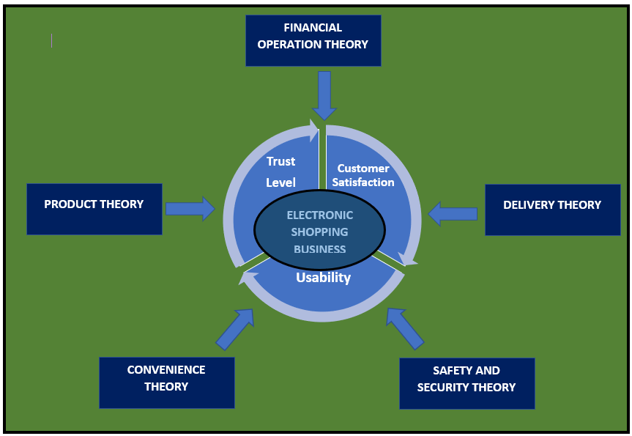

**Figure 2.** CJL Theory of electronic Shopping

**Findings**

This study was carried out in order to develop a guide that can be used to improve strategies that can be used in electronic shopping services in order to increase consumer satisfaction and trust. The descriptive method of research was used, as well as the survey technique. The questionnaire and structured and unstructured interviews, which were used at random to elicit additional insights from respondents, were the primary data collection tools.

The selected respondents from Metro Manila evaluated all of the indicators. Because of some restrictions and limitations, the questionnaires were distributed online via a survey platform. The questionnaire responses were supplemented with interviews conducted via phone calls, video calls, and messenger chat. The researcher arrived at the following conclusions based on the data gathered.

There were 37 respondents or 36% who belongs to the 21-30 age bracket, 28 respondents or 27% are aged 20 and below, 18 respondents or 18% are aged 31-40, 16 respondents or 16% who are aged 41-50, and 3 respondents or 3% who belong to the 51 and above bracket. There were 71 respondents or 70% who were female, and 31 respondents or 30% were male.

There were 46 respondents or 45% who were employed, 26 respondents or 25% who were students, 15 respondents or 15% were unemployed, 10 respondents or 10% are engaged in business, and 5 respondents or 5% are engaged in profession.

The first Three (3) in rank were: **a**. “Expensive shipping fee” with weighted a mean of 3.14 and is equivalent to verbal interpretation “Sometimes”, **b**. “Returning the product incur cost” with a weighted mean of 2.31 and is equivalent to “Rarely”, and **c**. “Shipping and handling incidents” with a weighted mean of 2.31 and is also equivalent to “Rarely”.

The first Three (3) in rank were: **a**. “Lack of reviews regarding quality of the products” with a weighted mean of 2.99 and is equivalent to verbal interpretation “Sometimes”, **b**. “Products do not meet expectations” with a weighted mean of 2.98 and is equivalent to “Sometimes”, and **c**. “Products were not as advertised” with weighted mean of 2.94 and is also equivalent to “Sometimes”.

The first Three (3) in rank were: **a**. “Difficulty in finding the products to Buy” with weighted mean of 2.75 and is equivalent to verbal interpretation of “Sometimes”, **b**. “Difficulty in returning the products” with weighted mean of 2.70 and is equivalent to “Sometimes”, and **c**. “Difficulty in cancelling an order” with weighted mean of 2.64 and is also equivalent to “Sometimes”.

The first Three (3) in rank were: **a**. “Damage goods” with a weighted mean of 2.38 and is equivalent to verbal interpretation of “Rarely”, **b**. “Improper packaging” with a weighted mean of 2.30 and is equivalent to “Rarely”, and **c**. “Improper handling of items” with weighted mean of 2.22 and is also equivalent to “Rarely”.

The two (2) factors encountered by the respondents were: **a**. “Personal details were disclosed to other parties” with a weighted mean of 2.16 and is equivalent to verbal interpretation of “Rarely”, and **b**. “Credit card details were used by other shoppers” with a weighted mean of 1.45 and is equivalent to verbal interpretation of “Never”.

The first Three (3) in rank were: **a**. “Application is easy to use” with a weighted mean of 3.87 and is equivalent to verbal of interpretation “Often”, **b**. “Searching is easy” with a weighted mean of 3.85 and is equivalent to “Often”, and **c**. “Navigation is easy” with a weighted mean of 3.84 and is also equivalent to “Often”.

There was no significant difference in the encounter of the different types of risks across age group. There was no significant difference in the encounter of the different types of risks across gender group. There was no significant difference in the encounter of the different types of risks across nature of work group.

The first Three (3) in rank were: **a**. “Expensive shipping fee” with a weighted mean of 3.14 and is equivalent to verbal interpretation of “Sometimes”, **b**. “Lack of reviews regarding the quality of products” with a weighted mean of 2.99 and is equivalent to “Sometimes”, and **c**. “Products do not meet expectations” with a weighted mean of 2.98 and is also equivalent to “Sometimes”.

The researcher was able to generate strategies based on the frequency of the different types of risk samples, on the usability attributes, and on the supplemental interview of the respondents. The strategies as a whole is exhibited in the appendix section of this paper.

**DISCUSSION**

**Conclusions**

Starting an electronic shopping business is unquestionably a wise investment for aspiring entrepreneurs. Clothing boutiques, beauty products, food delivery services, household goods stores, electronics stores, and so on are examples of these types of businesses. The important thing for businessmen to know is how to satisfy online customers by understanding the various factors that should be provided, as well as those that should not be done, in order to have a great online shopping experience.

The following conclusions are drawn based on the summary of findings from the data collected:

The age of the customer respondent of the electronic shopping business can be described. The majority of respondents were between the ages of 21 and 30. The majority of those who responded were in their twenties or younger. Even during this pandemic, the younger generation or young professionals preferred to shop online. Customers in the 31-40 and 41-50 age groups have been learning about the benefits of transacting online, so online sellers can continue to market to them. Nonetheless, adult customers (those aged 40 and up) account for 19% of all customers.

Gender can be used to categorize customer responses in the electronic shopping business. The majority of respondents are between the ages of 21 and 30. Female customers were increasingly using online shopping services offered by various websites. They were the most frequent visitors to online shopping websites in search of their requirements.

The customer respondents of electronic shopping business may be described as to nature of work. More employed groups are involved in electronic or online shopping because their dispensable income is greater than the other group. Working individuals are also more inclined to spend on online shopping because of the influence of their peers

The most often encountered financial risk was that shipping fees were expensive. Sometimes the weight of the items was not appropriate to the prices that they are paying. The prices were not uniform, there were items that priced higher than normal because of the packaging, and not because of the actual value of the items. It will result to customers having second thought on buying on line.

Online shoppers sometimes were worried about defective products, about shipping costs, credit card fraud and other problems that gave arise associated with their purchase. If there are no product reviews, it is risky because shoppers want to know what other shoppers are saying about a particular product when it comes to usability, quality, and application This is information is important for purchasing decision. Customers will change vendor if no product review done.

The risk of Difficulty in finding the products sometimes happens because it is exhausting to look among a huge number of product lines. It will result to customers not buying at all anymore. Consumers go to online stores to buy but they want to have the product fast. While they are attracted to customer-friendly sites, they are also easily get tired by constant site navigations, large number of options and useless details. A large number of potential sales will be lost because the shoppers cannot find what they are looking for.

The risk of damaged goods rarely happened because sellers ensured that the products were delivered to their customers in the best possible state. They were packed properly at the right size and protected safely. Sellers were investing on good packing materials. This reduced the chance of the items being damaged while on board. Likely, this resulted to more customers patronizing the business.

Disclosing of personal details to other parties rarely happened. The data such as personal details of the customers cannot be disclosed to outside parties because it is mandated by law. It results to more trustworthy transactions on the part of the sellers.

The respondents often experienced this usability factor because some shopping sites have recommendations and reviews features. Shoppers want applications that have options their apps to have an option to share the content on their social media accounts. It resulted to smooth navigation on the part of online shoppers.

All online shoppers when grouped according to age have the same frequency of encounter for all types of risks. All of them have rarely experienced those risks on their electronic shopping.

The online shoppers when grouped according to gender have the same frequency of encounter for all types of risks. All of them have rarely experienced those risks on their electronic shopping. All online shoppers when grouped according to nature of work have the same frequency of encounter on all types of risks. All of them have rarely experienced those risks on their electronic shopping. The expensive shipping fees imposed by online sellers was the primary reason why the customers are not satisfied in their shopping. Customers had lesser trust to the sellers, thinking that they were just after the profit and not on customer satisfaction.

The response of the respondents on the frequency of encounters, the frequency of the usability attributes and the result of the interview serve as a basis on developing strategies to increase customer satisfaction and trust level in electronic shopping.

**Recommendations**

According to the findings and conclusions, respondents prefer to increase their satisfaction and trust level in online shopping. These preferences have varying degrees of influence on the marketability of online businesses. Some recommendations were made in this agreement to improve operations and, eventually, to make online businesses more marketable. The following were the recommendations:

Younger generations of shoppers may be encouraged to continue shopping online. However, more older people, particularly those in their forties and fifties, may be motivated to participate. They may also be motivated to learn how to use and appreciate online shopping websites and applications.

Female customers may continue to use online shipping services. Their male counterparts, on the other hand, may be encouraged to use online shopping platforms more.

The other nature of work groups, particularly businessmen and those engaged in profession, may use online platforms more frequently to shop for the products that they require.

Online sellers can reduce the price of their products in a variety of ways. Prices should be consistent across the same product line and should be based on the actual weight, size, or value of the items rather than on packaging alone.

Electronic shopping website operators may include product reviews about the price, quality, authenticity of the website, availability of products, delivery, and return policy to assist customers in making purchasing decisions.

Online sellers can simplify the layout of their products on their websites for easy identification and location. They may also remove unnecessary details and specifications and only display the essentials. Online product support may also be used to assist customers.

Sellers may continue to provide products in the best condition possible. Pack them in appropriate protective containers and continue to invest in novel packaging materials.

Businesses can continue to assure their customers that their personal information will not be shared with third parties. Similarly, they may continue to educate themselves on how to avoid identity theft and invasion of privacy.

The sellers' application may be continuously upgraded, and they may always look for new ways to make it more interactive and user-friendly, resulting in a competitive advantage and customer loyalty.

Customers of any age can have their problems addressed by online sellers. They may continue to maintain the goal that these customers will rarely encounter all types of risks.

Sellers need only maintain the frequency of occurrence for all types of risks, regardless of whether the customers are male or female. It would be preferable if they could reduce the frequency to "Never."

Online sellers may only be able to sustain the frequency of occurrence for all types of risks across all work groups, namely employed businessmen, professionals, unemployed, and students. It would be far preferable if they could completely eliminate the occurrence of all risks.

Because expensive shipping fees are the main source of customer dissatisfaction and distrust, sellers may learn how to reduce their costs in order to eventually lower their price. They may meet with their courier partners to discuss this matter.

The sellers may utilize the guidelines or strategies created through the response and interview with the respondents. This may be implemented to enhance the existing policies of electronic shopping businesses towards marketability.

Future researchers may look into areas not covered in the study, such as profitability, liquidity, and online business growth.

**REFERENCES**

A. Books

Ethridge, D. E. (2004). *Research Methodology in Applied Economics*. John Wiley & Sons.

Evans, N, Bosua, R. (2017). Exploring innovation in regional manufacturing SMEs: Small Enterprise Research

Fox, W. & Bayat, M. S. (2017). *A Guide to Managing Research*. Cape Town

. Published and Unpublished Studies

Aziz, N.N.A., Wahid, N.A.(2018). Why Consumers are Hesitant to Shop Online: The Major Concerns towards Online Shopping. . *International Journal of Academic Research in Business and Social Sciences,*

Aziz, N. N. A., & Wahid, N. A. (2017). Understanding Customer Behaviour Towards Online Shopping. *In 2nd Business Management and Computing Research Colloquium* (pp.164-168). http://dx.doi.org/10.6007/IJARBSS/v8-9/4689

Aziz, N. N. A., & Wahid, N. A. (2018). Factors influencing online purchase intention among university students. *International Journal of Academic Research in Business and Social Sciences,* 8(7), 702– 717.

Amoroso, D. L., & Lim, R. A. (2015). Exploring the Personal Innovativeness Construct: The Roles of Ease of Use, Satisfaction and Attitudes. *Asia Pacific Journal of Information Systems*, 25(4), 662– 685. https://doi.org/10.14329/apjis.2015.25.4.662

Bilgihan, A. (2016). Gen Y customer loyalty in online shopping: An integrated model of trust, user experience and branding. Computers in Human Behavior, 61, 103–113.

Chakraborty, R., Lee, J., Bagchi-Sen, S., Upadhyaya, S., & Raghav Rao, H. (2016). Online shopping intention in the context of data breach in online retail stores: An examination of older and younger adults. Decision Support Systems, 83, 47–56.

Cheema, Umair, Rizwan,M.R., Durrani, J.F (2016). The trend of online shopping in 21st century: impact of enjoyment in tam model. *Asian Journal of Empirical Research 3(2):131-141*. http://aessweb.com/journal- detail.php?id=5004.

Dhiranty, A., Suharjo, B., & Suprayitno, G. (2017). An Analysis on Customer Satisfaction, Trust and Loyalty Toward Online Shop (A case study Of okopedia.com). *Indonesian Journal of Business and Entrepreneurship*, 3(2), 101–110. https://doi.org/10.17358/IJBE.3.2.101

Faqih, K. M. S. (2016). An empirical analysis of factors predicting the behavioral intention to adopt Internet shopping technology among non-shoppers in a developing country context: Does gender matter? Journal of Retailing and Consumer Services, 30, 140–164

Gnanadhas, M.E., Sunitha, C.K (2016). Online Shopping: A Overview. <https://www.researchgate.net/publication/264556861_Online_Shopping_-> _An_Overview/link/53e782fc0cf25d674ea59e7e/download.

Jayasubramanian, P., Sivasakthi, D., (2015). A Study on Customer Satisfaction Toward Online Shopping. *International Journal of Applied Research*, 5, 489–495.

Kartiwi, M., Hussin, H. (2018). Impact of external factors on determining E-commerce benefits among SMEs in Malaysia

Katawetawaraks, C.,Wang, Chang Lu (2015). Online Shopper Behavior: Influences of Online Shopping Decision*. Asian Journal of Business Research Volume 1 Number 2.* <https://swsu.ru/sbornik-> statey/pdf/Online%20Shopper%20Behavior%20Influences.pdf

Koch, Julia, Frommeyer, Britta., Schewe, Gerhard (2020). Online Shopping Motives during the COVID-19 Pandemic—Lessons from the Crisis. *Center for Management of Muenster University.* https://www.mdpi.com/2071-1050/12/24/10247/pdf

Moon, N., Sultana, S., Nur, F.N., Saifuzzaman, M. (2017) .A Literature Review of the Trend of Electronic Commerce in Bangladesh Perspective.

Nguyen, H. T. (2014). Factors affecting customer satisfaction and trust in an e-commerce setting: A case study of Muachung.vn in Vietnam. *AU-GSB e-Journal*, 7(1), 43–52. <http://www.assumptionjournal.au.edu/index.php/AU-> GSB/article/view/446

Forsythe, S.M. and Shi, B. (2013). Consumer Patronage and Risk Perceptions in Internet Shopping. *Journal of Business Research, 56, 867–875*.

Rabo, J.,Ang, M.l (2018). Determinants of Customer Satisfaction in a Philippine Retail Chain. DLSU Research Congress Journal. <https://www.dlsu.edu.ph/wp-content/uploads/pdf/conferences/research-> congress-proceedings/2018/ebm-13.pdf

Shanthi, R., Kannaiah, Desti (2016) Consumers’ Perception on Online Shopping.  *Journal of Marketing and Consumer Research* [*www.iiste.org*](http://www.iiste.org) *ISSN 2422-8451 An International Peer-reviewed Journal Vol.13, 2015*

<https://researchonline.jcu.edu.au/39753/1/Dr.%20Desti%20Consumers%20percep>

tion%20on%20Online%20Shopping.pdf

# Shergill, Gurvinder S.(2015). Web-based shopping: Consumers' attitudes towards online shopping in New Zealand. *Journal of Electronic* Commerce Research.

<https://www.researchgate.net/publication/228620838>

Tabaei, Z., Fathian, M., & Gholamian, M. R. (2011). Effective Factors on Electronic Customers Satisfaction. *3rd International Conference on Information and Financial Engineering Journal*, 12, 579–582.

Tagam, R. G., Fini, L., Toling, R. E., & Veri, M. G. C. (2016). *Consumer Perception and Purchase Behavior on Online Shopping Among Students in Mindanao University* .October, 0–14. https://doi.org/10.13140/RG.2.2.23011.35362

Todd, Peter A.,Jaryenpaa, Sirrka L., (2015). Consumer Reactions to Electronic Shopping on the World Wide Web. *International Journal of Electronic Commerce Volume 1, 1996 - Issue 2.*

https://www.tandfonline.com/doi/abs/10.1080/10864415.1996.11518283

C. Online Articles

Batongbakal, Luisito Jr.(2021, April 17). How to Use GCash: *A Complete Beginner’s Guide.* https://filipiknow.net/how-to-use-gcash/#What_is_GCash

Bringula, Rex P. (2016). *Reasons for Non-Engagement in Online Shopping : Evidence from the Philippines.* 12(2), 17–30. https://doi.org/10.4018/IJEBR.2016040102

Bringula, Rex Perez. (2016). *Taxonomy of Factors Influencing Non-Use of Online Shopping of Students. Modern Applied Science*, 10(4), 119. <https://doi.org/10.5539/mas.v10n4p119>

Campbell, Patrick (2021, April 18). Importance of pricing: why pricing is important for saas and beyond. https://www.priceintelligently.com/blog/bid/157964/two-reasons-why-

pricing-is-the-most-important-aspect-of-your-business

Caramela, Sammi ( 2021, May 1*). Elevating Expectations: 6 Ways Product Quality Affects Your Brand.* <https://www.business.com/articles/5-reasons->why-product-quality-matters/

Darji, Prachi ( 2021, May 18). *5 Most Common Problems faced by Consumers while Shopping Online.* <https://www.myadvo.in/blog/5-most-common->problems-faced-by-consumers-while-shopping-online

Devanesan, Joe (2021, April 21). *The Philippines is going cashless.* <https://techwireasia.com/2020/07/digital-payments-are-finally-soaring-in->the-philippines/

Dungo, Fehl (2021, May 12). *Best Online Shopping Sites in the Philippines You Must Visit in 2021*. <https://philpad.com/online-shopping-sites-philippines/>

Jain, Anamika S. (2021, April). *Top 10 Benefits and Disadvantages of Online Shopping.* <https://toughnickel.com/frugal-living/Online-shopping-sites->benefits#:~:text=Better%20prices.,coupons%20and%20rebates%2C%20as%20well

Hargrave, Marshall (2021, March). Electronic Retailing (E-tailing). https://www.investopedia.com/terms/e/electronic-retailing-e-tailing.asp

Hunt, Tian (2021) 5 Creative Advertising Trends Seen in 2021 . <Https://www.outbrain.com/blog/creative-advertising-trends/>

Lufkin, Bryan (2020) *The curious origins of online shopping.*  <https://www.bbc.com/worklife/article/20200722-the-curious-origins-of->

online-shopping

Mittal, Tarun ( 2021, April 20). *Common problems faced by customers while shopping online*. https://yourstory.com/2017/04/common-problems-online- shopping

Musa, H., Mohamad, M. A., Khalid, F. A., Rahim, N. A., Najihah, N., Zamri, A., Fakulti, Teknologi, P., & Teknousahawanan, D. (2015). *Factors Affecting Customer Satisfaction towards Online Shopping*. 1–17.

Purthi, C. D., & Gupta, P. (2017). *The Impact of Online Shopping on Customer Satisfaction in Mr . Chander Deep Purthi* , ( research scholar ). 5(5), 1–11.

Tram, Ngoc (2021, May 18). *Shopping Online: Common Problems Faced By Customers.* https://www.magesolution.com/blog/shopping-online- problems-customers-faced/

Yen, Nguyen (2021, April 11). *Buying things on the Internet.*  <https://ieltsonlinetests.com/writing-correction/buying-things-internet->corrected-essay

*Online Shopping – Definition and Meaning*. Market Business News <https://marketbusinessnews.com/financial-glossary/online-shopping->definition-meaning/

*What is Customer Satisfaction*. Learn About Quality. <https://asq.org/quality-> resources/customer-satisfaction

*Ecommerce Trends That Are Powering Online Retail* (2021). Forwardhttps://www.bigcommerce.com/articles/ecommerce/ecommerce- trends/

<https://www.investopedia.com/terms/s/stakeholder.asp> https://www.investopedia.com/terms/a/anova.asp