Performance Improvement in Generating Vendor Rate Analysis Report by Visual Basic for Applications (VBA): A Case Study of Footwear Industry
Tanveer Sarwar Malik
Executive Officer (Planning & Costing)
Starlet Shoes Private Limited, Lahore, Punjab, Pakistan

Muhammad Ahmed Kalwar
Post Graduate Alumini (MUET) & Assistant Manager Production
Shafi Private Limited, Lahore, Punjab, Pakistan
*kalwaramuhammadahmed@gmail.com

Muhammad Ali Khan
Post Graduate Student & Assistant Professor
Department of Industrial Engineering & Management
Mehran UET, Jamshoro, 76062,Sindh, Pakistan
muhammad.nagar@faculty.muet.edu.pk

Shakeel Ahmed Shaikh
Associate Professor & Co-director (Post Graduate Studies)
Department of Industrial Engineering & Management
Mehran UET, Jamshoro, 76062, Sindh, Pakistan
shakeel.shaikh@faculty.muet.edu.pk

Abstract
The purpose of the research initially was to optimize the vendor analysis report by automation in order to minimize the non-value added reporting time and to minimize the repeated reporting mistakes. All the manual steps of the report were learnt by the authors and they were translated by the help of visual basic for applications (VBA) in excel. The code was compiled and executed in the form of macros called at the back end of command buttons attached on the userform. Time study before and after automation of the report was conducted to reveal the effectiveness of the automated method.The comparison of total time of making the report indicated that the automated method took 88.56% less time in the comparison of old (manual) method of making vendor rate analysis report.Automated systems have always been time saving and productive especially in the computerized work. In the various industrial sectors, employees are hired to prepare the reports for top management for the analysis of various parameters of business. Since, the manual work takes time and there is the greater possibility of error in it. In that scenario, in order to minimize the non-value added time and increase the accuracy, automation is supremely considered.The mechanism of automated report formation can be incorporated in Microsoft Dynamics AX 2012 which is already implemented there; thus authors of this paper suggest that it should be implemented in AX ERP because excel automation is not the permanent solution.Since, automation by excel macros is the not the permanent solution, this is because it was the major limitation of carried out research.Tremendous amount to work has been done on the use of VBA and many researchers have used this for number of problems in excel, word, MS project and Auto-CAD. It was never been used for the report automation in MS excel. In the present research, it was used for the automation in such a way that user needs to do nothing but few clicks to complete the report in few seconds. Research gap of present research is enough to be reflected from the presented VBA code and purpose of report automation.
Keywords:Automation; visual basic for applications (VBA); macro; excel.

Introduction
Procurement and purchasing one of the main measures of supply chain (Sarkis and Srinivas Talluri 2002). Most important part of the final cost of any product is determined by the procurement cost; this is because, long-term company`s visibility is determined by the selection of vendors (Gallego 2011). Nowadays, in such a interrelated and competitive business environment, companies are dealing with the effective decision making in the context of business partner`s selection (Imeri et al. 2014).
Many international companies have increased their level of outsourcing and begun to rely more on their supply chain network as a foundation of competitive advantage(Lammi 2015). The difference of the new approaches is to apply a policy of using a single supplier (or a few), for a relatively long term, with agreement of continuous improvement and to maintain this relationship as long as there are no problems in the relationship with the supplier(Gallego 2011). The study depicted that quality and cost factors for supplier evaluation are insignificant. The delivery and supplier relationship management have significant influence on evaluation of the supplier. The research also depicted that supplier evaluation has significant influence on process improvement (Shiva Prasad et al. 2016). Suppliers are important to buying firms not only in financial terms but also to an increasing extent, they provide customers with access to technologies(Brusoni, Prencipe, and Keith 2001). Supplier performance has thus substantial impacts on the efficiency and effectiveness of their customers(Fredriksson and Araujo 2003).Over time a number of complementary dimensions have been proposed, but in practice the majority of supplier evaluations comprised just three factors: price/cost, quality, and delivery(Fredriksson and Araujo 2003; Imeri et al. 2014).
Visual Basic for Application VBA is the Microsoft’s programming language used in MS excel for the automating process of manual operation. In excel it performs calculations with 100% accuracy in less time. (Abidin et al. 2015). Generally VBA can be used for mathematical calculations like making variables, dealing with diverse equations and producing results (Bernard, Dwi Minarti, and Hutajulu 2018)(Norton and Tiwari 2013). It is also called a macro programming. Macro is the group of instructions by assistance of which complex user determined operations are automated in MS office environment (DING et al. 2017). When VBA in MS office is used to program applications, it involves no or very little cost. Moreover, accuracy in complex analysis also increases. In fact less skilled employee can set off such applications and can get precise results with increased efficiency (Blayney and Sun 2019). After macros are programmed in excel they can be run just in one click of the button .By using VBA user can initiate user-defined functions and automate all spreadsheet tasks.(Abraham and Corporation 2008). As compared to spreadsheet environment and excel formulae Visual basic editor (VB) and VBA are different (Abraham and Corporation 2008). The benefits of VBA in excel are automates repetitive and routine tasks, accessibility to other users, reduces the turnaround time, reduces the formulas burden used in excel reports protects workbook and hide worksheets. (Bernard et al. 2018). Microsoft has given the facility of VBA into its numerous office applications that is word, excel, access and PowerPoint. In the industrial world, Microsoft excel is classified as the most acceptable application as the worth for spreadsheets and at the mean time the application of VBA can also be used in the rooted (Cirujano and Zhu 2013). Current research paper presents the automation of material delivery time analysis report by using VBA in excel. Here by the administration of ABC Footwear Company thought to automate some of office work in MS excel because of substantial workload of manual work at the purchase department of ABC Footwear Company. In this regard extra time will be given to employees for relaxation and learning other activities. At the mean time the mistakes were also focused to be reduced from the calculations of the report. With respect to that material delivery time analysis report was automated by using VBA in excel.

Literature review
According to the needs of the purchase department of the ABC Company, plan and formulae were kept to be the same but the manual operations from the report were totally removed. As in apropos of VBA, literature was reviewed in the context of automation in MS excel. A research was conducted by Kalwar and Khan (2020) in which acquisition report and purchase order were automated by the help of VBA in excel. Instead of 2097 seconds both request took only 520 seconds after the automation. By using VBA in excel ZainulAbidin et al., (2015) summarized Air Pollution Index (API) and Water Quality Index (WQI). VBA program was used with converted formulae and the application was programmed for calculating the indices. In order to to climax the value of index coded details of the index was calculated by itself shown along with it. Ahmadi et al., (2018) accomplish as a Dairy model by using VBA in excel. The execution of the CTR Dairy Model was carried out in research by using VBA by Ahmadi et al., (2018). CTR dairy is a effective simulation model for grazing lactating dairy cows that is used to forecast the overall milk production and profits on numerous framework like under the irregular schedules of feeding the ruminaldigestion it is used for the absorption of the nutrients. In the last few years, spontaneous driving came on the surface before the government and general masses(Kalwar et al. 2020)(Khaskheli et al. 2018). To transform input in to output, the CTR dairy model was translated into excel VBA because pf infrequent clients and discontinuation of SMART software. By this research it was turned into accessible to the broad range of farmers, researchers and advisors, dairy nutrition consultants (Ahmadi et al. 2018). With the help of excel VBA Junior et al., (2011) made the result of Leak Analysis Program 5 (RELAP5) and Reactor Excursion through post-processing developed - . It was highlighted to be significant to pace up output data analysis(Belchior Junior et al. 2011). By using excel VBA Rushit Hila (2009) programmed to identify outliers in the data and arrangement of data by itself. For substantiating data and cleaning it before importing it into Microsoft access(used as database) various steps were automated (Hila 2009) By using VBA excel a new method was developed l in order to create manpower planning report automatically Ciruja and Zhu (2013). According to new method roles, assignments and schedules of the engineers for various projects were collected. After that collected information was examine, assemble and sort out. The method ensured its significance by getting validated in consulting firm with more than hundred employees. It highlighted that manpower planning report could be deduced through it; hence, it would result in reducing time and cost(Cirujano and Zhu 2013). By using VBA in excel an application to transfer an image data to a worksheet click of Web-icon from the data set was made as an application Sato and Yokoyama (2001) (SATO and YOKOYAMA 2001). Lessa et al., (2016) used visual basic for application (VBA) in excel to automated a practical mathematical model for calculation of logic program and packaging. For getting pakages filled automaticallythe designs of graphics were created (Daniel et al. 2016). Furthermore, VBA for the first time in 2014 H. Evenson (2014) used to excute instrument communication in excel(Evensen 2014).Donald E. Blattner and Valrico, FL (2007) by using VBA in Microsoft invented a project An automatic report generating system. The invented system created the way for users to select, format filter and sort the report with the help of dialogue box highlighted on the screen (Hila 2009).Mapping rules were also executed in the form of VBA macros in excel by Wettlaufer (2010). For each report one macro was programmed. Expected values were written in the separate spreadsheet i.e. expected value spreadsheet. Later on, it moved the patients follow-up to the merlin net server for processing the data and processed patient follow-up session was generated which included reports package in the WinRAR file (Hila 2009). Moreover,Norton and Tiwari (2013) used VBA to develop code for making engineering students comprehend the analysis of novel freezing technology (Norton and Tiwari 2013). Bartoszewicz and Wdowicz (2019) developed a new method for the analysis of production process, its automation and visualization was contained on the synchronization of production planning module of SAP enterprise resource planning (ERP) with VBA and excel worksheet. Another data analysis and migration was re-engineered and implemented- that was of 2 hours. It was more resilient and swift and with the assistance of which thorough process of convoluted analytical report was paced up for the novel process in just 5 minutes. ((Daniel et al. 2016). Harahap and Azmi (2017) conducted a research with the aim and objective to advance the application by using VBA excel that could make the mediocre level rainwater conveyance system- using rational method as highlighted in MSMA 2 (Evensen 2014). Furthermore, Yan and Wan (2017) created an application with the use of VBA excel for an automatic calculation and generation of bill of material (BOM) of transmission line. The application and design of the template and errors in the process of designing of total steel BOM were improved because Accuracy and efficiency are widely reduced (Yan and Wan 2017).At planning and costing department of ABC Company of Lahore a research was accomplished by Kalwar and Khan (2020) in which the acquisition and purchase order reports were automated The report formation time was reduced from 2076.751 seconds to 516.578 seconds (Kalwar and Khan 2020). A dynamic model in order to learn the concept of lag order and the developed model was to be used for financial data computation and statistics` classes was designed by Mustafa and Hatemi-J, 2020. It was multi-variate and multi-steped complex process. Finding optimal lag value was automated easily by the use of VBA in MS excel. (Mustafa and Hatemi-J 2020).

Research gap
Tremendous amount to work has been done on the use of VBA and many researchers have used this for number of problems in excel, word, MS project and Auto-CAD. It was never been used for the report automation in MS excel. In the present research, VBA was used for the automation in such a way that user needs to do nothing but few clicks to complete the report in few seconds. Research gap of present research is enough to be reflected from the presented VBA code and purpose of report automation.

Aims and objectives
Aim of the present research was to save the time the employee is using on the report formation and increase the reporting accuracy.
- To automate the report by using VBA in excel
- To minimize the calculation error to zero
- To increase the reporting productivity

Research methodology
Research methodology is the description of methods has been used for conducting research. Under this heading, data collection, data analysis, tools used for the report automation and method of calculations were discussed in detail below given headings.

Data Collection
The data used in the present research was primary in nature and was collected from the person who was supposed to make this report in excel. Data included the description of various activities needed to make the report. The time study (seconds) for the each of the manual activity performed for the making the report was conducted by using stop watch. Ten observations of time for the each of the manual activity were taken. After the report was automated, the again time study of the automated execution of the report was also conducted so that both of the methods could be compared in terms of time-effectiveness. Moreover, snipping tools in MS windows was used for taking the snaps of various manual and automated steps of the report.

Data Analysis
After the data was entered into MS excel, it was shaped in the form of tables, average time of each activity before and after automation was calculated. The performance of both methods was compared by making the equations (calculating total time of report formation).

Tool Used for Report Automation
At the very first, authors learned the manual way the report was made and all those manual steps were translated into the code of visual basic for applications (VBA) in MS excel. By the help of VBA vendor analysis report was completely automated and the code was compiled and executed in the visual basic editor of MS excel. The code was split into small parts in the form of macros and all those macros were called behind the command buttons attached on the userform. User just needed to click the button and the command was used to be executed.
Macro program included the use of nested if statements. When If statement is applied in the program, it searches for the values if they satisfy the defined criteria, desired result is returned and in case the condition is not true then another result is returned (Blayney and Sun 2019). When there more than one conditions on the analysis of scenario, set of operators used in that situation i.e. conjunction (And), disjunction (or) and negation (Not) (Hart-Davis 2005). When if statement is needed to be applied on the whole data, then there would be the use of something which can repeatedly apply that condition on each of the item one by one. For such situation, looping technique is used. Loop is used to repeat the block of code number of times (Walkenbach 2015). In the automation of present report, nested if conditions were used in loops so that they could be applied on the whole data. Mostly, for-next loop were used in the programing.

Method of Calculations
There were different indices and parameters which were used for formulating the equations are presented as under.

Indices
i | = | It refers to the items
j | = | It refers to the warehouse
k | = | It refers to the present year

Parameters
$${TQ}_{k}$$ | = | Sum of the quantity of item iof warehouse j purchased in the yeark
$${TQ}_{k-1}$$ | = | Sum of the quantity of item i of warehouse j purchased in the year k-1
$${TQ}_{k-2}$$ | = | Sum of the quantity of item i of warehouse j purchased in the year k-2
Q | = | Quantity of items
C | = | Financial cost of items
$${FC}_{k}$$ | = | Financial cost of item i of warehouse j purchased in year k
$${FC}_{k-1}$$ | = | Financial cost of item i of warehouse j purchased in year k-1
$${FC}_{k-2}$$ | = | Financial cost of item i of warehouse j purchased in year k-2
$${AV}_{k}$$ | = | Average value of item i of warehouse j purchased in the year k
$${AV}_{k-1}$$ | = | Average value of item i of warehouse j purchased in the year k-1
$${AV}_{k-2}$$ | = | Average value of item i of warehouse j purchased in the year k-2
$${QPv}_{k-2\bigwedge{k-1}}$$ | = | Quantity percentage variance of item i from warehouse j purchased in year k-2 and k-1
$${QPv}_{k-1\bigwedge{k}}$$ | = | Quantity percentage variance of item i from warehouse j purchased in year k-1 and k
$${ACPv}_{k-2\bigwedge{k-1}}$$ | = | Average cost percentage variance of item i from warehouse j purchased in year k-2 and k-1
$${ACPv}_{k-1\bigwedge{k}}$$ | = | Average cost percentage variance of item i from warehouse j purchased in year k-1 and k

Formulae and Equations
Different steps of calculations which were carried out during the repot formation were translated into mathematical formulae presented in the below given equations.The purpose of this report was to analyze the prices of different items purchased from different vendors across three years. Purchase department had the list of items procured by each of the vendor and the manager used to decide to work with the present vendors or not and the decision was to be based on the results of the report. Total quantity of the item ifrom warehouse j which was purchased in year kwas used to be calculated by the help of (1).
$${TQ}_{k}=\sum_{k-1}^{K}{\sum_{j=1}^{J}{\sum_{i=1}^{I}{Q_{ijk}}}}∀ \left\{\begin{aligned}i=1,2,3,…,I \\ j=1,2,3,…,J \\ Q>0\end{aligned}\right.$$ | (1)
Total quantity of the item i from warehouse j which was purchased in the year k-1and k-2 were used to be calculated by equation (2) and (3) respectively.
$${TQ}_{k-1}=\sum_{k}{\sum_{j=1}^{J}{\sum_{i=1}^{I}{Q_{ijk-1}}}}$$ | (2)

$${TQ}_{k-2}=\sum_{k}{\sum_{j=1}^{J}{\sum_{i=1}^{I}{Q_{ijk-2}}}}$$ | (3)
Total financial cost of item i of warehouse j which is purchase in year k, k-1 and k-2 were used to be calculated by the help of (4), (5) and (6) respectively.
$${FC}_{k}=\sum_{k}{\sum_{j=1}^{J}{\sum_{i=1}^{I}{C_{ijk}}}}∀ C≥0$$ | (4)
$${FC}_{k-1}=\sum_{k}{\sum_{j=1}^{J}{\sum_{i=1}^{I}{C_{ijk-1}}}}$$ | (5)
$${FC}_{k-2}=\sum_{k}{\sum_{j=1}^{J}{\sum_{i=1}^{I}{C_{ijk-2}}}}$$ | (6)
Equations (7), (8) and (9) were used for the calculation of average value of item i of warehouse j and purchased in year k, k-1 and k-2 respectively.
$${AV}_{k}=\sum_{k}{\sum_{j=1}^{J}{\sum_{i=1}^{I}{\left(\frac{C_{ijk}}{Q_{ijk}}\right)}}}$$ | (7)
$${AV}_{k-1}= \sum_{k}{\sum_{j=1}^{J}{\sum_{i=1}^{I}{\left(\frac{C_{ijk-1}}{Q_{ijk-1}}\right)}}}$$ | (8)
$${AV}_{k-2}= \sum_{k}{\sum_{j=1}^{J}{\sum_{i=1}^{I}{\left(\frac{C_{ijk-2}}{Q_{ijk-2}}\right)}}}$$ | (9)
By the help of equations (10) and (11) were used for the calculation of quantity percentage variance of item i of warehouse j which was purchased in the year k-2, k-1 and k-l, k respectively.
$${QPv}_{k-2\bigwedge{k-1}}= \sum_{k}{\sum_{j=1}^{J}{\sum_{i=1}^{I}{\left(\frac{Q_{ijk-1}}{Q_{ijk-2}}-1\right)}}}$$ | (10)
$${QPv}_{k-1\bigwedge{k}}= \sum_{k}{\sum_{j=1}^{J}{\sum_{i=1}^{I}{\left(\frac{Q_{ijk}}{Q_{ijk-1}}-1\right)}}}$$ | (11)
By the help of equations (12) and (13) were used for the calculation of average cost percentage variance of item i of warehouse j which was purchased in the year k-2, k-1 and k-l, k respectively.
$${ACPv}_{k-2\bigwedge{k-1}}= \sum_{k}{\sum_{j=1}^{J}{\sum_{i=1}^{I}{\left(\frac{Q_{ijk-2}C_{ijk-1}-Q_{ijk-1}C_{ijk-2}}{Q_{ijk-1}C_{ijk-2}}\right)}}}$$ | (12)
$${ACPv}_{k-1\bigwedge{k}}= \sum_{k}{\sum_{j=1}^{J}{\sum_{i=1}^{I}{\left(\frac{Q_{ijk-1}C_{ijk}-Q_{ijk}C_{ijk-1}}{Q_{ijk}C_{ijk-1}}\right)}}}$$ | (13)

OLD METHOD
Old method for making the vendor rate analysis report was consisted on the number of manual tasks which were used to be performed by an employee in MS excel in order to make the vendor rate analysis report. The descriptions of all those tasks are presented in the table 1.

Basic Data
Needed data for the preparation of vendor rate analysis report was used to be downloaded from Microsoft Dynamics AX in excel (basic data). Basic data along with all the fields are presented in the fig.1 shown below.
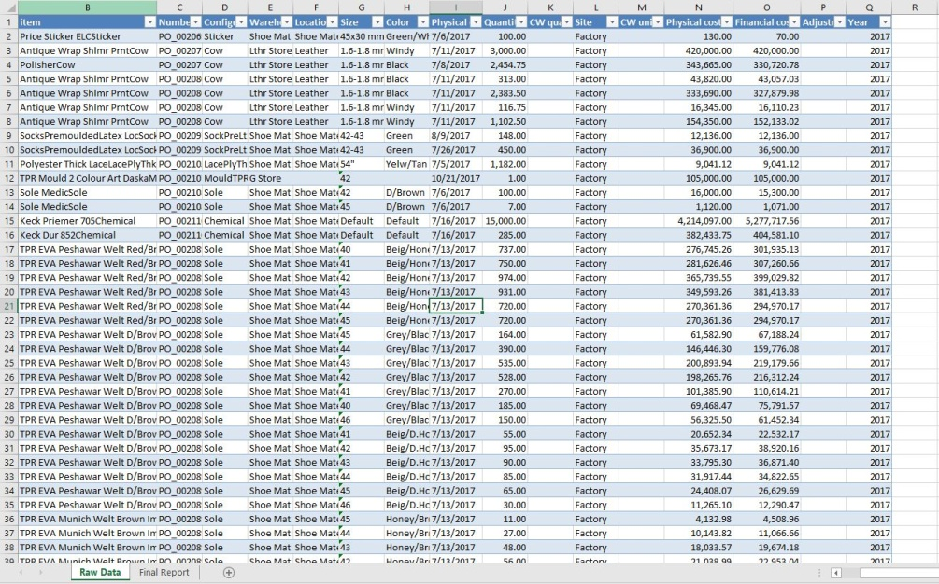
Fig.1.Basic data for the preparation of material delivery analysis report
Notations
a=Download Data from Microsoft Dynamics AX
b=Take year by the help of '=yaer' formula
c=insert the pivot table into the same worksheet
d=Delete the basic data
e=Copy data from the pivot table and paste next to it
f=Delete the pivot table
g=Inset the first column for warehouse
h=Put Warehouse for each category of items
i=Delete last two columns
j=Set the values in descending order as per the last column
k=Apply formulae for average price, quantity variance and item average of three years
l=Pu the interior color in headers and put borders on the data
T=Total time needed to prepare the vendor rate analysis report
Manual tasks needed to be performed in order to prepare the vendor rate analysis report are enlisted in table 1 along with their time study. on the same time, average time of each of an activity was calculated.
Table 1. Time study of the various manual tasks needed to do be performed for the preparation of vendor rate analysis report
Activity | Obs. 1  (sec) | Obs. 2  (sec) | Obs. 3  (sec) | Obs. 4  (sec) | Obs. 5  (sec) | Obs. 6  (sec) | Obs. 7  (sec) | Obs. 8  (sec) | Obs. 9  (sec) | Obs. 10  (sec) | Mean Time(sec)
a | 62.03 | 69.43 | 68.96 | 69.81 | 59.52 | 62.03 | 70.9 | 73.08 | 54.95 | 68.25 | 65.896
b | 7.77 | 8.07 | 6.35 | 9.41 | 3.19 | 8.77 | 9.02 | 9.21 | 6.66 | 9.1 | 7.755
c | 15.73 | 21.88 | 23.26 | 24.64 | 25.3 | 17.32 | 23.99 | 13.73 | 21.11 | 26.63 | 21.359
d | 5.16 | 4.61 | 2.75 | 3.39 | 4.23 | 2.47 | 6.34 | 1.97 | 6.7 | 2.53 | 4.015
e | 4.64 | 4.79 | 4.26 | 5.42 | 6.05 | 7.43 | 4.71 | 4.82 | 3.78 | 3.46 | 4.936
f | 3.83 | 2.91 | 2.79 | 3.29 | 2.32 | 3.3 | 2.7 | 3.37 | 3.39 | 4.05 | 3.195
g | 3.11 | 2.95 | 2.64 | 2.94 | 2.86 | 3.08 | 2.96 | 2.94 | 2.99 | 3.03 | 2.95
h | 365.59 | 387.97 | 290.04 | 316.48 | 277.54 | 300.14 | 403.79 | 315.16 | 327.55 | 260.08 | 324.434
i | 6.61 | 2.9 | 5.34 | 3.33 | 4.41 | 6.25 | 4.83 | 4.12 | 5.35 | 3.88 | 4.702
j | 8.45 | 10.68 | 8.12 | 12.11 | 11.52 | 8.32 | 7.94 | 8.27 | 8.16 | 11.12 | 9.469
k | 149.21 | 179.93 | 220.21 | 180.19 | 156.49 | 155.88 | 178.61 | 174.35 | 162.77 | 162.65 | 172.029
l | 67.77 | 63.04 | 53.14 | 53.49 | 48.13 | 64.05 | 66.68 | 62.2 | 57.4 | 59.96 | 59.586
T = a + b + c + d + e + f + g + h + i + j + k + l
T = 680.326 sec
T = 11.33 min
Total average time needed to prepare the vendor rate analysis report was calculated to be 680.326 sec (11.33 min) as calculated by the help of above equation.

SUGGESTED METHOD
Suggested method is the automation of all the manual tasks which were used to be performed by the operator to prepare the report. This automation was made possible by the help of visual basic for applications in excel.

Designed Interface for Execution of Macros
Interface of the report which is basically a userform(see fig.2) that has been used for the execution of various macros on the click of command buttons as can be seen in the fig.2.
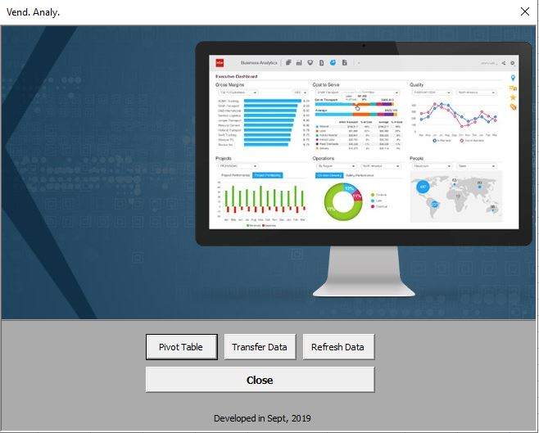
Fig.2.Userform designed for execution of macros
All macros at the back of command buttons are presented in the fig.3.
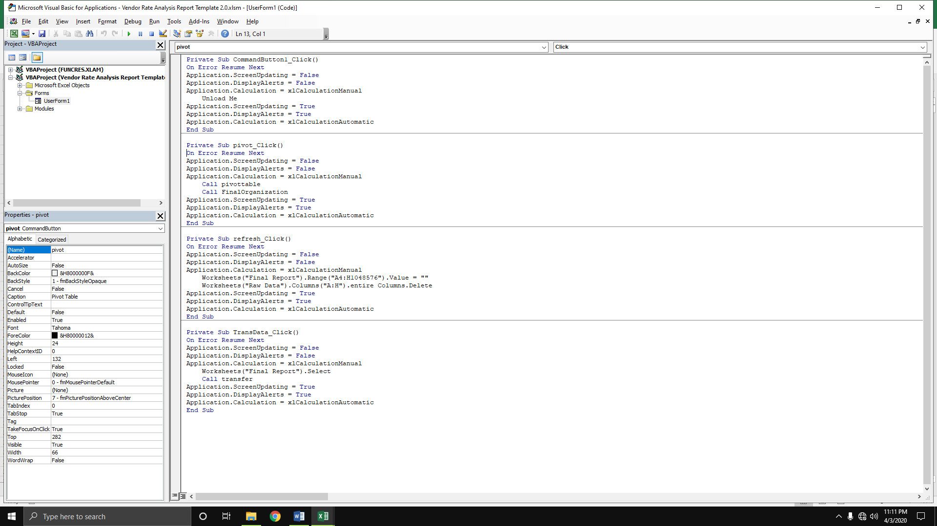
Fig.3. Macros behind each of the command button of the userform presented in fig.2

Needed Worksheets
In the template with the feature of automation need only two worksheets in order to prepare the vendor rate analysis report. Initially, data is processed into the ‘Raw Data’ worksheet by the help of various macros and in last, whole data is transferred to ‘Final Report’ by the help of for loop.
Fig.4. Needed worksheets for the automated material delivery analysis report

Macros Behind Command Buttons
Macros, which were programed to for the automation of all the manual tasks in excel are described in detail in below given headings.

Refresh Data
After the template is opened with the intention of preparing the vendor rate analysis report, contents from both the worksheets i.e. ‘Raw Data’ and ‘Final Report’ are cleared so as to prepare the new report. The code given below was used to clear the contents from both sheets.
Private Sub refresh_Click()
On Error Resume Next
Application.ScreenUpdating = False
Worksheets("Final Report").Range("A4:H1048576").Value = ""
Worksheets("Raw Data").Columns("A:H").entire Columns.Delete
Application.ScreenUpdating = True
End Sub

Insert Pivot Table
After the data is downloaded into the MS excel from Microsoft Dynamics AX, in last column i.e. Q ‘=year’ formula is applied (fig.1) in order to take out the year from the data given in 9th column (fig.1). Whole data is converted into the pivot table afterwards. Data from the pivottable and pivot table is deleted which can be seen in the fig.5.
Sub pivottable()
On Error Resume Next
Application.ScreenUpdating = False
rowscount = Worksheets("Raw Data").Cells(Rows.Count, 1).End(xlUp).Row
ActiveWorkbook.PivotCaches.Create(SourceType:=xlDatabase, SourceData:=Worksheets("Raw Data").Range(Cells(1, 1), Cells(rowscount, 17)), Version:=xlPivotTableVersion15).CreatePivotTableTableDestination:=Worksheets("Raw Data").Range("R1"), TableName:="PivotTable4", DefaultVersion:=xlPivotTableVersion15
With ActiveSheet.PivotTables("PivotTable4").PivotFields("Warehouse")
.Orientation = xlRowField
.Position = 1
End With
With ActiveSheet.PivotTables("PivotTable4").PivotFields("Item")
.Orientation = xlRowField
.Position = 2
End With
ActiveSheet.PivotTables("PivotTable4").AddDataFieldActiveSheet.PivotTables("PivotTable4").PivotFields("Quantity"), "Sum of Quantity", xlSum
ActiveSheet.PivotTables("PivotTable4").AddDataFieldActiveSheet.PivotTables("PivotTable4").PivotFields("Financial cost amount"), "Sum of Financial Cost Amount", xlSum
With ActiveSheet.PivotTables("PivotTable4").PivotFields("Year")
.Orientation = xlColumnField
.Position = 2
End With
ActiveWorkbook.ShowPivotTableFieldList = False

With Worksheets("Raw Data")
.Columns("A:Q").EntireColumn.Delete
End With
rowscount = Worksheets("Raw Data").Cells(Rows.Count, 1).End(xlUp).Row
colcount = Worksheets("Raw Data").Cells(2, Columns.Count).End(xlToLeft).Column
'MsgBox (rowscount)
With Worksheets("Raw Data")
.Range(Cells(2, 1), Cells(rowscount, colcount)).Copy
.Cells(1, colcount + 1).Select
.Paste
End With
rowscount = Worksheets("Raw Data").Cells(Rows.Count, 1).End(xlUp).Row
With Worksheets("Raw Data")
.Rows(rowscount).EntireRow.Delete
.Columns("A:I").EntireColumn.Delete
End With
Application.ScreenUpdating = True
End Sub
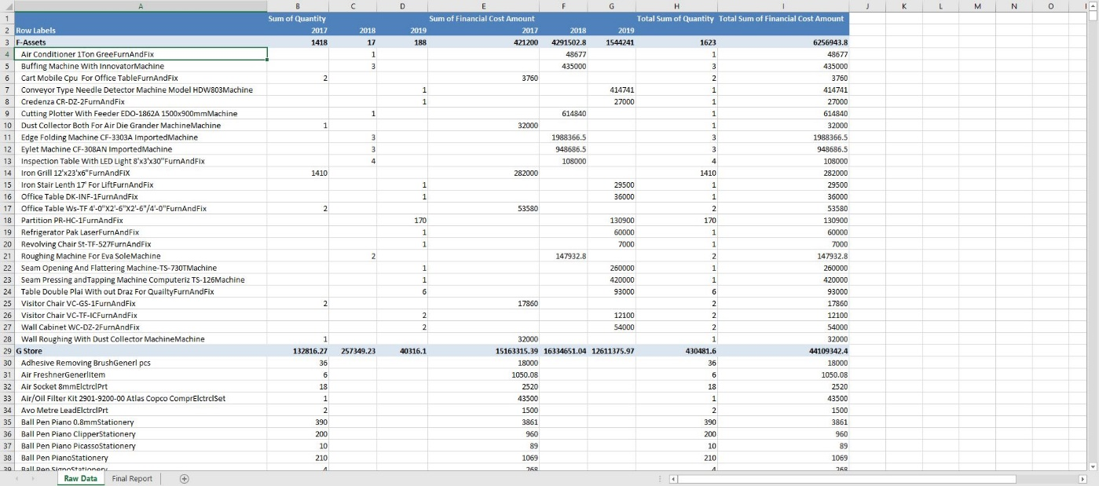
Fig.5.Result of above given code

Organize Data
Code just given was used to inset the first column in order to put the warehouse. By the help of two for loops (executed as much as the number of rows in ‘Raw Data’ worksheet) warehouse of each of the item is put against it.
Sub FinalOrganization()
Application.ScreenUpdating = False
On Error Resume Next
Dim rowscount As Long
Dim colcount As Integer
With Worksheets("Raw Data")
.Columns("A").Insert
.Cells(1, 1).Value = "Warehouse"
rowscount =.Cells(Rows.Count, 2).End(xlUp).Row
colcount =.Cells(3, Columns.Count).End(xlToLeft).Column
End With
Row = 3
For i = 1 Torowscount
If Worksheets("Raw Data").Cells(Row, 2).Font.Bold = True Then
With Worksheets("Raw Data")
.Cells(Row, 2).Offset(1, -1).Value =.Cells(Row, 2).Value
.Rows(Row).EntireRow.Delete
End With
End If
Row = Row + 1
Next
rowscount = Worksheets("Raw Data").Cells(Rows.Count, 2).End(xlUp).Row
For i = 2 Torowscount
If Worksheets("Raw Data").Cells(i, 1).Value = "" Then
With worksheets(“Raw Data”)
.Cells(i, 1).Value =.Cells(i, 1).Offset(-1, 0).Value
End With
End If
Next
With Worksheets("Raw Data")
.Columns("I:J").EntireColumn.Delete
.Range(Cells(1, 1), Cells(rowscount, colcount)).AutoFilter Field:=1, Criteria1:=Array("F-Assets", "LG Material", "T-F-Assets", "T-Shoe Mat"), Operator:=xlFilterValues
.Activate
.Cells.Select
Selection.SpecialCells(xlCellTypeVisible).EntireRow.Delete
.ShowAllData
rowscount =.Cells(Rows.Count, 1).End(xlUp).Row
.Cells(rowscount, 1).Value = ""
Range("A1:H1048576").Sort Key1:=Range("H1"), Order1:=xlDescending, Header:=xlYes
End With
Application.ScreenUpdating = True
End Sub
Columns I:J are deleted and all those items are deleted which belong to the stores i.e. F-Assets, LG Material, T-F-Assets, T-Shoe Mat. In last, the values are set into descending order as per 8th column as can be seen in the fig.6.
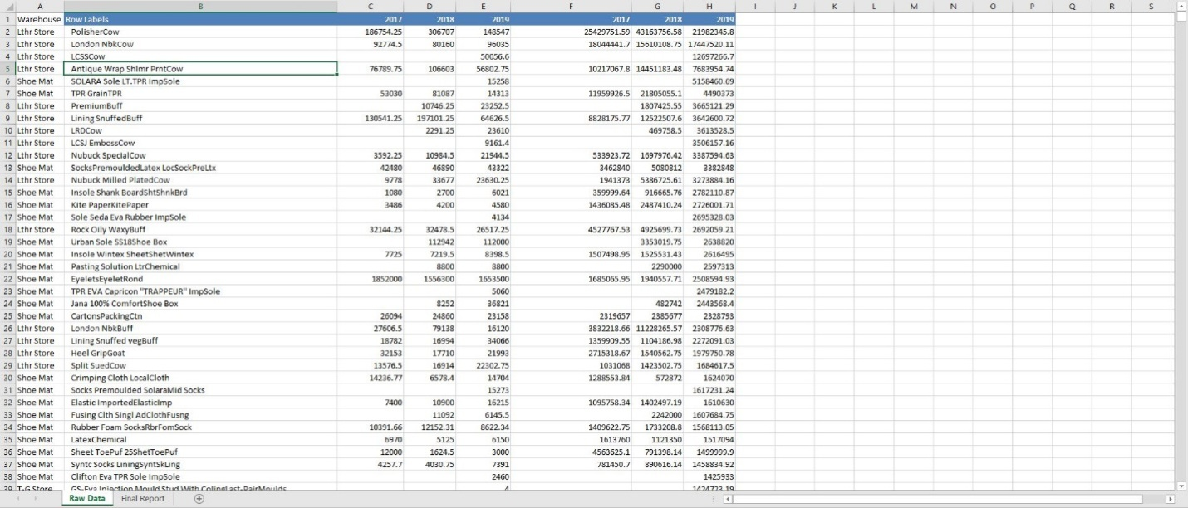
Fig.6.Result of above given code

Transfer Data
Now the data read to be pasted into the ‘Final Report’ worksheet. By the help of macro given below, the data is transferred from ‘Raw Data’ worksheet to the ‘Final Report’ worksheet as given below in fig.7.
Sub transfer()
Application.ScreenUpdating = False
On Error Resume Next
rowscount = Worksheets("Raw Data").Cells(Rows.Count, 1).End(xlUp).Row
colcount = Worksheets("Raw Data").Cells(2, Columns.Count).End(xlToLeft).Column
Worksheets("Final Report").Range("A4:H1048576").Value = ""
Row = 4
For i = 1 Torowscount
For j = 1 Tocolcount
With Worksheets("Final Report")
.Cells(Row, j).Value = Worksheets("Raw Data").Cells(Row - 2, j)
End With
Next j
Row = Row + 1
Next
Application.ScreenUpdating = True
End Sub
The average values of an each item for previous three years were calculated (I:K column); on the same time, quantity variance and average price of an item during pairs of years is also calculated (see fig.7 column L:O).
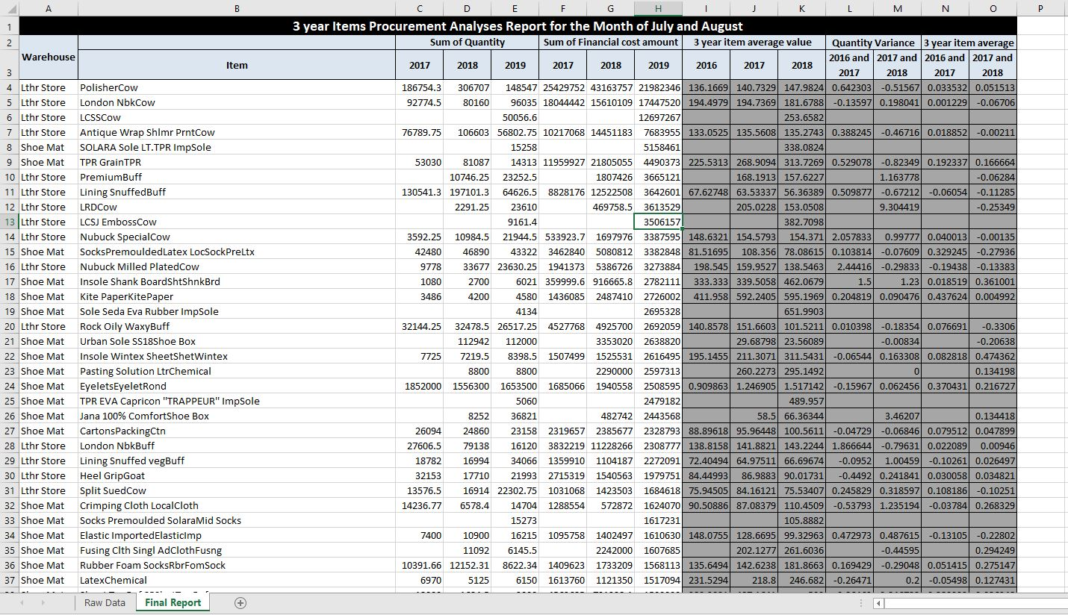
Fig.7.Result of above given code

Time Consumed by New Method
In order to compare the performance of old and suggested method; therefore, time study of all activities performed in order to prepare the vendor rate analysis by new method was conducted (see table 2).
Notations
m=Press Ctrl + Q and Form Appears
n=Execution time of Command Button 'Refresh Data'
o=Execution time of Command Button 'Pivot Table'
p=Execution time of Command Button 'Transfer Data'
q=Close Form
Table 2. Time study of various tasks to be performed in order to prepare the vendor rate analysis as per suggested method
Activity | Obs. 1  (sec) | Obs. 2  (sec) | Obs. 3  (sec) | Obs. 4  (sec) | Obs. 5  (sec) | Obs. 6  (sec) | Obs. 7  (sec) | Obs. 8  (sec) | Obs. 9  (sec) | Obs. 10  (sec) | Mean Time (sec)
a | 62.03 | 69.43 | 68.96 | 69.81 | 59.52 | 62.03 | 70.9 | 73.08 | 54.95 | 68.25 | 65.896
m | 2.15 | 1.84 | 2.11 | 1.99 | 1.93 | 2.25 | 1.96 | 1.72 | 1.94 | 2.21 | 2.01
n | 3.21 | 3.72 | 3.5 | 3.8 | 3.25 | 3.34 | 3.74 | 3.11 | 3.21 | 3.18 | 3.406
o | 2.96 | 2.92 | 3.07 | 2.98 | 2.98 | 3.16 | 2.74 | 3.17 | 3.24 | 2.97 | 3.019
p | 1.96 | 2.12 | 1.96 | 1.84 | 1.77 | 1.72 | 1.9 | 2.14 | 1.83 | 1.91 | 1.915
q | 1.73 | 1.51 | 1.5 | 1.45 | 1.45 | 1.66 | 1.65 | 1.42 | 1.45 | 1.43 | 1.525
T = a + m + n + o + p + q
T = 77.771 sec
T= 1.296 min
Total average time taken by suggested method during the preparation of vendor rate analysis report was calculated to be 77.771 sec (1.29 min).

DISCUSSION
Employees are hired for every small and medisieum enterprise (SME) for making reports on daily monthly and yearly basis. Almost all of the report in mentioned sector is executed in MS excel. Sometimes in MS excel there are more chances of error and it takes massive amount of time generally in case of complex reporting. For that reason MS has given mouldability of customized automation in its applications like Excel Word Power point and VBA. The work on VBA is conducted in visual basic editor (VBE). Therefore, Other technologies are developed by Microsoft that are VBA, VSTO, ActiveX and etc. (DING et al. 2017)(Porter and Stretcher 2012). VBA technology is provided on the platform of many softwares of Microsoft window (Kuka and Karamani 2011)(Norton and Tiwari 2013)(Harahap and Azmi 2017). Nowadays companies, industries, employees are enforcing to get the information and knowledge of using VBA (CHATVICHIENCHA 2015). When it is about VBA, then it is about the customization and development in integrated development environment (IDE) in the applications of MS office for the automation and simplification of manual, complex and repeated work (DING et al. 2017)(Evensen 2014)(Minto 2009)(Harahap and Azmi 2017)(Kuka and Karamani 2011). Simply, it is known for automating the routine work in existing office productivity applications (DING et al. 2017)(CHATVICHIENCHA 2015). Objective of the present research was to automate the material delivery time report analysis. However when employees often used to forget the steps of making the report and due to this chance of error was greater, this report was used to be prepared at that case company once in a month. Number of macros were programed to implement those commands which were once done manually in excel. All the macros were on the hand of userforms to give command as they could be start by clicking once. Userforms are used when the input from user is to be taken (Evensen 2014). A code is needed so that operations can be run by itself. (Evensen 2014)(Harahap and Azmi 2017)(Kalwar and Khan 2020). If literature is traced back and the prevalence of same research is found. Like VBA was used by Bartoszewicz and Wdowicz (2019) in contrast to remake and execute the process for migration of data and its analysis, it was faster, flexible and the way to speed the complex analytical report formation, comparison of old and new method revealed that by the help of VBA, and as usual time of report was reduced form 2 hours to 5 minutes (Bartoszewicz and Wdowicz 2019). Furthermore VBA was also used by Cirujano and Zhu (2013) , they performed a work on the manpower resource planning report, an experienced employee had to work for 30 working hours to make the report but after the automation by VBA, it takes 10 minutes (Cirujano and Zhu 2013). Just like that, by using VBA Kalwar and Khan (2020) automated the acquisition report at the designing and costing department of the company by which 75% of the employee`s time was saved (Kalwar and Khan 2020). Instead of using old method which took 5.324 minutes for preparing the material delivery analysis but by using new method it takes 1.55 minutes. Comparison of the time study of both methods shows that the new method takes 70.86% less time as compared to the old method. It is obvious that new method is more favourable, and there is no any chance of error in the report as if basic data is 100% accurate because of automated operation. By using VBAYan and Wan (2017) created a mechanism of generating bill of material of transmission line ; efficiency and accuracy of calculation are tremendously improved, at the same time, errors in the calculation process of steel BOMs were lowered (Yan and Wan 2017). VBA was also used by Abidin et al., (2013) and figured API and WQI in the automated way. In this way the errors turnaround time were reduced.

CONCLUSION
Automated systems have always been time saving and productive especially in the computerized work. In the same way, vendor rate analysis report was automated by the help of visual basic for applications (VBA). Time study of old and automated method for making the vendor rate analysis report was conducted. In old method, user used to take 680.326 seconds (11.33 min) to prepare the vendor rate analysis report; whereas, by new method he/she needed 77.771 seconds (1.29 min) to make the vendor rate analysis report. The comparison of both methods indicated that the new method takes 88.56% less time as compared to old method (manual method). At the same time, the accuracy of the new method was verified to be 100%.

FUTURE IMPLICATIONS
The mechanism of automated report formation can be incorporated in Microsoft Dynamics AX 2012 which is already implemented there; thus authors of this paper suggest that it should be implemented in AX ERP because excel automation is not the permanent solution.

ACKNOWLEDGEMENT
We thank the staff of the purchase department of ABC footwear Company for their good cooperation during the conduct of this research.

CONFLICT OF INTERESTS
There was no conflict of interest among the authors of present research paper.

REFERENCES
Abidin, Ismail Zainal, HafizanJuahir, AzmanAzid, Ahmad Dasuki Mustafa, and FazureenAzaman., Application of Excel-VBA for Computation of Water Quality Index and Air Pollutant Index, Malaysian Journal of Analytical Sciences, vol. 19, no. 5, pp. 1056–64, 2015.
Abraham, Robin, and Microsoft Corporation. 2008. Spreadsheet Programming, Wiley Encyclopedia of Computer Science and Engineering, 2008.
Ahmadi, A., P. H. Robinson, F. Elizondo, and P. Chilibroste. 2018. Implementation of CTR Dairy Model Using the Visual Basic for Application Language of Microsoft Excel, International Journal of Agricultural and Environmental Information Systems, vol. 9, no. 3, pp. 74–86, 2018.
Bartoszewicz, Grzegorz, and MaciejWdowicz. 2019., Automation of the Process of Reporting the Compliance of the Production Plan with Its Execution Based on Integration of SAP ERP System In Connection With Excel Spreadsheet and VBA Application, Digitalization of Supply Chains, pp. 101–16, 2019.
Belchior Junior, Antonio, Renata N. Bruel, Delvonei A. Andrade, GaianeSabundjian, Luiz A. Macedo, Gabriel Angelo, Walmir M. Torres, Pedro E. Umbehaun, and Thadeu N. Conti., Development of a VBA Macro-Based Spreadsheet Application for Relap5 Data Post-Processing, International Nuclear Atlantic Conference, pp. 978–85, 2011.
Bernard, Martin, Eva DwiMinarti, and MastaHutajulu. 2018. “Constructing Student’s Mathematical Understanding Skills and Self Confidence: Math Game with Visual Basic Application for Microsoft Excel in Learning Phytagoras at Junior High School.” International Journal of Engineering & Technology, vol. 7, no. 3.2, pp. 732–36, 2018.
Blayney, Paul John, and Zhaohao Sun. 2019., Using Excel and Excel VBA for Preliminary Analysis in Big Data Research, Managerial Perspectives on Intelligent Big Data Analytics, Pp. 110–36, 2019
Brusoni, Stefano, Andrea Prencipe, and Pavitt Keith., Knowledge Specialization, Organizational Coupling, and the Boundaries of the Firm: Why Do Firms Know More than They Make? Administrative Science Quarterly, vol. 46, no. 4, pp. 597–621, 2001.
CHATVICHIENCHA, Somchai., Enhancing Computational Thinking by Excel-VBA Based Problem Solving, The 2nd International Conference on Innovation in Education, pp. 284–90, 2015.
Cirujano, J., and Z. Zhu., Automatic Reporting for Manpower Resources, Proceedings of Annual Conference- Canadian Society for Civil Engineering, no. 1, pp. 710–19, 2013.
Daniel, João, Reis Lessa, Paulo Fabiano, Reis Lessa, Pedro Américo Almeida, Magalhães Junior, and Henrique De VilhenaGuimarães., Mathematical Model and Programming in VBA Excel for Package Calculation, International Journal of Engineering Research and Applications, vol. 6, no. 5, pp. 55–61, 2016.
DING, Hai-Lan, Kun-Yu QI, Xiao-Long ZHAO, and Gui-Fu XU., Tibetan Typographical Specifications and Technical Realization Based on Word VBA, 4th International Conference on Advanced Education and Management, pp. 407–12, 2017.
Evensen, Harold T., A Versatile Platform for Programming and Data Acquisition: Excel and Visual Basic for Applications, ASEE Annual Conference and Exposition, 2014.
Fredriksson, Peter, and Luis Araujo., The Evaluation of Supplier Performance: A Case Study of Volvo Cars and Its Module Suppliers.” Journal of Customer Behaviour, vol. 2, no. 3, pp. 365–84, 2003.
Gallego, Laura Virseda., Review of Existing Methods, Models and Tools for Supplier Evaluation, LinköpingsUniversitet, 2011.
Harahap, MohamadIrwan P., and Muhammad Hafiz Azmi., Development of Excel VBA Program for Small Drainage Network, E-Academia Journal, vol. 6, no. 1, pp. 216–27, 2017.
Hart-Davis, Guy., Making Decisions in Your Code, Mastering MIcrosoft VBA, pp. 202, 2005.
Hila, Rushit., Water Quality Data Management Database, 2009.
Imeri, Shpend, KhuramShahzad, JosuTakala, Yang Liu, and Tahir Ali., Suppliers’ Evaluation: An Empirical Study, 2014.
Kalwar, Muhammad Ahmed, and Muhammad Ali Khan., Optimization of Procurement & Purchase Order Process in Foot Wear Industry by Using VBA in MS Excel, International Journal of Business Education and Management Studies, vol. 5, no. 2, pp. 80–100, 2020.
Kalwar, Muhammad Ahmed, Muhammad Ali Khan, Shakil Ahmed Shaikh, Abdul Salam, Muhammad SaadMemon, and Sarmad Ali Khaskheli., Aggressive Driving Behavior : A Case Study of Mehran UET, Proceedings of the International Conference on Industrial Engineering and Operations Management Dubai,. Dubai, UAE, pp. 2350–59, 2020.
Khaskheli, Sarmad Ali, Muhammad Ahmed Kalwar, Ali Arsalan Siddiqui, Muhammad Ali Khan Nagar, and TamoorHussainWadho., Impatience among Drivers With Varying Demographics, Professional Trends in Industrial and Systems Engineering. UET, Peshawar, pp. 465–69, 2018.
Kuka, Shkelqim, and BrunelaKaramani., Using Excel and VBA for Excel to Learn Numerical Methods, 1st International Sympsosium on Computing in Informatics and Mathematics, pp. 365–76, 2011.
Lammi, Hannele., Supplier Evaluation and Selection, Helsinki Metropolia University, 2015.
Minto, Charles F., PKPD Tools for Excel, 2009.
Mustafa, Alan, and AbdulnasserHatemi-J., A VBA Module Simulation for Finding Optimal Lag Order in Time Series Models and Its Use on Teaching Financial Data Computation, Applied Computing and Informatics, 2020.
Norton, Tomas, and Brijesh Tiwari., Aiding the Understanding of Novel Freezing Technology through Numerical Modelling with Visual Basic for Applications (VBA), Computer Applications in Engineering Education vol. 21, no. 3, pp. 530–38, 2013.
Porter, David, and Robert Stretcher., Automating Markowitz Optimizations Using VBA, Journal of Instructional Techniques in Finance, vol. 4, no. 1, pp. 9–16, 2012.
Sarkis, Joseph, and SrinivasTalluri., A Model for Strategic Supplier Selection, Journal of Supply Chain Management, vol. 38, no. 4, pp. 18–28, 2002..
SATO, Kiyotada, and Ryuzo YOKOYAMA., Teaching Aid for Remote Sensing and Map Imagery Analysis Using Excel Spreadsheet and VBA, 22nd Asian Conference on Remote Sensing, 2001
Shiva Prasad, H. C., Giridhar Kamath, GopalkrishnaBarkur, and RakeshNayak., Does Supplier Evaluation Impact Process Improvement?, Journal of Industrial Engineering and Management, vol. 9, no. 3, pp. 708–31, 2016.
Walkenbach, John.,Controling Program Flow and Making Decisions, Excel VBA Programming For Dummies, pp. 153, 2015.
Yan, Qingyou, and Youwei Wan., Using the Special Font and VBA Program to Make Bill of Materials in the Transmission Line Engineering, Revista de La Facultad de Ingenieria, vol. 32, no. 2, pp. 335–41, 2017.

