PERFORMANCE IMPROVEMENT OF SALE ORDER DETAIL PREPARATION BY USING VISUAL BASIC APPLICATIONS: A CASE STUDY OF FOOTWEAR INDUSTRY

Muhammad Ahmed Kalwar
Post Graduate Alumini (MUET) & Assistant Manager Production
Shafi Private Limited, Lahore, Punjab, Pakistan
*kalwara.muhammad.ahmed@gmail.com

Hussain Bux Marri
Meritorious Professor & Ex-Chairman
Department of Industrial Engineering and Management
Mehran University of Engineering and Technology
Jamshoro, 76062, Sindh, Pakistan.

Muhammad Ali Khan
Post Graduate Student & Assistant Professor
Department of Industrial Engineering & Management
Mehran UET, Jamshoro, 76062,Sindh, Pakistan

ABSTRACT
Purpose: Purpose behind the automation of sale order detail report was to decrease the workload of the employee and at the same time, minimization of non-value added reporting tasks was also the target.
Methodology: Sale order detail report was used to be made at the planning department of ABC footwear Company. Authors learnt the manual steps and method so that they could translate them into the visual basic of applications (VBA) code for its automation in excel. Visual basic editor was used for the compilation and to run the coded macros. Time of each of the manual activities was recorded before and after the report automation so as to compare the efficiency of methods.
Findings: Since, the time study of both (manual and automated) methods was compared and the comparison indicated that the automated method took 84.42% less time than manual method. Furthermore, the accuracy of the report if prepared by new method was checked to be 100%. Most importantly, no single manual operation was left to be performed by the user in the report.
Importance: Human mind bears a limited workload and due to fatigue, irritation and frustration, it can cause an error and if that error is the part of big plan and associated with some amount of cost then that will not be bearable. Therefore, such tasks and activities should be automated because machine cannot be mistaken if the code and its execution is proper. In this regard, sale order detail report was automated at the planning department of ABC footwear Company.
Implications: Since, automation in excel reporting is not the permanent solution when there is the usage of Microsoft Dynamics AX 2012 in the company. Automation in excel is a good solution but it is not counted for the long run. Therefore, it was suggested to the company for the incorporation of the report into Microsoft Dynamics AX 2012.
Limitations: Major limitations of the present automated template included: excel file can get corrupted easily, if any error comes, there was no one in the company who could trace and solve that error.
Originality: Many researchers have used VBA for numerous purposes in the wide variety of works at the different platforms. Already conducted work includes: one of the researchers integrated production planning module of SAP with Excel for data analysis, another transferred the image data in excel spreadsheet and one of patents indicate that manpower resource planning report was automatically generated in MS project by use of VBA. In the light of conducted literature review, it was indicated that besides implementation of mathematical model by using VBA in excel, no work on the full report automation has been conducted in excel by the use of VBA. In this regard, due to immense need and highlighted research gap present research paper was organized.

INTRODUCTION
VBA is a simple but powerful tool developed by Microsoft’s event-driven programming language which is used for the automation of manual operation. It gives 100% accurate results and requires a very little time.[1]. Visual Basic for Applications is used generally for algebraic calculations just like creating variables, interacting with different equations and creating results [2][3]. VBA or Macro programming is diverse group of instruction through which complex user specified operations are automated in MS excel[4]. No or a very little cost is needed and complex with substantial accuracy can be conducted during when applications is being programmed in excel VBA. Moreover a less skilled employees can easily run VBA in excel and operate many tasks and applications and can get accurate results. [5]. It can be run easily in just single click. By using Macro a user can begin user-defined functions and automate all spreadsheet tasks [6]. Visual basic editor and VBA are different as compared to the spreadsheet environment and excel formulae respectively [6]. When we talk about spreadsheet environment and excel formulae Visual basic editor and VBA are quite different [2]. VBA is effective and efficient in such a way that it saves time, gives accurate results, lower the formulae burden and secure the worksheets. The facility of VBA is being facilitated to many other application like access, word, excel, and power point. MS excel is accepted as one of the major application as it is the standard for spreadsheets in the world of industry and at the same time, VBA can be used comfortably [7]. Current research paper shows the automation of material delivery time analysis report by using excel VBA. Therefore ABC footwear company thought to use VBA in excel to automate some of the office work due to heavy workload f manual work at the purchase center of ABC footwear company. In that case employees will be given enough time for relaxation and learning other activities. So it is the effective way to use VBA and at the mean time mistakes were also focused to be minimized in the calculation results and material delivery time analysis report was also automated.

LITERATURE REVIEW
As per demand of sale order detail at planning and costing department of ABC Company, design and formulae were kept to be the exact but the manual operation from the report were totally escaped. Provision report and purchase order report ere automated through a research observed by Kalwar and Khan (2020). The time of report was reduced from 2096 seconds to 520 seconds. ZainalAbidin et al., (2015) summed up Air pollutant Index (API) and water quality index (AQI) with the help of VBA in excel. Calculating indices was done with the help of VBA. Moreover, coded detail of the index was calculated in order to highlight value of index by itself shown along with it [1].Through VBA in excel Ahmadi et al., (2010) implemented a dairy model. The execution of the CTR Dairy model was carried out as research with the use of VBA in excel by Ahmadi et al., (2018). CTR dairy is a vigorous simulation model for grazing lactating dairy cows that is used to predict the overall milk production and profits on various parameters i.e. the absorption of nutrients under intermittent schedules of feeding and luminal digestion. In the last few years, impulsive driving came on the surface before the government and general masses[8][9]. The CTR dairy model was translated into excel VBA due to infrequent clients and discontinuation of SMART software; to transform input in to output. It was turned into existence to the broad range of farmers, researchers and advisors, dairy nutrition consultants through this research[10]. Using VBA in excel Junior et al., (2011) find out the result of Leak Analysis Program 5 (RELAP5) and Reactor Excursion through post-processing developed. Through VBA Rushit Hila (2009) highlighted to be significant to pace up output data analysis[11]. It was also programmed by in VBA excel in order to identify outliers in the data and arrangement of data by itself. The number of steps were automated for verifying data and cleaning it before importing it into MS access (used as a database) [12]. Cirujano and Zhu (2013) created a advanced method of manpower planning report automatically in Macro programming. Furthermore with the help of new methods Roles, assignments and schedules of the engineers for various projects were collected. .Later on, collected information was compiled, analyzed and organized. After getting validated in consulting firm with more than hundred employees the method ensured its significance. It highlighted that manpower planning report could be deduced through it; hence, it would result in reducing time and cost [7].Sato and Yokoyama (2001) set An application to transfer an image data to a worksheet click of Web-icon from the data set was developed as an application by using VBA in excel [13]. For calculation of logic program and packaging Lessa et al., (2016) used visual basic for application (VBA) in excel to automate a practical mathematical model.The designs of graphics were created so that packages get filled by itself easily [14]. Moreover through Visual Basic for Application H. Evenson (2014) execute instrument communication in excel for the very first time in 2014 [15]. By using excel VBA an automatic report generating system was invented in MS project by Donald E. Blattner and Valrico, FL (2007). The invented system pave the way for users to select, format filter and sort the report with the help of dialogue box highlighted on the screen [12].Through VBA mapping rules were created by Wettlaufer (2010). One macro was programmed for each report. In another spreadsheet expected values were written that were expected value spreadsheet. Later on, it moved the patients follow-up to the merline net server for processing the data and processed patient follow-up session was generated which included reports package in the winrar file [12].For making engineering students comprehend the analysis of novel freezing technology VBA in excel was used by Norton and Tiwari (2013) [3]. Through excel VBA new method was proposed for the analysis of production process, its automation and visualization was containe on the synchronization of production planning module of SAP enterprise resource planning (ERP) proposed by Bartoszewicz and Wdowicz (2019). The novel process for data analysis and migration was re-engineered and executed- which was more resilient and swift and with the assistance of which thorough process of convoluted analytical report was paced up ( reduction in time to 5 minutes from 2 hours) [14].Using excel VBA a research was conducted with the aim and objective to advance the application that could make the mediocre level rainwater conveyance system- using rational method as highlighted in MSMA 2 by Harahap and Azmi (2017) [15]. Moreover with the usage of VBA excel for an automatic calculation and generation of bill of material (BOM) of transmission line was prepared by Yan and Wan (2017). Accuracy and efficiency are widely upgraded. with the application and design of the template and errors in the process of designing of total steel BOM were reduced [16]. Provision report and purchase order report ere automated through a research obsereved by Kalwar and Khan (2020) at the organization and costing department of ABC Footwear Company. The time of report was reduced from 2096 seconds to 520 seconds[17]. Mustafa and Hatemi-J, 2020 created a dynamic model in order to learn the concept of lag order and the developed model was to be used for financial data computation and statistics` classes. Through the VBA in excel the complex process of finding optimal lag value was automated which was a multi-variate and multi-step process .Furthermore, by the usage of excel in VBA multivariate dynamic model was estimated and at the meantime, the optimal lag value was found through the mentioned program [18].

RESEARCH GAP
Many researchers have used VBA for numerous purposes in the wide variety of works at the different platforms. Already conducted work includes: one of the researchers integrated production planning module of SAP with Excel for data analysis, another transferred the image data in excel spreadsheet and one of patents indicate that manpower resource planning report was automatically generated in MS project by use of VBA. In the light of conducted literature review, it was indicated that besides implementation of mathematical model by using VBA in excel, no work on the full report automation has been conducted in excel by the use of VBA. In this regard, due to immense need and highlighted research gap present research paper was organized.

NEED FOR AUTOMATION
As for the as the small orders i.e. below 10000 shoe pairs, are concerned, their sale order detail report is prepared in 6 to 7 min but when the big order i.e. 80000, 200000 shoe pairs; then sale order detail takes more time and the chance of error is also greater. Therefore, it was the extreme need to automate the sale order detail in order to save the employees` time and chance of error can be avoided. For the automation of report, visual basic for applications (VBA) in excel was used.

RESEARCH METHODOLOGY
Basic methods which were used in the present research were time study of tasks performed during report formation before and after automation and programing of manual tasks of sale order detail report in MS excel by using VBA.

Data Collection
Only one type of data was used in the present research which was only collected to reflect the performance of automated method of report formation. The data included the descriptions of manual operations and those were collected from the concerned employee by conducting an interview. The time of tasks which were performed to make the report was collected by the help of stop watch. Ten observations for each of the task were collected. The method and process of report formation was learnt by authors from the concerned person. Furthermore, snipping tool in windows 10 was used to take snaps of the excel screen on order to show the output of automated sale order detail (ASOD) version 1.

Data Analysis
The data (task descriptions and collected observations of time) were put into MS excel for calculation of average time of each of the task and total time of report formation. The data was present in the paper in a tabular form for both methods and in last the comparison of both method was conducted.

Tool Used for Report Automation
Manual operation of the sale order detail report was automated by the help of visual basic for applications in excel as mentioned earlier. In order to execute the macros; an interface (based on one user-form) was design in visual basic editor of excel. For the automation of manual operation if statements, for loop, do while loop were used to perform the various tasks in the automated template.

OLD METHOD
Old method is consisted on the series of the tasks performed manually in excel i.e. delete columns, insert rows, put headers on the column, put totals etc. The purpose of sale order detail is to sum the total pairs in one assortment; and the assortment is the series of given ordered sizes in the order as can be seen in the fig.1 from cell D2 to cell D9. Total number of pairs in first assortment is 480 (see fig.1)

Basic Data
Data presented in the fig.1 is required data for making sale order detail. Basic data is consisted of the production number, article number, size, quantity and sole (column H) to be used in the articles. The mentioned fields are needed for the preparation of sale order detail.
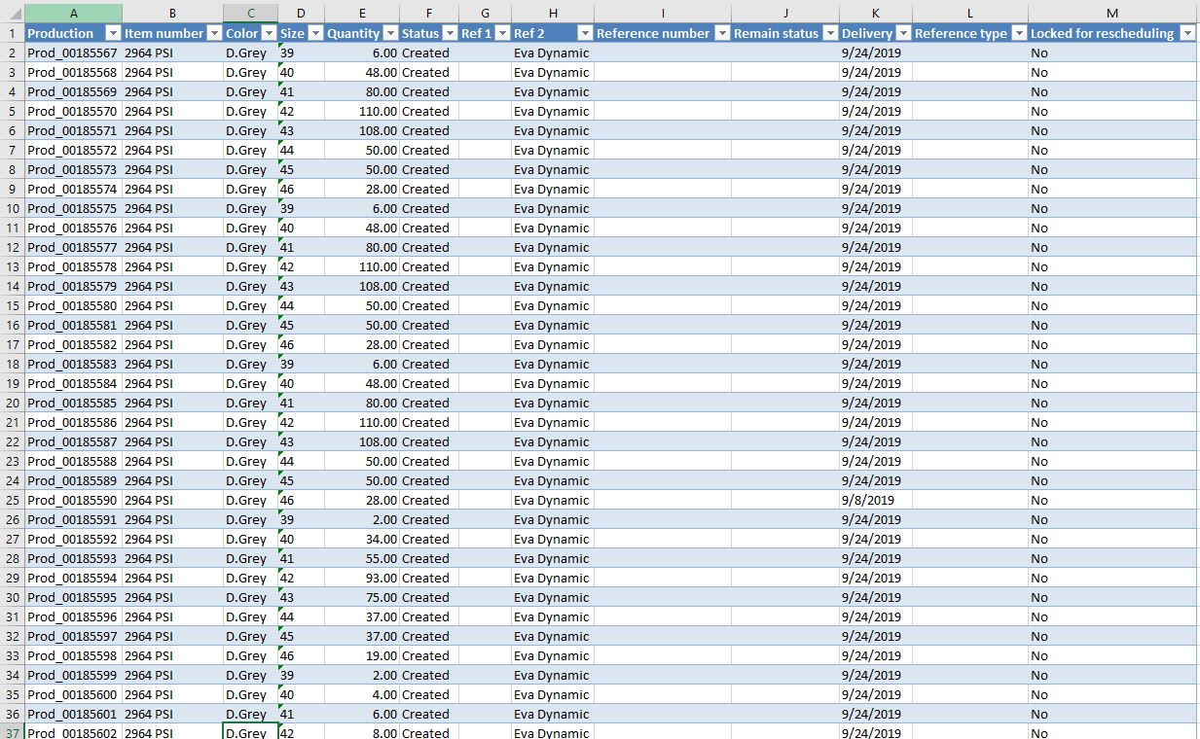
Fig.1.Basic data for the preparation of sale order detail report
Notations
a=Download Data from Microsoft Dynamics AX
b=Delete columns from F to S
c=Put headers from columns F to I (Sole, Start Date, End Date, Reference Number)
d=Copy the data from the active sheet to another sheet
e=Insert row for putting 'Total Pairs'
f=Put Totals below each assortment
g=Put Grand Total
h=change row height of the occupied cells of the worksheet
Activities to be performed in excel during the preparation of sale order detail report are presented in the table 1 given below.
Table 1. Time Study of all the activities of old method for preparing the sale order detail
Activity | Obs. 1  (sec) | Obs. 2  (sec) | Obs. 3  (sec) | Obs. 4  (sec) | Obs. 5  (sec) | Obs. 6  (sec) | Obs. 7  (sec) | Obs. 8  (sec) | Obs. 9  (sec) | Obs. 10  (sec) | Mean Time (sec)
a | 59.28 | 44.44 | 52.44 | 55.7 | 47.23 | 42.13 | 48.34 | 42.62 | 43.61 | 62.36 | 49.82
b | 3.14 | 2.88 | 2.61 | 2.62 | 2.77 | 3.08 | 3.12 | 3.01 | 2.6 | 3.18 | 2.901
c | 18.27 | 13.04 | 14.92 | 14.35 | 14.45 | 11.81 | 12.68 | 15.55 | 18.79 | 13.61 | 14.75
d | 8.73 | 10.76 | 7.52 | 8.21 | 8.08 | 9.82 | 10.84 | 8.69 | 9.43 | 10.09 | 9.217
e | 3.9 | 4 | 4.52 | 4.69 | 3.73 | 3.61 | 3.87 | 3.34 | 4.25 | 3.61 | 3.952
f | 5.06 | 5.25 | 5.3 | 4.8 | 5.21 | 4.66 | 4.84 | 5.05 | 5.52 | 5.11 | 5.08
g | 8.63 | 5.35 | 6.44 | 6.18 | 6.4 | 8.57 | 7.89 | 7.17 | 7.47 | 6.27 | 7.037
h | 14.55 | 15.34 | 13.81 | 14.81 | 13.06 | 8.55 | 12.46 | 14.04 | 8.62 | 8.62 | 12.39
Notations
T = Total Time of the Reprot
n = number of assortments
T= a + b + c + d + n (e + f) + g + h
n = 35
T= 412.223 sec
T = 6.87 min
Old method of preparing the sale order detail used to take 6.87 min.

SUGGESTED METHOD
Automated system contained the user interface for the execution of commands (see fig.2). There were VBA macros behind every command button (see fig.3). Macros were written in two different modules in VBA editor in MS excel and those macros were called behind the command button (see fig.3). The name of suggested template was kept to be automated sale order detail 1.0 (ASOD 1.0) as shown in the fig.2.

Designed Interface for Execution of Macros
For the execution of macros coded for the automation of sale order detail (SOD), a userform was designed containing one picture, three command buttons (Organize SOD, Final Result and Close) and one textbox for the taking the input of ‘sale order number’. The userform appears on the screen when user press ‘Ctrl + q’.
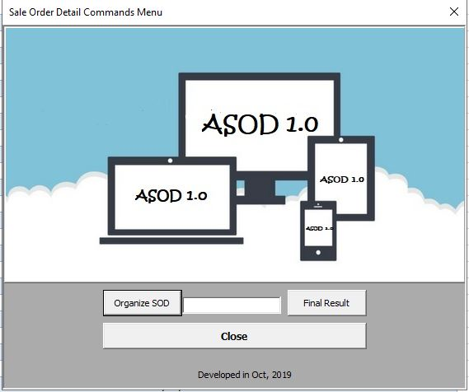
Fig.2.Userform designed for execution of macros
Macros on the back of these command buttons are presented in fig.3. there were eight macros (2 for command button ‘organize SOD’ and six for command button ‘final result’.
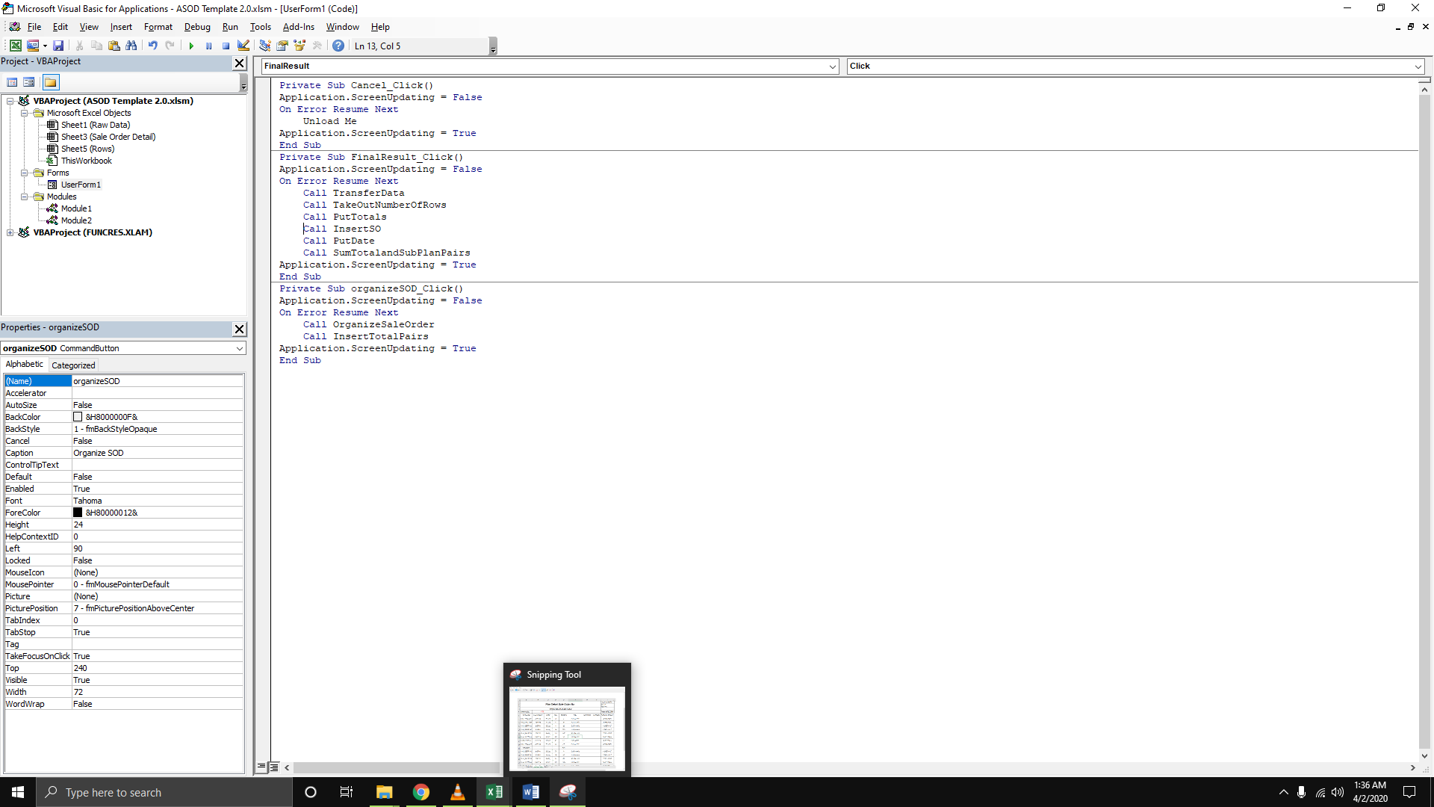
Fig.3. Macros behind each of the command button of the userform presented in fig.2

Needed Worksheets
There arethree worksheets which are used during the preparation of sale order detail. At the very first, data as downloaded from ERP is pasted into ‘Raw Data’ worksheet and after the execution of one macro, it is then transferred to ‘Sale Order Detail’ worksheet in order to calculate individual and collected total for the assortments.
Fig.4. Needed worksheets for the automated sale order detail report
Since, it is very difficult to calculate total of the unknown range in excel; that`s why the starting row of each assortment was printed (see fig.8) in the ‘Rows’ worksheet; so that, the range can be defined (as summation range is defined in summation formula by using rownum variable in 6.1.5) at the time of summation in ‘Sale Order Detail’ worksheet.

Macros behind Command Buttons
All macros are explained individually in below given headings.

Organize Sale Order
The code given below is used for the deleting the columns (F to S) and then for inserting the column headers on the columns from F1 to I1.
Sub OrganizeSaleOrder()
With Worksheets("Raw Data")
.Columns("F:g").EntireColumn.Delete
.Columns("G:R").EntireColumn.Delete
.Range("F1").Value = "Sole"
.Range("G1").Value = "Start Date"
.Range("H1").Value = "End Date"
.Range("I1").Value = "Reference Number"
End With
End Sub
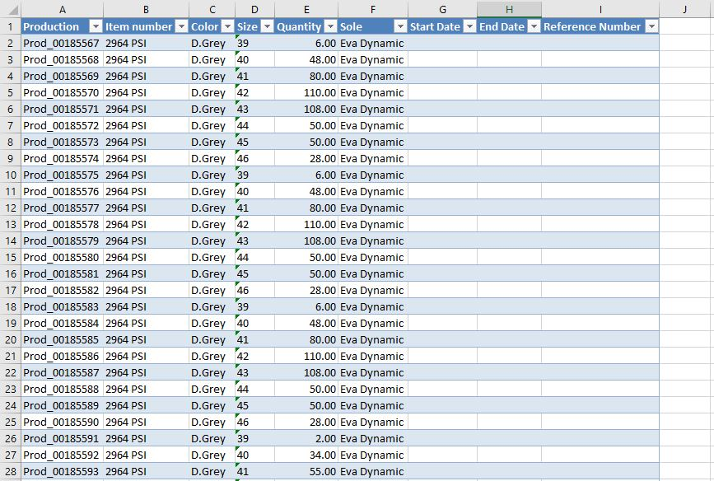
Fig.5.Result of above given code
Result of the code given above is presented in the fig.5.

Insert Heading of ‘Total Pairs’
In order to insert the row after every assortment, do while loop was used with the condition of if the next cell value (downward) is less than the value in above cell; in case, the condition comes true then the row is inserted and the loop is forwarded with the increment of two. In case, condition comes false then the loop is forwarded with one increment as presented in the code below.
Sub PutHeadingOfTotalPair()
Dim row As Long
Dim rowscount As Long
rowscount = Worksheets("Raw Data").Cells(rows.Count, 1).End(xlUp).row
row = 2
Do Until Worksheets("Raw Data").Cells(row, 1).Value = ""
If Worksheets("Raw Data").Cells(row + 1, 4).Value < Worksheets("Raw Data").Cells(row, 4).Value Then
With Worksheets("Raw Data")
.rows(row + 1).Insert
.Cells(row + 1, 1).Value = "Total Pairs"
.Cells(row + 1, 1).Font.Bold = True
row = row + 2
End With
Else
row = row + 1
End If
Loop
With Worksheets("Raw Data")
.Cells(row, 1).Value = "Grand Total"
.Cells(row, 1).Font.Bold = True
End With
End Sub
Inserted rows can be seen in the fig.6 with the header of ‘Total Pairs’.
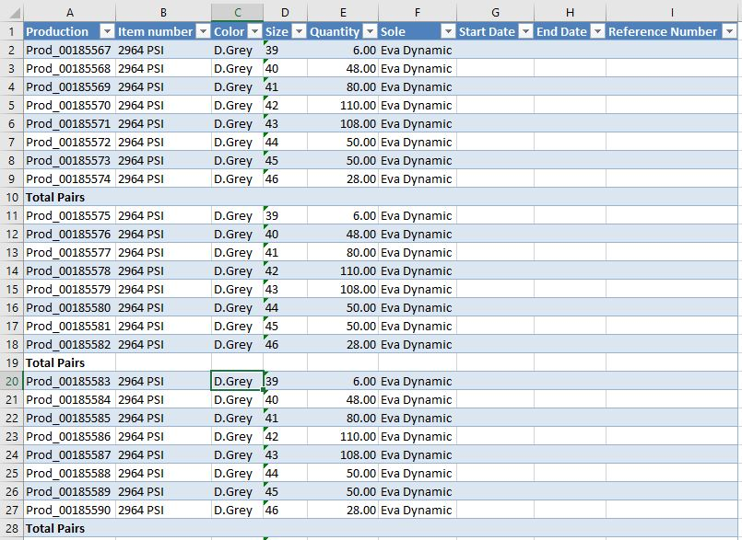
Fig.6.Result of above given code

Transfer Data from ‘Raw Data’ Worksheet to Sale Order Detail
By the help of macro presented below, the data is transferred from ‘Raw Data’ worksheet to ‘Sale Order Detail’ worksheet cell by cell. This whole process is performed by the help of for loop executed for as much times as much there are non-empty cells in the first column. Non-empty rows are counted by the help of rowscount variable; and in order paste in the ‘Sale Order Detail’ worksheet, variable i.e. row is taken with the value of 6. For loop starts pasting the data from ‘Raw Data’ worksheet (From A1) in ’Sale Order Detail’ form 6th row (see fig.7).
Dim row As Long
Dim rowscount As Long
rowscount = Worksheets("Raw Data").Cells(rows.Count, 1).End(xlUp).row
row = 6
Worksheets("Sale Order Detail").Select
For i = 1 Torowscount
With Worksheets("Sale Order Detail")
.Cells(row, 1).Value = Worksheets("Raw Data").Cells(i, 1)
.Cells(row, 2).Value = Worksheets("Raw Data").Cells(i, 2)
.Cells(row, 3).Value = Worksheets("Raw Data").Cells(i, 3)
.Cells(row, 4).Value = Worksheets("Raw Data").Cells(i, 4)
.Cells(row, 5).Value = Worksheets("Raw Data").Cells(i, 5)
.Cells(row, 6).Value = Worksheets("Raw Data").Cells(i, 6)
End With
row = row + 1
Next
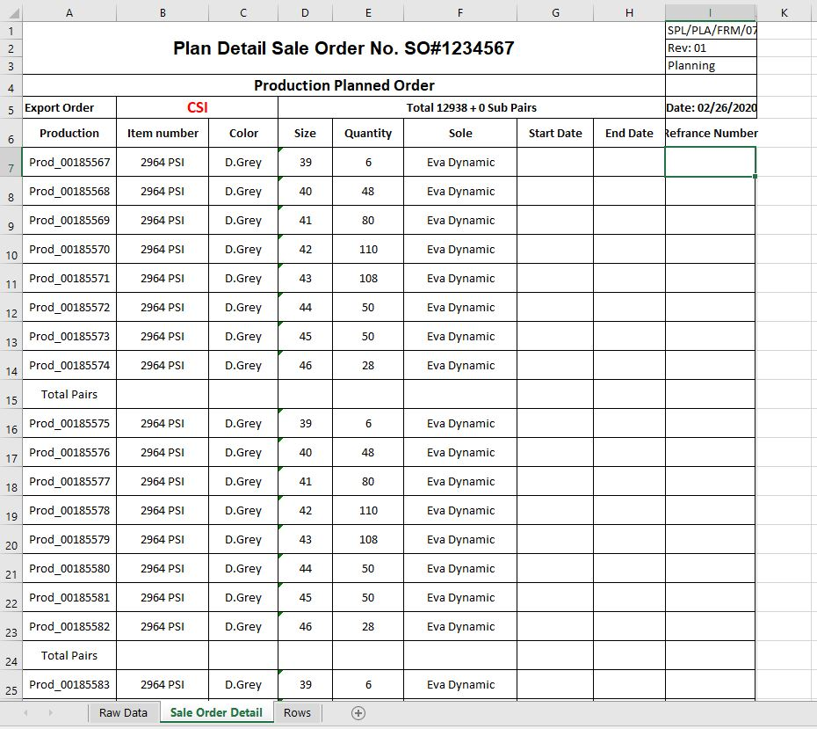
Fig.7.Result of above given code

Print Row Number of ‘Rows’ Worksheet
In order to put the totals of assortments, it was necessary to define the row number (from where each assortment starts) of each assortment. By the of code of below given macro, the headings i.e. ‘Total Pairs’ is made bold and on the same time, number of that row is pasted in ‘Rows’ worksheet (see fig.8). In fig. 7, it can be seen that first heading i.e. ‘Total Pairs’ is contained by 15th row as pasted in ‘Rows’ worksheet, which can be seen in the fig.8.
Dim row As Long
Dim rowscount As Long
rowscount = Worksheets("Sale Order Detail").Cells(rows.Count, 1).End(xlUp).row
row = 1
For i = 7 Torowscount
If Worksheets("Sale Order Detail").Cells(i, 1).Value = "Total Pairs" Then
With Worksheets("Sale Order Detail")
.Cells(i, 1).Font.Bold = True
End With
Worksheets("Rows").Cells(row, 1).Value = Worksheets("Sale Order Detail").Cells(i, 1)
Worksheets("Rows").Cells(row, 2).Value = i
row = row + 1
End If
Next
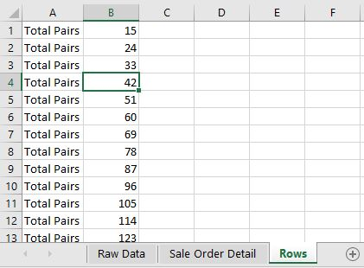
Fig.8.Result of above given code

Put Totals Below Each Assortment
In the macro as presented in the below given code, two variables i.e. rownum and rowsum are used to define the range for putting sum of total pairs of each assortment. Variable i.e. rownum contains the value present in the rowsum cell of second column in the ‘Rows’ worksheet. The value stored in rownum variable is stored in another variable called ‘row’ after the first execution of for loop with the increment of 1; on the same time, the value of rowsum variable is increased by one after the first execution of for loop. Since, the value of rowsum is increased by one then the value of rownum will automatically change. This cycle repeats itself as much as the number of rows in the first column of the ‘Sale Order worksheet’.
Dim row As Long
Dim rowscount As Long
Dim rownum As Long
Dim rowsum As Long
On Error Resume Next
Dim rowscountrows As Integer
Dim RowsSaleOrderDetailAs Integer
rowscount = Worksheets("Sale Order Detail").Cells(rows.Count, 1).End(xlUp).row
'MsgBox (rowscount)
row = 7
rowsum = 1
For i = 1 Torowscount
rownum = Worksheets("Rows").Cells(rowsum, 2).Value
If Worksheets("Sale Order Detail").Cells(i, 1).Value = "Total Pairs" Then
With Worksheets("Sale Order Detail")
.Cells(i,5).Value=Application.WorksheetFunction.Sum(Worksheets("Sale OrderDetail").Range(Cells(row, 5), Cells(rownum - 1, 5)))
.Cells(i, 5).Font.Bold = True
Worksheets("Rows").Cells(rowsum, 3) = Worksheets("Sale Order Detail").Cells(i, 5).Value
End With
row = rownum + 1
rowsum = rowsum + 1
End If
Next
With Worksheets("Sale Order Detail")
.Cells(rowscount, 5).Value = Application.WorksheetFunction.SumIf(Worksheets("Sale Order Detail").Range("A7:A10485"), "Total Pairs", Worksheets("Sale Order Detail").Range("E7:E10485"))
.Cells(rowscount, 5).Font.Bold = True
.Cells(rowscount, 1).Font.Bold = True
.Range(Cells(7, 1), Cells(rowscount, 9)).RowHeight = 25
End With
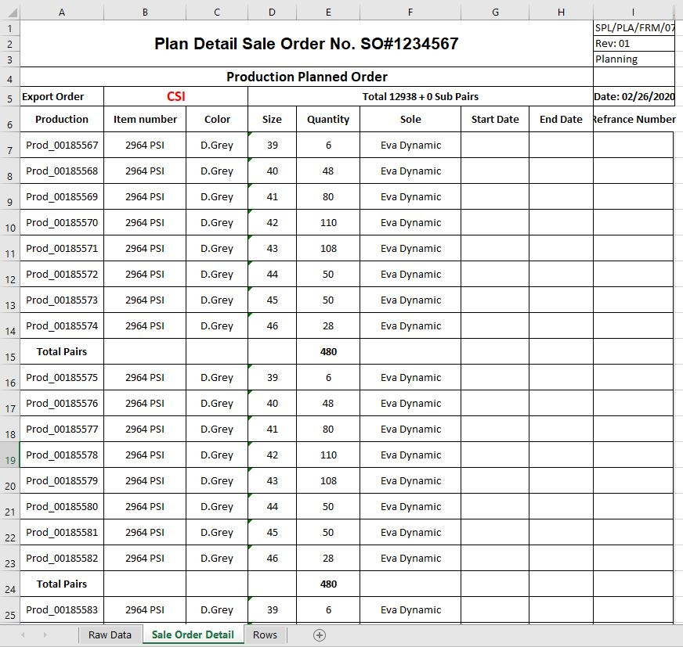
Fig.9.Result of above given code
By the help of loop, the total pairs of each of the assortment are put against the row number in the ‘Rows Worksheet’ which can be seen in the fig.10. The font of headings (Total Pairs and Grand Total) is made bold at the end and the height of the rows in ‘Sale Order Detail’ worksheet is increased to 25 as shown in the fig.9.
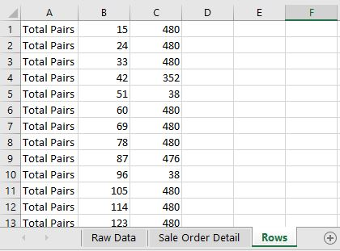
Fig.10.Result of above given code in the ‘Rows’ worksheet

Insert SO Number and Date
After putting the totals below each assortment, the sale order number is put the 9th column of the ‘Sale order Detail; worksheet. On the empty textbox, the message for filling the textbox is received as shown in the fig.11.
If UserForm1.TextBox1.Text = "" Then
MsgBox "Please Insert SO#", vbCritical
Else
rowscount = Worksheets("Sale Order Detail").Cells(rows.Count, 1).End(xlUp).row
For i = 7 Torowscount
If Worksheets("Sale Order Detail").Cells(i, 1).Value = "Total Pairs" Or Worksheets("Sale Order Detail").Cells(i, 1).Value = "Grand Total" Then
With Worksheets("Sale Order Detail")
.Cells(i, 9).Value = ""
End With
Else
With Worksheets("Sale Order Detail")
.Cells(i, 9).Value = UserForm1.TextBox1.Text
End With
End If
Next
End If
Put Date
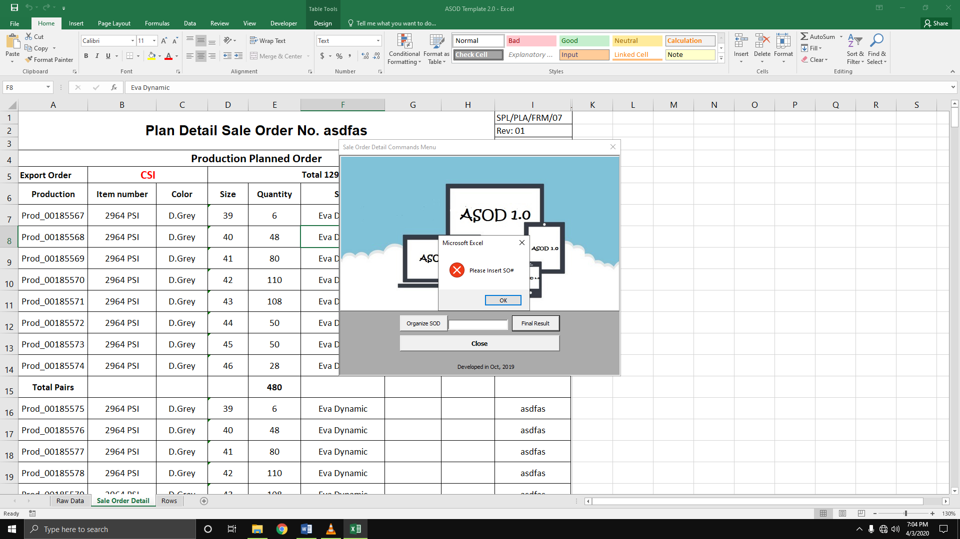
Fig.11.Result of above given code
By using the code given below, date is put into the cell ‘I5’ which can be seen in the fig.12 below.
Worksheets("Sale Order Detail").Range("I5").Value = "Date: " & Format(Now(), "mm/dd/yyyy")
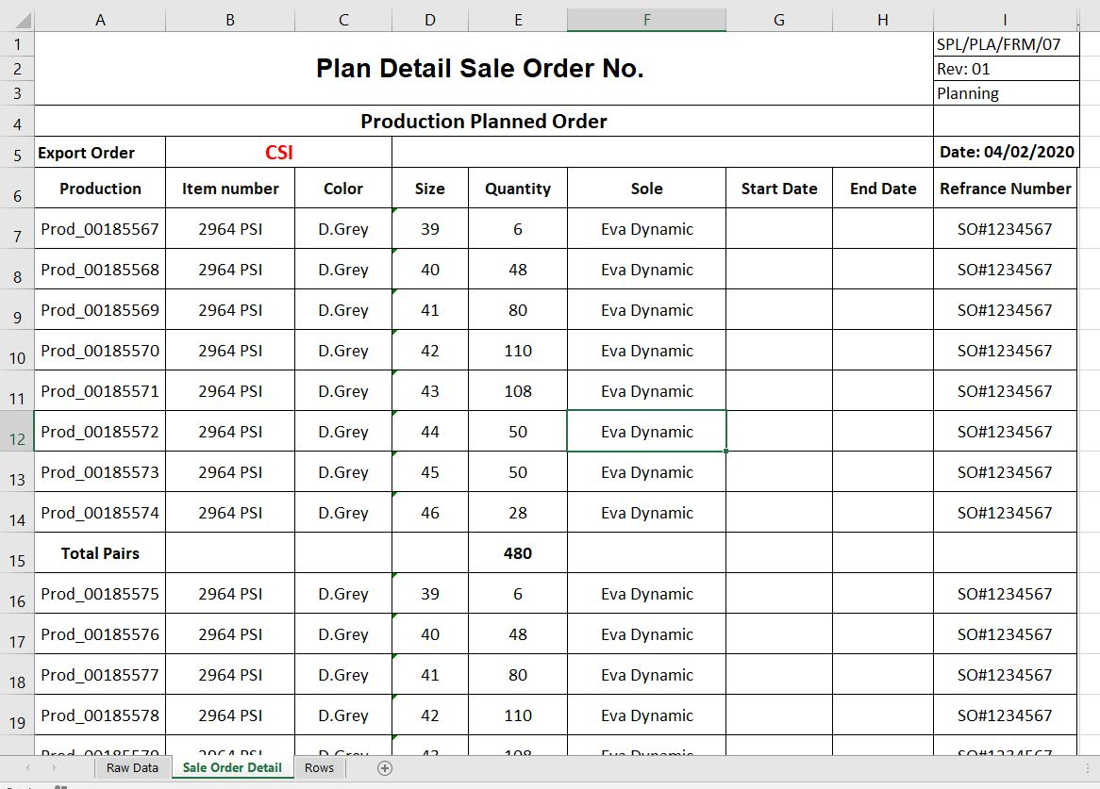
Fig.12.Result of above given code

Put Total Plan Pairs and Sub Plan Pairs
After all tasks discussed earlier, total plan pairs and sub plan pairs are put into the merged cells i.e. D5:H5 (see fig.13).
rowscount = Worksheets("Rows").Cells(rows.Count, 1).End(xlUp).row
For i = 1 Torowscount
If Worksheets("Rows").Cells(i, 3).Value <= 20 Then
Worksheets("Rows").Cells(i, 4).Value = Worksheets("Rows").Cells(i, 3).Value
Worksheets("Rows").Cells(i, 3).Value = ""
Else
Worksheets("Rows").Cells(i, 4).Value = ""
End If
Next
PlanPairs = Application.WorksheetFunction.SumIf(Worksheets("Rows").Range("A1:A10485"), "Total Pairs", Worksheets("Rows").Range("C1:C10485"))
SubPlanPairs = Application.WorksheetFunction.SumIf(Worksheets("Rows").Range("A1:A10485"), "Total Pairs", Worksheets("Rows").Range("D1:D10485"))
With Worksheets("Sale Order Detail")
.Select
.Range("D5").Value = "Total " &PlanPairs& " + " &SubPlanPairs& " Sub Pairs"
.Range("A1").Value = "Plan Detail Sale Order No. " & UserForm1.TextBox1.Text
End With
Criteria for plan pairs is defined earlier in the code given just above; the number of pairs > 20 are recognized as the plan pairs and number of pairs < 20 are defined as the sub plan pairs. therefore, sub plan pairs are copied from third column of ‘Rows’ worksheet to 4th column of the active worksheet; on the same, sub plan pairs are deleted from 3rd column of the active worksheet.
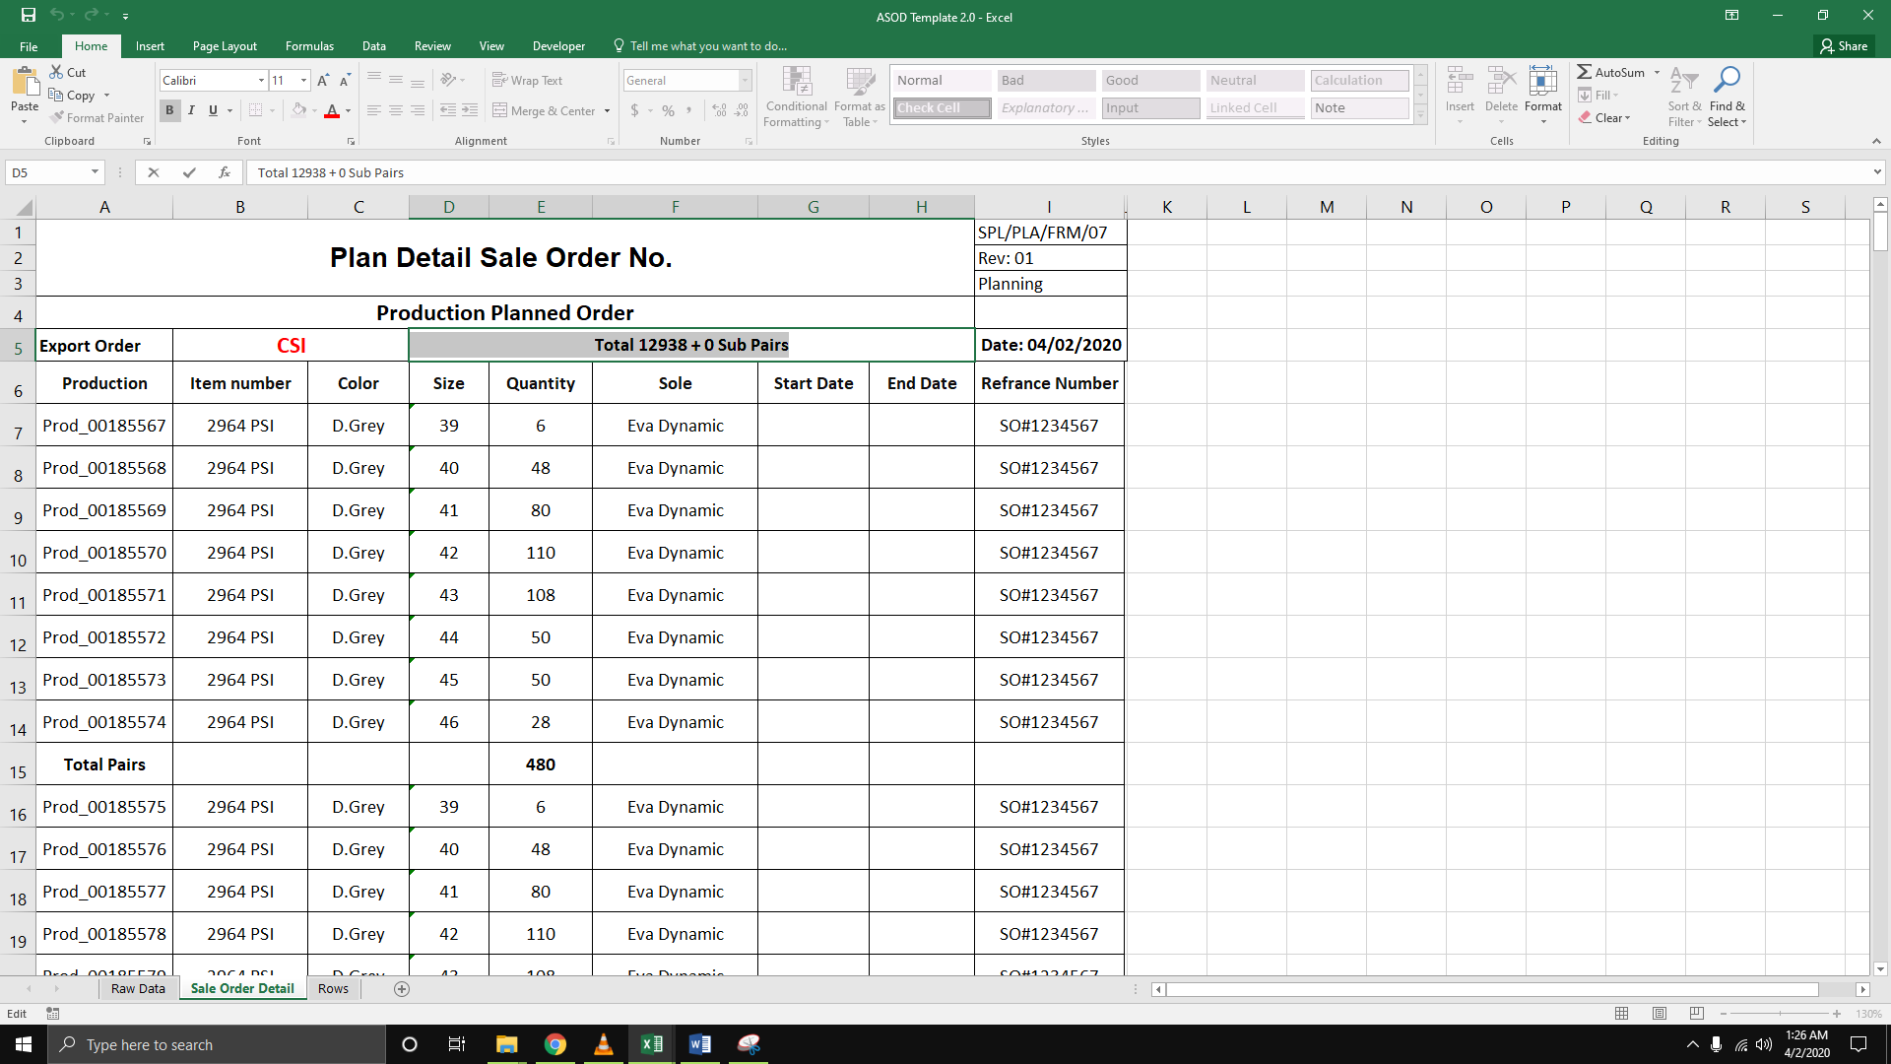
Fig.13.Result of above given code

Time Consumed by New Method
Similar to the old method of preparing SOD, time study of various automated tasks performed in ASOD 1.0 was conducted (see table 2).
Notations
i=Press Ctrl + Q and Form Appears
j=Execution time of Command Button 'Organize SOD'
k=Write SO# into the textbox
l=Execution time of Command Button 'Organize SOD'
m=Close Form
Table 2. Time study of suggested method
Activity | Obs. 1  (sec) | Obs. 2  (sec) | Obs. 3  (sec) | Obs. 4  (sec) | Obs. 5  (sec) | Obs. 6  (sec) | Obs. 7  (sec) | Obs. 8  (sec) | Obs. 9  (sec) | Obs. 10  (sec) | Mean Time (sec)
a | 59.28 | 44.44 | 52.44 | 55.7 | 47.23 | 42.13 | 48.34 | 42.62 | 43.61 | 62.36 | 49.82
i | 1.27 | 1.23 | 1.51 | 1.87 | 1.25 | 1.36 | 1.15 | 1.81 | 1.45 | 1.4 | 1.43
j | 2.44 | 1.8 | 1.4 | 2.83 | 2.22 | 1.76 | 3.07 | 2.15 | 1.16 | 2.11 | 2.094
k | 4.3 | 4.49 | 4.64 | 3.7 | 4.25 | 4.08 | 5.02 | 4.53 | 4.28 | 4.43 | 4.372
l | 5.25 | 5.52 | 5.63 | 5.19 | 5.71 | 5.65 | 5.81 | 5.28 | 5.11 | 5.07 | 5.422
m | 1.28 | 0.94 | 1.12 | 0.97 | 1.26 | 1.13 | 0.8 | 1.18 | 1.04 | 1.08 | 1.08
T = a + i + j + k + l + m
T = 64.213 sec
Total time consumed by ASOD 1.0 for preparing the sale order detail as calculated by the formula.
T= 1.07 min

COMPARISON OF BOTH METHODS
Old method used to take 6.87 min for preparing the sale order detail whereas, ASOD 1.0 took 1.07 min. comparison of both methods indicated that new method took 84.42% less time and the accuracy of the new method was 100% if the basic data is accurate.

DISCUSSIONS
For making reports on daily, monthly, quarterly bi-annually and yearly basis every small and medium enterprise (SME) hires employees. In MS excel Most of the report in mentioned sector is conducted. MS excel takes large amount of time manually in the case of complex reporting and at the meantime, there is the extra chance of error as well. Microsoft has thus already kept the flexibility of customized automation in its application such as Word, Excel, PowerPoint and Project by Visual basic for applications (VBA) especially for this problem. Visual basic editor (VBE) conducts the work on VBA. Therefore, Microsoft has already developed the technologies i.e. VBA, VSTO, ActiveX and etc. [4][19]. In Microsoft windows, VBA technology is provided on the platform of many software [20][3][21]. Currently, companies, employees are promoted for gaining the skills and knowledge of using excel and VBA [22]. When it is about VBA, then it is about the customization and development in integrated development environment (IDE) in the applications of MS office for the automation and simplification of manual, complex and repeated work [4][15][23][21][20].Basically it is known for automating the routine work in existing office productivity applications [4][22]. Objective of the recently research was to automate the material delivery time report analysis. Whenever the employees used to forget the steps of making the report and due to that error were greater. This report was used to be prepared at the case company once in a month and in the meantime. A large Number of VBA in excel were programmed to implement those commands which were once done manually in excel. All those macros used to be run on the single click. When the input from user is to be taken userforms are used [15]. A code is required to run the operations automatically [15][21][17]. If literature is traced back and the prevalence of same research is found. As VBA was used by Bartoszewicz and Wdowicz (2019) in order to recreate and execute the process for migration of data and its analysis; was quite faster, flexible and the way to speed the complex analytical report formation; comparison of old and new method revealed , and as usual time of report was reduced form 2 hours to 5 minutes [24]. By the usage of excel VBA Cirujano and Zhu (2013) worked on the manpower resource planning report; an experienced employee had to work for 30 working hours to make the report but after the automation by VBA, it takes 10 minutes [7]. In the same way through VBA in excel Kalwar and Khan (2020) automated the provision report at the planning and costing department of the company through which 75% of the employee`s time was saved [17] New method takes 1.55 minutes to complete the report whereas Old method of preparing the material delivery analysis report used to take 5.324 minutes. So if we compare both methods it is clear that the new method takes 70.86% less time as compared to the old method. Because of automated operation, there would be no chance or error in the report if the basic data is 100% accurate, so it is obvious that new method is more efficient and effective. A mechanism of generating bill of material of transmission line by using VBA was developed by Yan and Wan (2017) ; efficiency and accuracy of calculation are tremendously reduced; at the same time, errors in the calculation process of steel BOMs were improved [16].Another researcher Abidin et al., (2013) also calculated API and WQI in the automated way; they reported that calculation time and errors were reduced by automating the calculations in the Microsoft excel VBA [1].

CONCLUSION
Repeated manual operation leads to mental fatigue and it includes the greater chance of human error; therefore, in order to save employees from quick mental fatigue, one of the report i.e. sale order detail report was automated with visual basic for applications in excel. Time consumption both (old and new method) methods were calculated and the comparison showed that new method takes 84.42% less time than old method. Furthermore, the most important benefit of this automation is that there is no need to recheck the report (which is prepared by new method) for mistakes.

FUTURE IMPLICATIONS
Since, automation in excel reporting is not the permanent solution when there is the usage of Microsoft Dynamics AX 2012 in the company. Automation in excel is a good solution but it is not counted for the long run. Therefore, it was suggested to the company for the incorporation of the report into Microsoft Dynamics AX 2012.

ACKNOWLEDGEMENT
Authors of this research paper would like to thank the employee of the planning and costing department who cooperated in making them learn the report and gave proper feedback to brings its accuracy.

CONFLICT OF INTEREST
Among the authors of the present paper, there was no conflict of interest.

REFERENCES
[1] I. Z. Abidin, H. Juahir, A. Azid, A. D. Mustafa, and F. Azaman, “Application of Excel-VBA for computation of water quality index and air pollutant index,” Malaysian J. Anal. Sci., vol. 19, no. 5, pp. 1056–1064, 2015.
[2] M. Bernard, E. Dwi Minarti, and M. Hutajulu, “Constructing Student’s Mathematical Understanding Skills and Self Confidence: Math Game with Visual Basic Application for Microsoft Excel in Learning Phytagoras at Junior High School,” Int. J. Eng. Technol., vol. 7, no. 3.2, pp. 732–736, 2018, doi: 10.14419/ijet.v7i3.2.18738.
[3] T. Norton and B. Tiwari, “Aiding the understanding of novel freezing technology through numerical modelling with visual basic for applications (VBA),” Comput. Appl. Eng. Educ., vol. 21, no. 3, pp. 530–538, 2013, doi: 10.1002/cae.20498.
[4] H.-L. DING, K.-Y. QI, X.-L. ZHAO, and G.-F. XU, “Tibetan Typographical Specifications and Technical Realization Based on Word VBA,” in 4th International Conference on Advanced Education and Management, 2017, pp. 407–412, doi: 10.12783/dtssehs/icaem2017/19117.
[5] P. J. Blayney and Z. Sun, “Using Excel and Excel VBA for Preliminary Analysis in Big Data Research,” in Managerial Perspectives on Intelligent Big Data Analytics. IGI Global, no. March, 2019, pp. 110–136.
[6] R. Abraham and M. Corporation, “Spreadsheet Programming,” Wiley Encyclopedia of Computer Science and Engineering. 2008.
[7] J. Cirujano and Z. Zhu, “Automatic reporting for manpower resources,” Proceedings, Annu. Conf. - Can. Soc. Civ. Eng., vol. 1, no. January, pp. 710–719, 2013.
[8] M. A. Kalwar, M. A. Khan, S. A. Shaikh, A. Salam, M. S. Memon, and S. A. Khaskheli, “Aggressive Driving Behavior : A Case Study of Mehran UET ,” in Proceedings of the International Conference on Industrial Engineering and Operations Management Dubai, 2020, pp. 2350–2359, [Online]. Available: http://www.ieomsociety.org/ieom2020/papers/175.pdf.
[9] S. A. Khaskheli, M. A. Kalwar, A. A. Siddiqui, M. A. K. Nagar, and T. H. Wadho, “Impatience Among Drivers With Varying Demographics,” in Professional Trends in Industrial and Systems Engineering, 2018, pp. 465–469.
[10] A. Ahmadi, P. H. Robinson, F. Elizondo, and P. Chilibroste, “Implementation of CTR dairy model using the visual basic for application language of Microsoft excel,” Int. J. Agric. Environ. Inf. Syst., vol. 9, no. 3, pp. 74–86, 2018, doi: 10.4018/IJAEIS.2018070105.
[11] A. Belchior Junior et al., “Development of a Vba Macro-Based Spreadsheet Application for Relap5 Data Post-Processing,” in International Nuclear Atlantic Conference, 2011, pp. 978–85.
[12] R. Hila, “Water Quality Data Management Database,” 2009.
[13] K. SATO and R. YOKOYAMA, “Teaching Aid for Remote Sensing and Map Imagery Analysis Using Excel Spreadsheet and VBA,” 2001, [Online]. Available: http://www.crisp.nus.edu.sg/~acrs2001/pdf/015venka.pdf.
[14] J. Daniel et al., “Mathematical Model and Programming in VBA Excel for Package Calculation,” Int. J. Eng. Res. Appl., vol. 6, no. 5, pp. 55–61, 2016.
[15] H. T. Evensen, “A versatile platform for programming and data acquisition: Excel and Visual Basic for Applications,” 2014.
[16] Q. Yan and Y. Wan, “Using the special font and VBA program to make bill of materials in the transmission line engineering,” Rev. la Fac. Ing., vol. 32, no. 2, pp. 335–341, 2017.
[17] M. A. Kalwar and M. A. Khan, “Optimization of Procurement & Purchase Order Process in Foot Wear Industry by Using VBA in Ms Excel,” Int. J. Bus. Educ. Manag. Stud., vol. 5, no. 2, pp. 80–100, 2020, [Online]. Available: https://www.ijbems.com/doc/IJBEMS-124.pdf.
[18] A. Mustafa and A. Hatemi-J, “A VBA module simulation for finding optimal lag order in time series models and its use on teaching financial data computation,” Appl. Comput. Informatics, 2020, doi: 10.1016/j.aci.2019.04.003.
[19] D. Porter and R. Stretcher, “Automating Markowitz Optimizations Using VBA,” J. Instr. Tech. Financ., vol. 4, no. 1, pp. 9–16, 2012.
[20] S. Kuka and B. Karamani, “Using Excel and VBA for Excel to Learn Numerical Methods,” in 1st International Sympsosium on Computing in Informatics and Mathematics, 2011, pp. 365–376.
[21] M. I. P. Harahap and M. H. Azmi, “Development of Excel Vba Program for Small Drainage Network,” E-Academia J., vol. 6, no. 1, pp. 216–227, 2017.
[22] S. CHATVICHIENCHA, “Enhancing Computational Thinking by Excel-VBA Based Problem Solving,” in The 2nd International Conference on Innovation in Education, 2015, pp. 284–290, [Online]. Available: http://www.il.mahidol.ac.th/icie2015/images/ICIE2015 Conference Proceeding-Final.pdf.
[23] C. F. Minto, PKPD Tools for Excel. 2009.
[24] G. Bartoszewicz and M. Wdowicz, “Automation of the Process of Reporting the Compliance of the Production Plan with Its Execution Based on Integration of SAP ERP System In Connection With Excel Spreadsheet and VBA Application,” in Digitalization of Supply Chains, 2019, pp. 101–116.

