**AN ASSESSMENT OF HOUSING CONDITIONS ON SUSTAINABLE HUMAN SETTLEMENT IN THE CORE AREAS OF ADO-EKITI, METROPOLIS, NIGERIA.**

**DARAMOLA JOSHUA O.1 IBITOYE OYEWOLE A.2 AND AGBOOLA JOSEPH T.3**

**DEPARTMENT OF URBAN AND REGIONAL PLANNING**

**THE FEDERAL POLYTECHNIC ADO-EKITI1,3**

**DEPARTMENT OF GEOGRAPHY AND PLANNING SCIENCE,**

**FACULTY OF THE SOCIAL SCIENCES, EKITI STATE UNIVERSITY,**

**ADO-EKITI2**

**Tel: 08034066021 Email: orimo60@yahoo.com1, Tel: 08033829110 Email:** [**woleibitoye@yahoo.com**](mailto:woleibitoye@yahoo.com)**2. and Tel: 08063351265 Email: agboolame2002@yahoo.com3**

**ABSTRACT**

The rate of population growth and rapid urbanization all over the world has made housing problem a global issue, confronting both the developed and developing countries although with varying degree of severity. The aim of this research work, is to assess the housing conditions in terms of overcrowding, inadequate infrastructural facilities, physical conditions of the buildings, surrounding environmental quality and socio-economic characteristic of the residents, in the 5 wards of the core areas of Ado-Ekiti, out of the 13 wards of the local government area. These five wards were digitized through Google map and a total number of 28374 buildings were identified. According to Neuman (1991) larger population permits smaller sampling ratio for equal good samples. Therefore 2% of the buildings give 568 copies of question that were administered. Findings revealed that, majority of the buildings are deficient of indices of housing qualities such as water supply, lighting, toilets, kitchens, sub- standard and environmental quality for sustainable human settlement. The implications of these are that social environmental, economic and other societal problems will contribute to the challenges of residential housing in the study area. There is a need for integrated urban infrastructure and services needed not only to reduce existing deficiencies as revealed from the findings but also to meet the rapidly expanding infrastructural facilities in an integrated project framework like water supply, electricity, sewage, solid waste management, drainage and other essential public services.

**Keywords:** Housing Condition, Ado-Ekiti, Infrastructural Facilities, Environmental Quality, Sustainable human Settlement.

**Introduction**

Housing represents the most basic of human needs and has a profound impact on the health, welfare and productivity of individuals. (FCDA 1999).

Decent housing is one of the needs of individuals, the family and the environment it has a profound influence on health, efficacy, social behaviour, satisfaction and general welfare of the community. It reflects the cultural, social aesthetic and economic values of society as it is the best physical and historical evidence of civilization in a country (Adeoye et al 2014).

The problem of housing in Nigeria are enormous and complex, exhibiting apparent and marked regional differences.

In most of our urban centres, the problem is not only restricted to quantity but also to the poor quality of available housing units and the environment. The result is manifested in growing overcrowding in homes and increasing pressure on infrastructural facilities and rapidly deteriorating environment (New National Housing Policy, 1985).

House inhabited by poor people are always overcrowded in the poor neighbourhoods and are prone to infection diseases, poor sanitation, and lack of drinkable water. In most of Nigeria cities, because there is inadequate houses to meet the increase urban population, poor people that want to have roof over their heads have no option than to provide houses for themselves whatever the standard in relation to their economic capacity. This always result to ramshackle or shanty buildings and dirty environment not suitable for human settlement.

“Housing” is more than merely the dwelling unit. It is a complex product made up of a combination of services; indoor living spaces, land, utilities, locational situations (with respect to work and community services), outdoor living space, and relationships to neigbours, family members and friends.

In Nigeria today, as in most developing countries, the mix of the elements constituting housing varies widely, ranging from spacious. Well serviced homes, accessible to a wide range of jobs and community services, to unserviced slum dwellings far from job location (FCDA 1979).

Characteristics of slum associated with poor housing condition and environment are- lack of basic services, absence of waste collection systems, electricity supply, surfaced roads, and foothpaths, street lighting and rain water drainage; substandard housing or illegal and inadequate building structures, overcrowding and high density, unhealthy living conditions and hazardous locations, insecure tenure, irregular or informal settlements, poverty and social exclusion and minimum settlement (Challenges of Slum, Global Report on Human Settlements 2003).

The quality and living conditions of the house that one lives has great impact in the socio-economic and mental wellbeing of the residents of such building.

Observation of the study area revealed that houses and the environment are characterised with overcrowding dilapidated building, poor drainage system for storm water, which contributes greatly to flooding. Major parts of the area is piled up with solid wastes due to absence of adequate waste collection system. The houses are constructed without adequate open spaces from other buildings creating the problem of open air living between the houses. There is sanitary problems due to inadequate and proper disposal of human excreta that affects the quality of drinking water and also cause environmental pollution. Most of the houses are in rectangular form with detached kitchen without toilet facilities lighting and ventilation, with the absence of electricity and portable water supply. In these core areas housing challenges are both qualitative and quantitative.

**Literature Review**

Shelter has been universally accepted to be one of man’s second most important essential human need, after food. Housing in all its ramifications is more than shelter since it embraces all of the social services and utilities that go to make a community or neighbourhood a liveable environment. (New National Housing Policy 1985).

In any particular human settlement, housing quality is very important achieve a conducive human living. The physical condition, with the provision of essential facilities in housing are major factors that make a housing to be liveable and healthy for man in an environment. In many urban areas in Nigeria, population increase through the influx of people from rural areas has not be been able to meet up with housing need and standard in areas of basic amenities and infrastructural facilities.

Amao (2012), observed that with increase in population from rural areas to urban centres, old settlements are congested and crowded, new formentions emerge without preliminary design and planning and without infrastructure. Quoting from the Draft National urban Development Policy (NUDP 2004), Amao (2012) also observed that the problem of uncontrolled urbanization in Nigeria is already with us in all our cities, Nigeria towns are growing without adequate planning, millions of Nigerians live in sub-standard and sub-human environment, played by slum, squarlor and grossly inadequate social amenities. The result is manifested in growing overcrowding in homes and increasing pressure on infrastructural facilities and rapid deterioting environment.

Amao (2012) opined that, the greater percentage of the poor in the urban area lives in the slum area of the city. This is mainly because substandard accommodation that is very cheap and the neighbourhoods are in close proximity to their working place.

Substandard housing is the type of housing that does not meet the standards for living by people. These standards are usually set by governments and deal with how safe the dwelling is for the people to live. For example, there may not be appropriate heating, plumbng, electricity or proper sanitation. Often substandard housing that has not all these facilities does not meet building codes. (Amao, 2012).

Factors such as tenure, dwelling type, physical conditions of buildings, infrastructural facilities and services in the dwelling unit and surrounding environment can be used to measure housing conditions and liveability in an environment.

Nor et al. (2012), opined in support of Harker (2007) and Green (2011) respectively, said that housing condition and overcrowding could have a significant impact on children’s immediate and long-term effects on health, education, safety and behaviours and that physical housing conditions such as the presence of roaches, plumbing defects and heating cooling problems contribute significantly to mental health dysfunction such as being depressed, feeling worried, feeling sad, feeling helpless and feeling emotionally upset.

Another factor related to housing condition is the surrounding environment. Most of squatter areas and low cost houses have limited space and recreation areas, such as multipurpose hall, and play ground to be used for community and recreational activities (Nor et al., 2012).

Variables or indicators such as adequate space for circulation, safety of the environment, privacy, ventilation, adequate water supply, lighting, waste management, sanitation and social services are important factors that make a community or a neighbourhood to be a sustainable human settlement.

Qualitative determinants in a dwelling unit and its environs are related to age of the building aesthetics, availability of basic housing facilities, absence of noise and air pollution, good neighbourhood road network, waste disposal management and provision of other infrastructural facilities. All these will bring sustainable growth and development and improve the livelihood of the residents.

**Research Locale**

Ado-Ekiti Local Government is centrally and strategically located in Ekiti land to give way for maximum spatial interaction with all towns in the state. The existing road network that links Ado Ekiti Local Government Area with these towns and other towns in the neighbouring states are Ado–Akure, Ado-Omuo Aran, Ado-Ilesa and Ado- Ikare roads. Others are Ado-Ilawe and Ado- Afao roads. The administrative changes over the years have contributed immensely to the population growth and development of the area (Adeoti and Odeyemi 2014)

According to Oriye (2013), the expansion of Ado-Ekiti and its surrounding villages, that constitute the local government area, started with the creation of Ado-Ekiti as the divisional headquarters of Ekiti Division in 1945 and with the creation of old Ondo State in 1976, the city continued to expand; this expansion became significant with the creation of Ekiti State in 1996. The resultant expansion had caused a change in the use and apportioning of land because various forms of people, goods and services found their way into the local government area; thus diversifying the land use and making it more intense with the resultant city expansion. The city at 10years intervals from 1956-2006 and note how this has affected the land use.

Ado-Ekiti local government area is located on about latitude 70 32’ and 70 40’ North of the Equator and about Longitude 5o 6’ and 50 25’ East of the Greenwich Meridian. It has a number of satellite towns around it. To the North is Iworoko, about 16 kilometers away from Ado city centre; to the east are Are and Afao, about 16 kilometers, to the west are Iyin and Igede, about 20 kilometers, and to the south is another major town Ikere Ekiti, about 18 kilometer. Ado-Ekiti enjoys the privilege of been a nodal town and status of capital town of Ekiti state hence roads that leads to other parts of the state converge in the city. The area lies within the topical climate with two distinct seasons of wet and dry. The dry weather is brought by the tropical continental (CT) air mass blowing in from the Sahara desert between the months of November and March and the wet season comes either the tropical maritime (MT) air mass originating from the Atlantic Ocean between the months of April and October. The total rainfall is 450mm giving a mean monthly rainfall of 121mm. there is a sharp fall in rainfall at a period between July and August (August break). Temperature in the region is high throughout the year with a means monthly temperature of 270c temperature (February) and the month lowest (August).

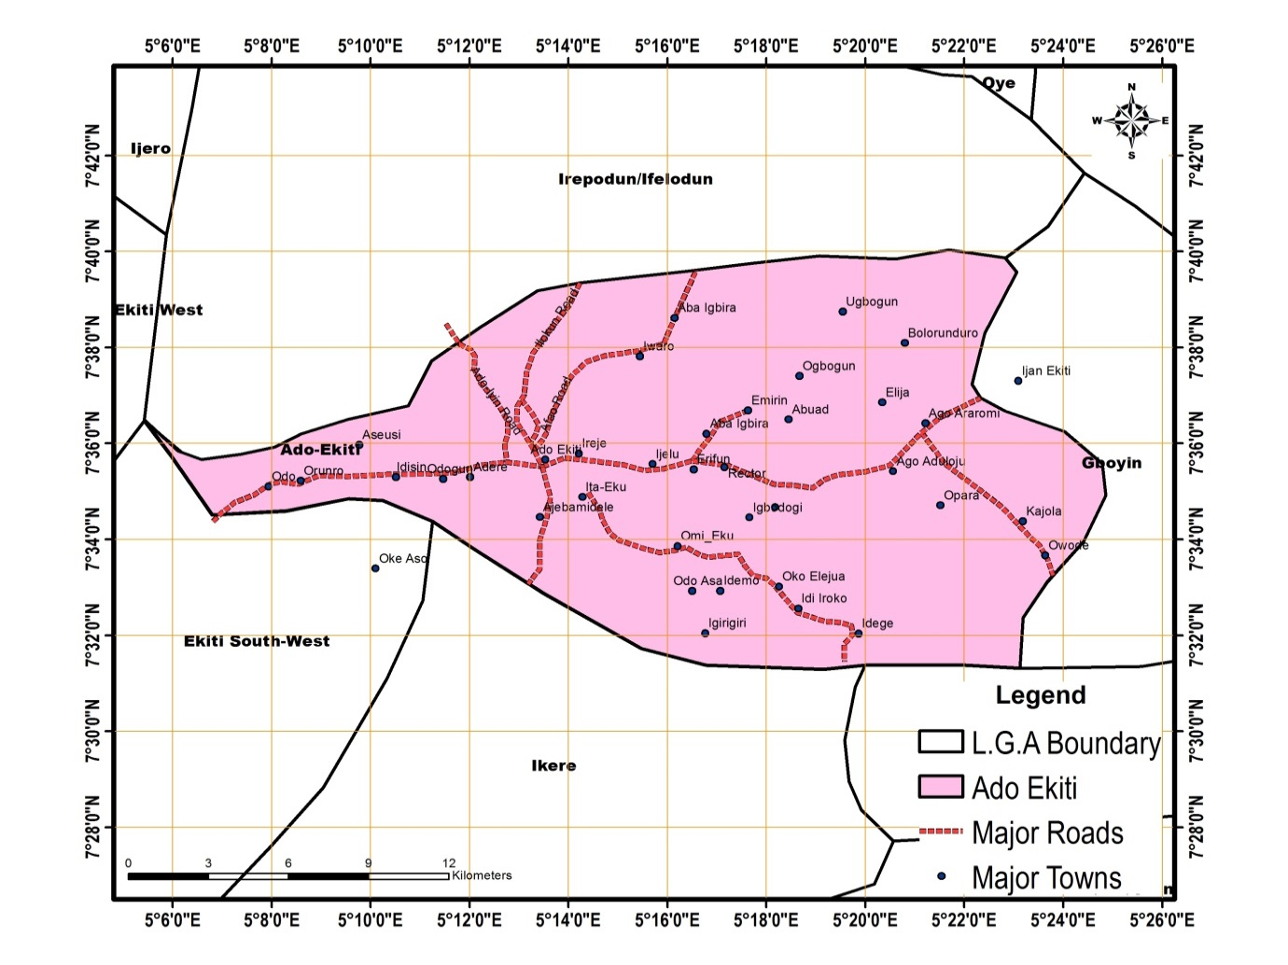Figure 1: Map of Ado-Ekiti Local Government Area

Source. Ekiti State Ministry of Land, Housing and Urban Development (2018)

**Research Methodology.**

Ado-Ekiti Local Government Area has thirteen (13) wards. The core areas of the metropolis have five (5) wards. These are ward 4, ward 5, ward 6, ward 10 and ward 11. 28,374 building were identified in the core area by digitized map. According to Neuman (1991) larger population permits smaller sampling ratio for equal good samples. Therefore 2% of the buildings gives 568 copies of questionnaire that were administered. Research assistants were used to administered and interpret the questionnaire in local dialect where it is applicable.

**Research Analysis**

Findings on occupational structure of the respondents revealed that 8.35% were retired self-employed is 39.46%, 31.94% engaged in trading, 11.69% were civil servants and 8.56% were unemployed. This shows that majority of the respondents are self-employed.

Educational qualification of the respondents showed that only 18.79% of them had tertiary education ranging from National Certificate of Education (NCE) to Degree Level; 22.55% stopped at Secondary School Level, 27.77% had Primary Education while the remaining 30.90% were illiterates. This is an evidence that majority of the respondent were illiterates. Total annual income of the respondents showed that many of them were poor as 34.33% earned below N240,000, 41.02% between N240,001 - N480,000, 18.48% between N480,001- N720,000, 6.16% between N720,001- N960,000. Hence inability of the respondents to construct and build standard housing for human habitation.

Out of the houses sampled, 56.69% were Brazilian type, 29.57% were storey buildings while 13.73% were two bedroom bungalows. Brazilian types with low quality have the highest percentage. Walling showed that 54.92% were mud type while 45.07 were made of block building condition revealed that 24.29% were good, 38.38% were fair; 30.28% were poor while 7.04% were dilapidated. The condition of the wall shows that 30.80% were plastered and painted, 43.30% were plastered but not painted while 25.88% were not plastered and painted. This shows the low quality condition of the buildings in the study area.

Bathroom facilities shows that 11.625% of the buildings have their bathroom within the house while 88.38% have their own outside the buildings which were constructed with planks and rusted corrugated roof sheets 26.23% of the buildings have their kitchens facilities exclusively inside the buildings, 13.90% have it inside and shared among the occupants, 18.30% have their own outside while 41.54% have their own outside and share it among occupants. This shows the poor arrangement of the kitchens facilities which is not hygienic to the residents because most of the kitchens are located very close to the toilets. Roofing condition showed that 23.41% of the buildings were not leaking, 62.67% were susceptible to leaking in the nearest future while 13.90% were leaking. Majority of the buildings have roofs with rusted corrugated iron sheets due to long years of usage that affects the good quality of the buildings.

Method of refuse disposal revealed that 61.44% of the occupants used open dump while 38.55% is through waste management agency. Open dump of refuse contributes to air pollution and environmental degradation in the area.

The major of power supply is through Benin Electricity Distribution company with 72.71%, followed by solar energy with 5.98% while generation plant was 21.30%. The use of power generation plants contribute to air and noise pollution in the environment. The major source of water supply is through well with 67.42%, pipe borne water is 22.18% while borehole is 10.56%. the well may not be pure and hygienic for drinking if not treated.

Finally, by rating, the general condition of the building environment is not satisfactory. It is below acceptable standard for setback from road, drainage system, land fragmentation for buildings and window standard for ventilation.

**Research Findings**

The results of the research work revealed housing condition and facility problems in the study area. Majority of these houses lack basic facilities that make building to be conducive to human living which the housing policy aimed to address. The research paper showed that the majority of the residents in the core area were illiterates. High percentage of the respondents were low income earners with higher number of house hold size. This low income of the respondents did not allow them to afford to pay for some services that can make their housing environment better. There is strong relationship between the socio-economic characteristics of the residents and housing condition problems in the area, in terms of provision of toilets, bathrooms, power supply, drinkable water, and general conditions of the buildings.

Finally ,it was discovered that many of the houses surveyed were in shortage of requisite housing facilities. For instance ,the major source of water which is well water of which are located very close to septic tank thereby making drinking water to be unsafe for consumption.

**Recommendations and Conclusion**

Based on the major findings in the study, the following policy recommendations are put forward as solutions to housing condition problems to achieve a conducive and sustainable human settlement in the study area.

Firstly, there is a need for urban renewal programme through rehabilitation/ renovation approach as well as provision of urban basic services such as water supply, electricity, upgrading the roads, provision of good drainage system and refuse disposal system. All these will improve the structural quality and aesthetic nature of the environment.

The poverty alleviation programmes of the government should be stepped up through economic revitalization programme to reduce unemployment rate and improve the level of capital base and potential for capital formation of the people, this will enhance their level of provision for basis household facilities and adequate and regular maintenance of the buildings. There is need for integrated urban infrastructure and services to reduce the existing deficiencies that was revealed in the findings of this study, to meet the growing need of rapid urban expansion. Infrastructural facilities frame work, like water supply, sewage, drainage, solid and liquid waste disposal and other essential public services like schools, health facilities, public markets.

Government should embark on housing scheme with all the indices of housing facilities having undergone all the necessary steps of ensuring the feasibility and viability of such in the community.

**Conclusion.**

In conclusion, it is observed that rapid urban population and development has created a lot dynamic changes to large and medium size cities in developing nations, including Nigeria. This research discusses on the soico-economic life style and poor qualitative housing conditions and problems associated with it in the study area and proffered policy recommendations to improve them and to reduce poverty level of the residents.

**References**

Adeoye, D.O and Akangbe O.O. (2014) Sustainable Housing Development Strategy by Cooperative Housing for low-Income earners in Oyo State, Nigeria. Urban Environmental Sustainability: Liveable Cities. Published by Urban Design Research Team (UDRT) Department of Architecture School of Environmental Technology, Federal University of Technology Akure, Nigeria 2014 Edition

Amao, F.L (2012) Urbanization, Housing Quality and Environmental Degeneration in Nigeria. Journal of Geography and Regional Planning Vol.5(1) Pp.422-429, December, 2012.

Draft National Urban Development Policy 2004

FCDA, 1979, The Master Plan for Abuja The New Federal Capital of Nigeria. Federal Capital Development Authority (FCDA) State House, Marina Lagos, Nigeria.

Global Report on Human settlements 2003 [www.unhabitat.org/grhs/2003](http://www.unhabitat.org/grhs/2003). Retrieved Jan.4.2019

Green R.D. (2011). The Impact of Housing Stressors on the Mental Health of a Low-income African –American Population. The Review of Black Political Economy doi 10.1007/512114-011-9109-z.

Harker, L. (2007), the Impact of Housing on Children Life Chances. Journal of Children’s Services. 2(3), 4-41-43.

https;//www.researchgate.net. retrieved 31/7/19

Neuma (1991)

New National Housing Policy, 1985 Federal Republic of Nigeria, report of the Special Committee on New National Housing Policy July 1985.

Nor. R.Z, Gurmit K., Nor. A.A and Jamaliah M.K. (2012). Housing Conditions and Quality of Life of the Urban poor in Malaysia. Asean Conference on Environment-Behaviour Studies, Bangkok, Thailand, 16-18 July 2012.

Un-Habitat (2005),